x360Sync End User Guide
Updated: October 2023

Table of Contents

Contents
How to Log in to the Web Portal 6
How to Manage Account Settings 7
How to Configure Two-Step Authentication 9
Overview 9
Configuring Two-Step Authentication 9
Accessing the Web Portal 12
Registering the Desktop Client 13
Registering and Accessing Mobile Apps 13
Registering and Accessing the Outlook Add-In 19
The Web Portal 21
How to Upload Files in the Web Portal 21
How to Create and Manage Files and Folders in the Web Portal 23
Overview 23
Previewing Content 24
Editing Content 24
Creating and Managing Content 25
A Note about Excluded Extensions 27
Live Databases 27
Mobile Apps 28
How to Download Mobile Apps 28
How to Use the Android App 29
Logging In 29
Navigating 33
Locking a File or Folder 34
Editing Files and Folders 35
Sending Share Links 37
Backing Up the Gallery 43
Turning on Grid View 44
Pinning Files for Offline Viewing 46
How to Use the iOS App 47
Logging In 48
Navigating 51
Operations 52
Viewing and Editing Files 52
Locking Files and Folders 54
Sharing Files and Folders 55
Backing Up the Camera Roll 58
Setting a File or Folder as a Favorite for Offline Viewing 60
Synced Tool for Windows and Mac Machines 63
How to Download the Desktop Client 63
How to Register the Desktop Client 66
How to Upload Files in the Desktop Client 69
How to Manage Preferences for the Desktop Client 70
Managing Preferences 70
Pausing a Sync Process 74
Viewing Warning Messages 76
How to Use the Selective Sync Feature 76
Sharing and Collaborating 78
How to Create a New Team Share 78
Team Share Permissions 79
Instructions 80
How to Send Share Links to Files 81
How to Manage Guest Accounts 84
How to Send Share Links to Folders 85
How to Manage Shared Items 87
How to Edit Files in the Web Portal Using the Collabora- tive Web Editor 89
Overview 89
Revisions 90
Anonymous Editing Permissions 90
Notifications and File Locking 90
Launching the Collaborative Web Editor 91
Inviting Coauthors to Collaborate 94
Chatting with Coauthors 97
Editing with Coauthors 98
How to Edit Files in the Web Portal Using Microsoft 365 Apps 100
Overview 100
Supported File Formats 101
Notifications and File Locking 101
Launching a Microsoft 365 App 102
Locking Files and Folders 105
How to Lock Files and Folders in the Web Portal 105
Viewing Lock Information 106
How to Lock Files and Folders in the Desktop Client 107
Manually Locking a File or Folder 107
Auto-Locking Files 107
Viewing Lock Information 109
How to Resolve File Sync Warnings 109
Common Types of File Sync Warnings 110
Other Types of File Sync Warnings 115
File Collision 115
Folder Exists Upstream (Folder collision) 115
Invalid Credentials for Synced Network Path 116
File Is Locked 116
Sync Root Folder Missing 116
Folder Permission 116
Team Share Permission 117
Restoring Files and Folders 119
How to View and Restore a Revision 119
How to View and Restore Deleted Files and Folders 120
How to Use the Rollback Feature 122
Backups 124
How to Create Backups in the Web Portal 124
How to Create Backups on your Local Machine 125
How to Manage Backups in the Web Portal 126
File Report and Activity Log 128
How to View File Reports 128
How to Track Activity 129
Outlook Add-In 131
Configuring the Outlook Add-In 131
Using the Outlook Add-In 133
How to Install the Outlook Add-In 133
How to Configure the Outlook Add-In 136
How to Use the Outlook Add-In 138
WebDAV 141
How to Map a Network Drive on a Windows Machine 141
How to Map a Network Drive on a Mac OS X Machine 142

x360Sync for End Users

Your File Sync Tool allows you to share files and folders across your devices, and helps you collaborate and share content with others. Using the system, you can:

- Collaborate with members of your organization, as well as with people outside of your organization
- Manage file revisions and versioning
- Audit and track your files
- Share files and folders through email with the Outlook add-in
- Back up and restore important files

This User Guide will help you set up and use the system, and will provide you with the information you need to incorporate the system’s toolset into your daily work activities.

How to Log in to the Web Portal

When a user account is first created for you, you will receive a Welcome email from your administrator, providing you with important information to help you get started us- ing the system. For example, your email might include a link to the web portal, a user- name (or an email address), and a password.

- Navigate to the URL listed in your email (for example, https://www.synced- tool.com).
- Enter your username (or email) and password.
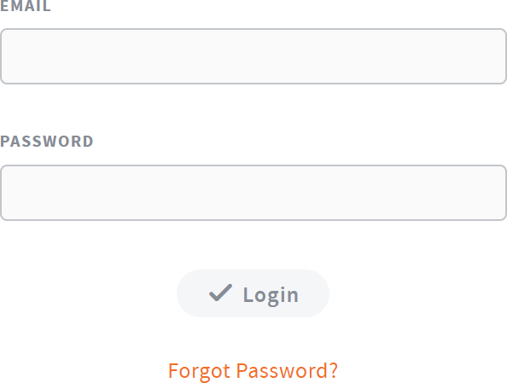
- Click the Log In button.

- Alternatively, if you do not remember your password, click the Forgot Password link. You will be prompted to enter your email address to begin the password-re- set process.
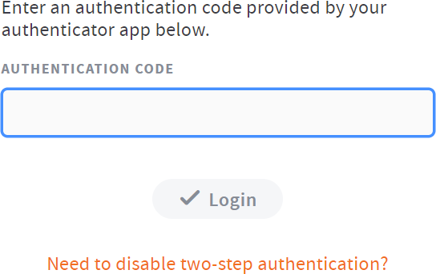
- If Two-Step Authentication is configured for your account, enter your Authentica- tor Code and click the Login button.

How to Manage Account Settings
In the web portal, you can update your account settings, including your name, email address, and password. You can also set up advanced settings, such as Two-Step Au- thentication, quota alerts, and WebDAV access.

To manage account settings:

- In the web portal, click the username drop-down button and select Account Set- tings.
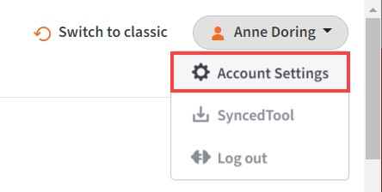

The Account Settings page displays.

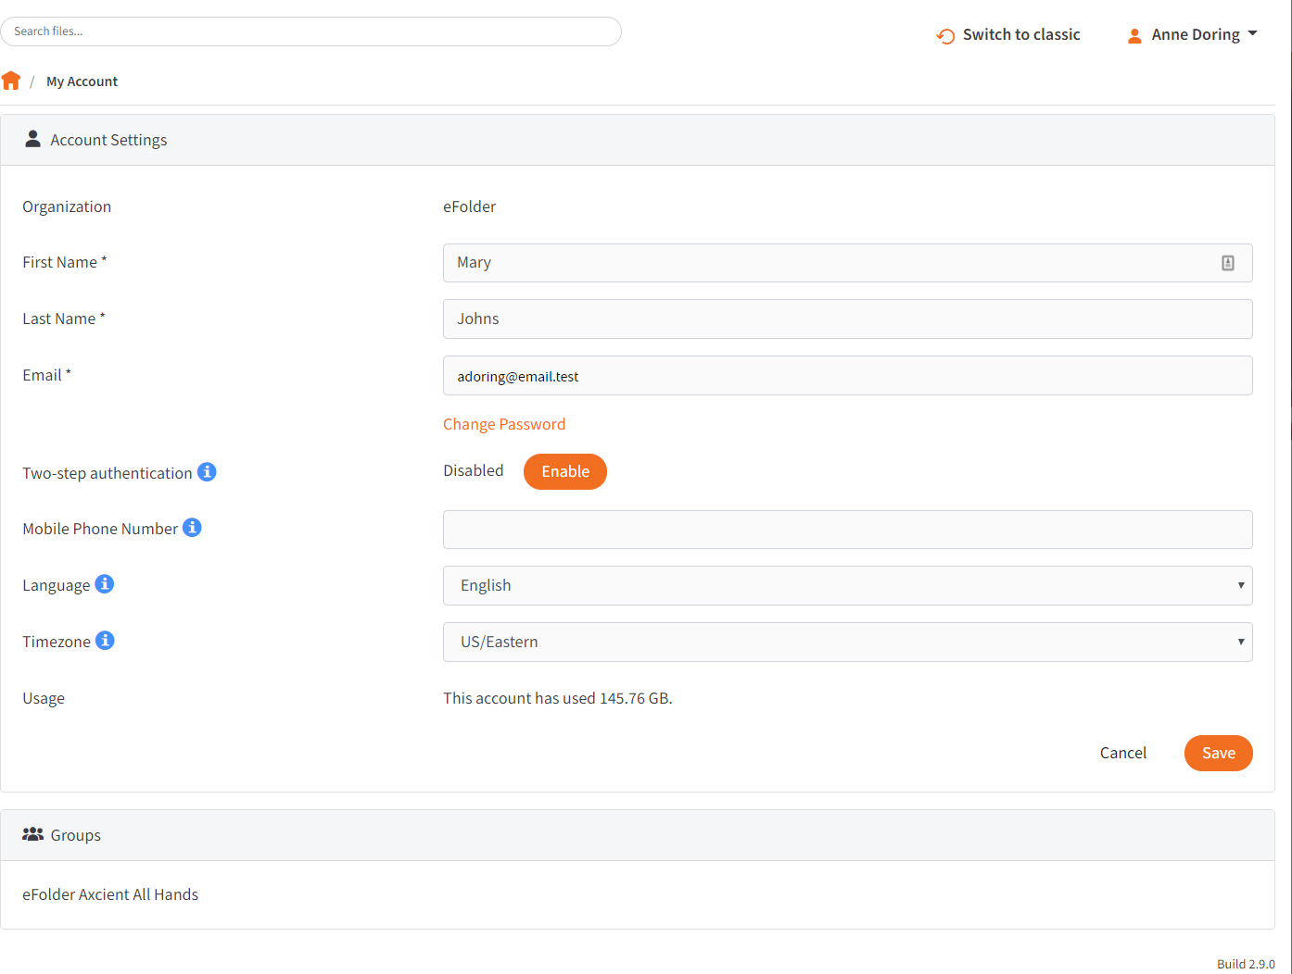
- In the Account Settings page, you can update account information, including:
  - Use the First Name field to update your first name.
  - Use the Last Name field to update your last name.
  - Use the Email field to update your email address.
  - Click the Change Password link to change your password.
  - Use the Mobile Phone Number field to change your mobilephone number.
  - In the Language drop-down menu, select your preferred site language, which controls the language settings displayed in the web portal and mobile apps, as well as number formatting. Leave this field blank to use the default language set for the system, which you will see displayed when you hover over the blue Question icon.
  - In the Timezone drop-down menu, select your preferred timezone, which af- fects dates and times displayed across the system. You can also leave this field blank to use the system default, which you will see displayed when you hover over the blue Question icon.
- Optionally, in the Two-Step Authentication section, click the Enable button to ena- ble Two-Step Authentication. Two-Step Authentication adds an extra layer of se- curity to your account. Each time you log in to the web portal, or register a desk- top client, the Outlook add-in, or a mobile device, you will be prompted to enter an authentication code. This code will be delivered to you through a mobile app, a text message, or an email, depending on your settings. For more information, please reference the How to Configure Two Step Authentication section of this guide.
- In the Groups section of the page, you can view the groups to which you belong.
- Click the Save button when you are finished making changes to your account.

How to Configure Two-Step Authentication

Overview

In the web portal, you can optionally configure Two-Step Authentication for your ac- count. In some instances, your administrator might require that you set up Two-Step Authentication.

Two-Step Authentication adds a second verification step when you log into the web portal, or register the desktop client, the Outlook add-in, or a mobile device. With Two- Step Authentication, you will be sent an authentication code through an Authenticator Mobile App, text message, or email, depending on your selected configuration. You must then enter this authentication code—along with your username and password— before you can access the web portal, or register the desktop client, the Outlook add- in, or a mobile device.

Two-Step Authentication can be configured in one of two ways.

- You can optionally configure your own Two-Step Authentication settings in your Ac- count Settings page.
- Administrators can also require the use of Two-Step Authentication for your organi- zation. If your administrator has turned on this policy, you will be prompted to config- ure your own Two-Step Authentication settings as soon as you log in to the web por- tal.

Configuring Two-Step Authentication

To configure Two-Step Authentication:

- Click the Logged In As button in the web portal.

The Account Settings page displays.

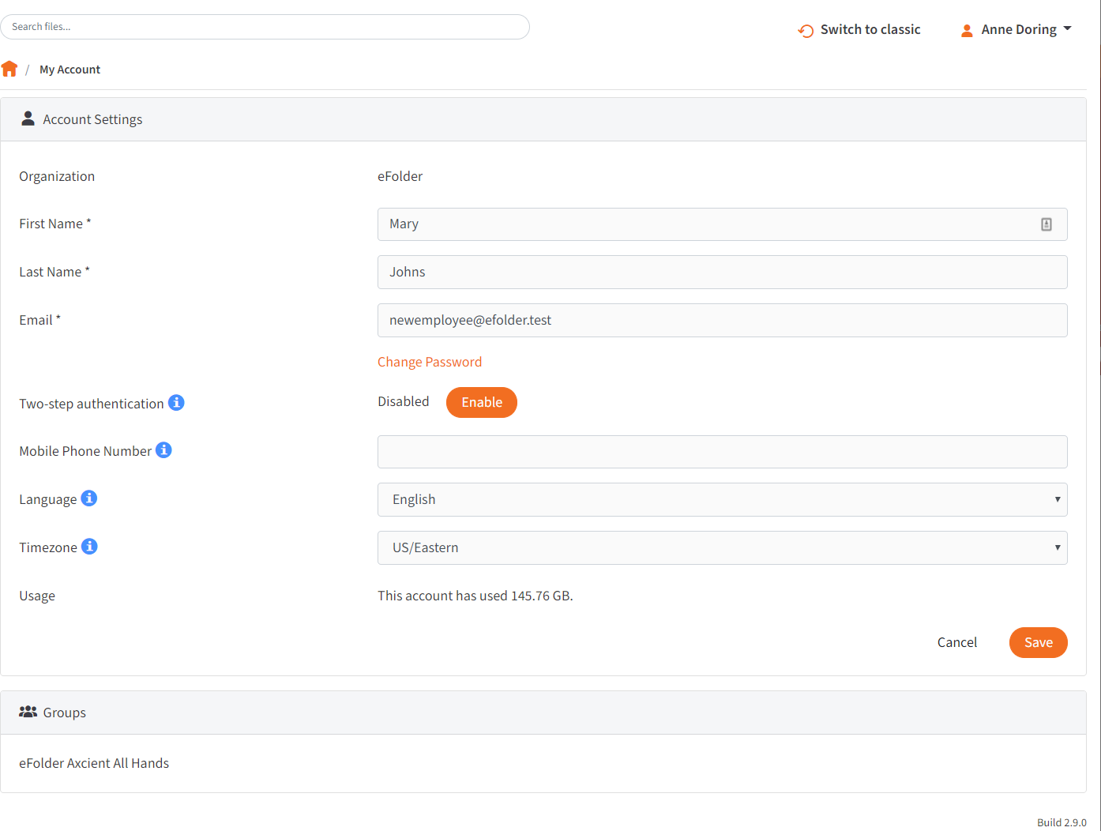
- In the Two-Step Authentication section, click the Enable button. Your administra- tor might require that you use Two-Step Authentication. If you are required to set up Two-Step Authentication, you will be prompted to configure an authentication mode when you log in to your account in the web portal.

You will be redirected to the Enable Two-Step Authentication page.
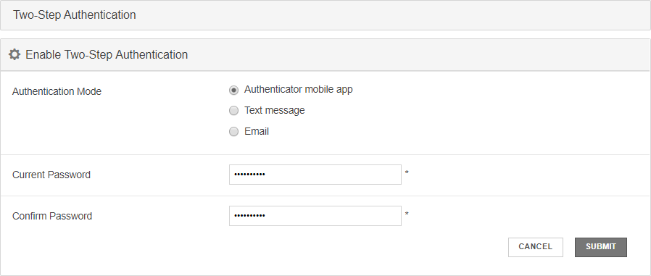
- In the Authentication Mode field, select the delivery method through which you want to receive your authentication code. You can choose from Authenticator Mo- bile App, Text Message, and Email. If you select Authenticator Mobile App as your delivery method, you must install an authenticator app of your choice, such as Google Authenticator, Amazon AWS Virtual MFA, or any of the many other TOTP- compatible apps available for download.
- In the Current Password field, enter your password.
- In the Confirm Password field, confirm your password.
- If you selected Text message as your delivery method, you will also be prompted to enter your mobile phone number.
- Click the Submit button when you are finished. You will be redirected to the Con- firm Two-Step Authentication page, which will vary based on your selected deliv- ery method.
  - If you selected Authenticator mobile app as your delivery method:

    - Save the Backup key that is listed in the confirmation page. You will need this key if you need to recover access to your account.
    - On your mobile phone, install a mobile authenticator app, such as Goo- gle Authenticator, Amazon AWS Virtual MFA, or any of the many other TOTP-compatible apps available.
    - In the mobile authenticator app, create an account, and enter the secret key to confirm your identity, which you will find listed in the Confirm Two- Step Authentication page. A few mobile authenticator apps, such as Google Authenticator, will allow you to scan the barcode to confirm your identity.
    - In the web portal, enter the authentication code provided by your authen- ticator app in the Authentication Code field.
    - Click the Submit button when you are finished.
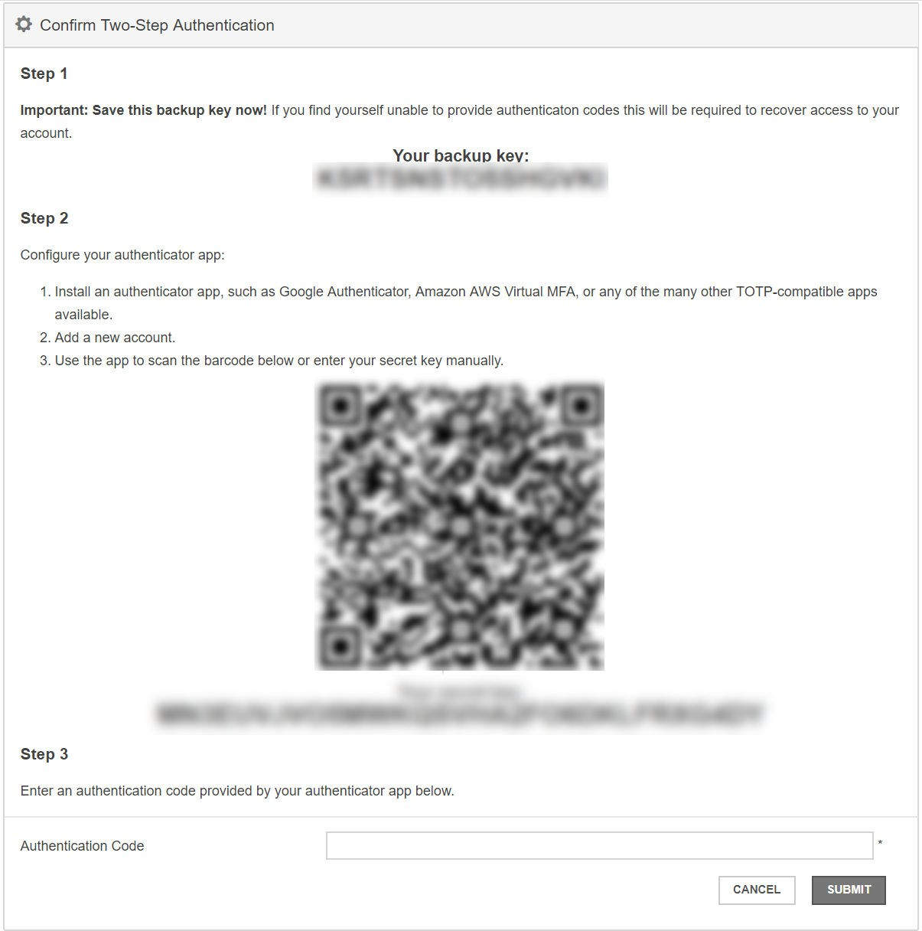
  - If you selected Text message as the delivery method:
    - Save the Backup key that is listed in the confirmation page. You will need this key if you need to recover access to your account.
    - You will receive a text message with an authentication code. Enter that code in the Authentication Code field.
    - Click the Submit button when you are finished.
  - If you selected Email as the delivery method:
    - Save the Backup key that is listed in the confirmation page. You will need this key if you need to recover access to your account.

    - You will receive an email with an authentication code. Enter that code in the Authentication Code field.
    - Click the Submit button when you are finished.

Accessing the Web Portal

After your Two-Step Authentication settings are configured, you will be prompted for a second step authentication code each time you log in.

NOTE

Authentication codes are only valid for a limited amount of time. Make sure you enter your validation code promptly.

If you are ever unable to provide the correct authentication code, you can use the Backup key to recover your account.

- In the Login page, click the Need to disable two-step authentication link.

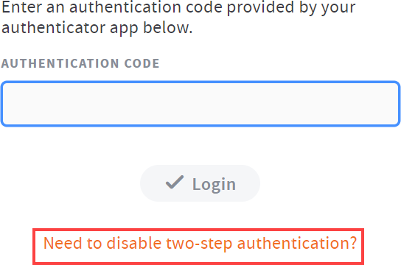
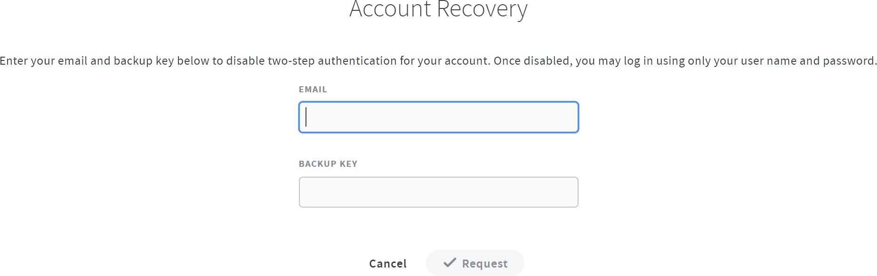
The Account Recovery page displays.

- In the Account Recovery page, enter your email address as well as the Backup key that was saved when you first configured your verification settings.
- Click the Request button when you are finished. When Two-Step Authentication has been disabled, you will be able to log in using just your username and pass- word.

Registering the Desktop Client

When registering the desktop client for the first time, you will be asked to enter an au- thentication code.

- If Two-Step Authentication has been enabled for your organization or for your user account, you will be prompted to enter an authentication code at the time of registration.

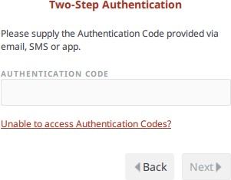
- After you receive your authentication code, enter the authentication code and press the Next button. You can then complete the registration process.

Registering and Accessing Mobile Apps

When accessing your mobile app for the first time, you will be prompted to enter an authentication code. You will also be asked to configure a passcode (also called a PIN if you are using an Android device) when you access your mobile app at subsequent sessions.

- If Two-Step Authentication has been enabled for your organization or for your user account, you will be prompted to enter an authentication code at the time of initial registration. Enter the authentication code and press the OK button.

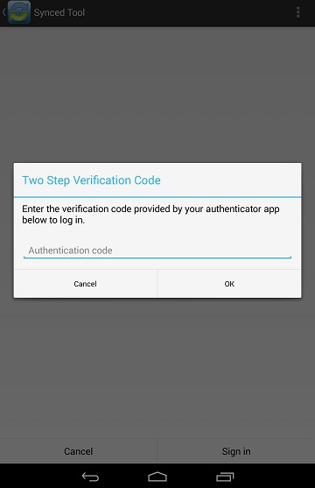

Image of the Android App Two Step Authentication Prompt

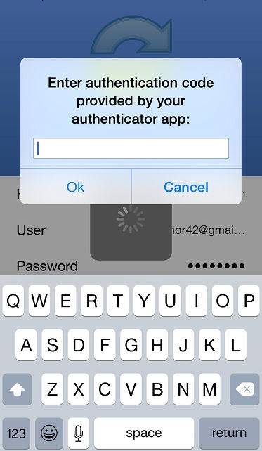

Image of the iOS App Two Step Authentication Prompt
- f Two-Step Authentication has been enabled for your entire organization, you will also be asked to configure a passcode (for your iOS device) or a PIN (for your Android device). At subsequent sessions, you will be prompted to enter this PIN or passcode when you access your mobile app.
Note: If Two-Step Authentication has been turned on only for your user account (either by you or by your administrator) you will not be required to configure a passcode or PIN.

  - On an Android device, you will be directed to the Settings page. Select Re- quire PIN.

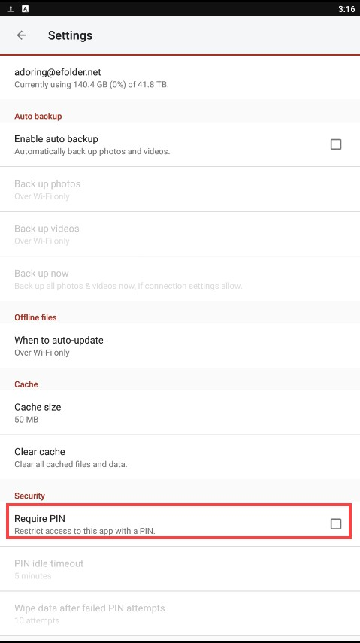

You will be prompted to enter a PIN.

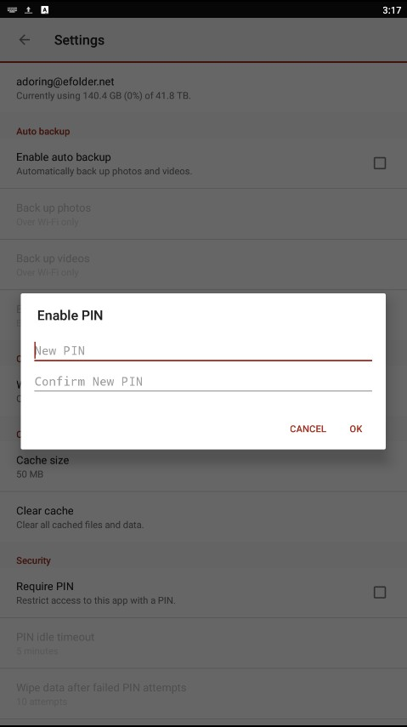
  - Alternatively, if you are using an iOS device, you will be directed to the Set- tings page. Select Use Passcode.

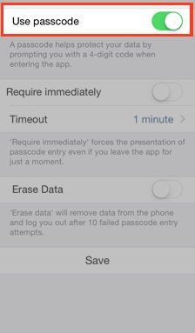

You will be prompted to enter a Passcode.

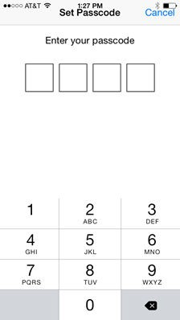
  - When accessing the mobile app in the future, you will be prompted to first en- ter this PIN or passcode.

Registering and Accessing the Outlook Add-In

When accessing the Outlook add-in for the first time, you will be prompted to enter an authentication code. You will also be prompted for an authentication code when open- ing a new Outlook session, or when changing your add-in credentials.

- If Two-Step Authentication has been enabled for your organization or for your user account, you will be prompted to enter an authentication code when you open Microsoft Outlook.

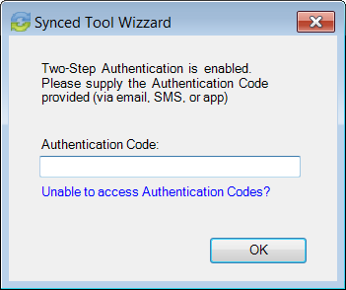
- After you receive your authentication code, enter the authentication code and press the OK button. You will be prompted for this authentication code at the time of add-in registration, when opening a new Outlook session, or when changing your add-in credentials.

The Web Portal

After you have an account, you can begin to create and upload content into the web portal. The web portal provides user-friendly features—including drag and drop func- tionality, multi-select options, and the ability to view dozens of file types directly in your web browser.
In the web portal, you can access your personal dashboard, search for files and fold- ers, and manage your personal and shared content. For example, you can:
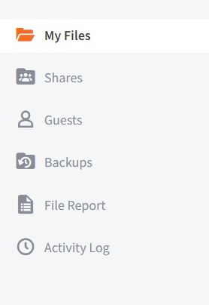
- Click the Files tab to access your files and folders, or create new files and folders.
- Click the Shares tab to access Team Shares, items shared by you, and items shared with you.
- Click the Guests tab to collaborate and share with people outside of your organiza- tion.
- Click the Backups tab to create and man- age your backups.
- Click the File Report tab to view or export a list of your files.
- Click the Activity Log tab to review your activity within the system.

How to Upload Files in the Web Portal
When files and folders are uploaded to the web portal, all of these items will propagate down to any of your connected devices, such as your mobile device or your local ma- chine. You can access your uploaded content from any computer that has a supported web browser and an Internet connection.
To upload files in the web portal:

- In the web portal, click the Files tab. The Browse Files page displays.
- Navigate to the appropriate location, and then drag and drop files and folders onto the page, or into a personal folder or Team Share. Uploaded folders will retain their original structure.
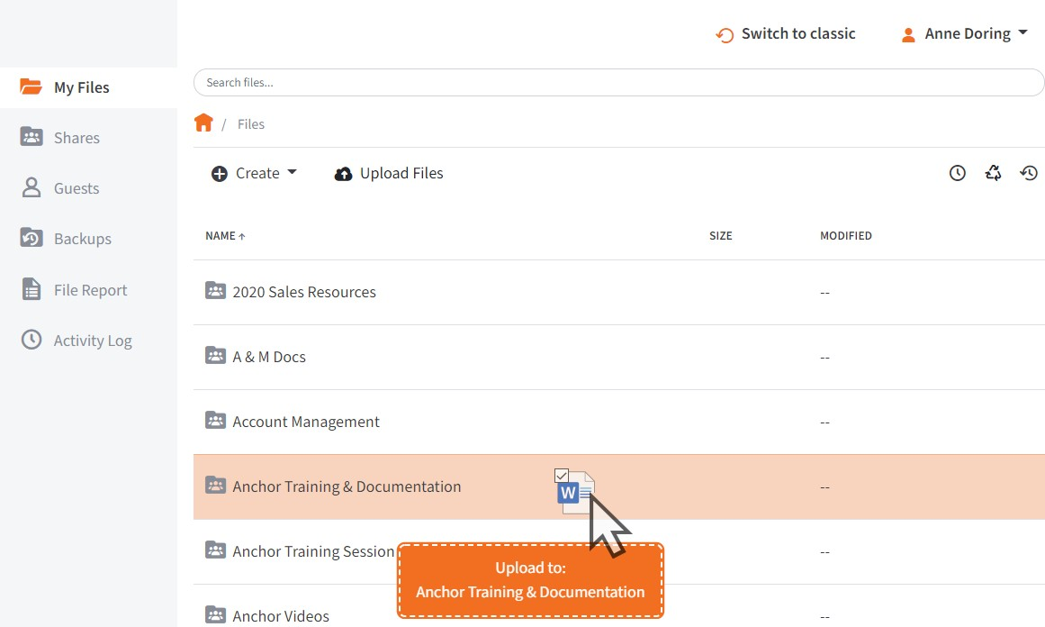

An Upload Files pop-up window displays, showing you the status up the upload process.
  - Alternatively, while inside the appropriate folder, click the Upload Files but- ton. The Upload Files page displays.
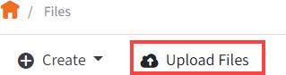
  - In the Upload Files page, you can drag and drop files onto the page and click the Upload button. The files will upload. Or, click the Add Files button to manually search for files on your local machine. The files will upload.
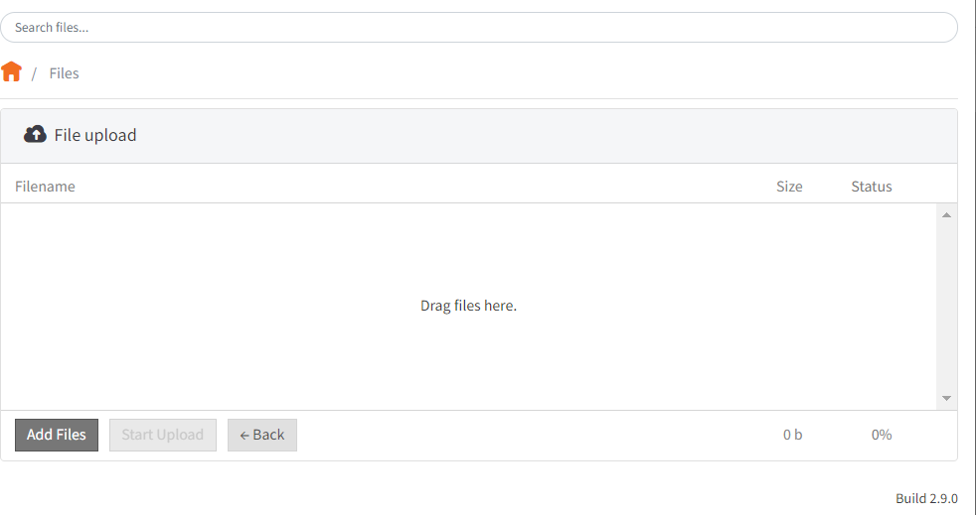

How to Create and Manage Files and Folders in the Web Portal

Overview

You can create and manage all of your files and folders in the Browse Files page of the web portal. In this page, you can utilize advanced drag and drop functionality, cre- ate files folders, upload files, and manage revisions. You can also preview dozens of file types directly in your web browser and edit files simultaneously with coauthors us- ing the fully integrated Collaborative Web Editor.

Finding Content

- In the web portal, click the Files tab. The Browse Files page displays, giving you access to your files, folders, and Team Shares.
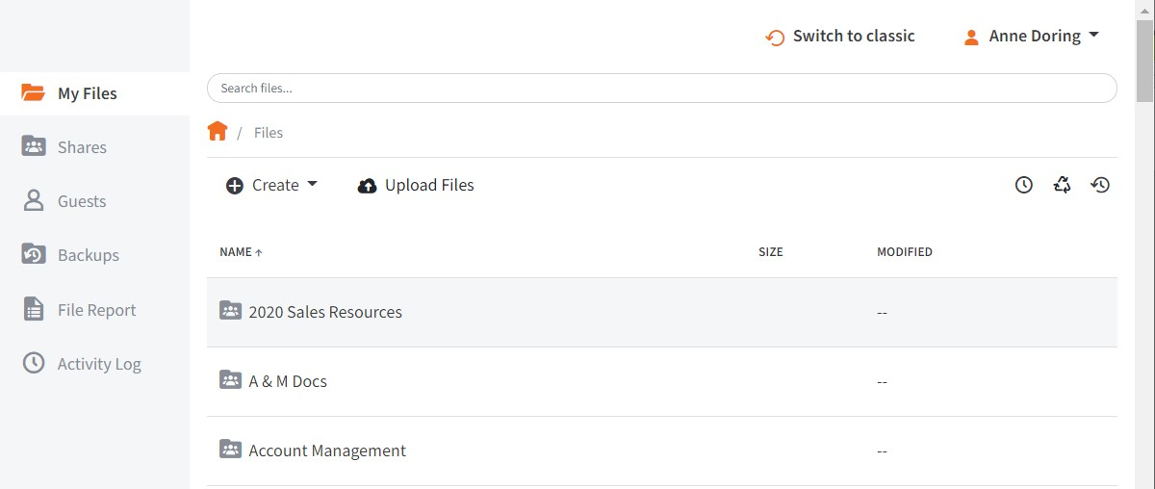
- To quickly organize your content, drag and drop files and folders within the Browse Files page. You cannot drag and drop a personal file or folder into a Team Share. You can, however, drag and drop personal files and folders, or drag and drop files and folders while inside a Team Share.
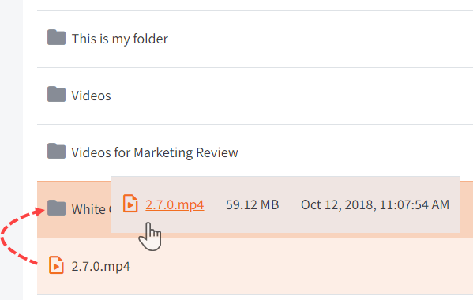
- You can also select multiple items at one time by holding down the Shift key on your keyboard. You can then perform mass actions, including download, lock, move, deleted, and more.

Previewing Content

- To preview a file in your web browser, right-click the file and select View. Or, sim- ply click the file to view its contents.
The selected file will open, allowing you to utilize advanced search tools, select and copy text, print, download, and more.
- Click the Close button when you are finished previewing the file.

Editing Content

- Right-click a supported file type, point to Open in and select your preferred edi- tor. Depending on administrative settings, you might have access to the Web Edi- tor or a Microsoft app.
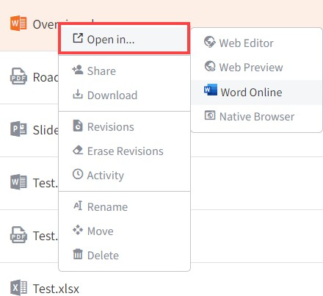

For example, if you select Web Editor, the file opens in the fully integrated, real- time Collaborative Web Editor.
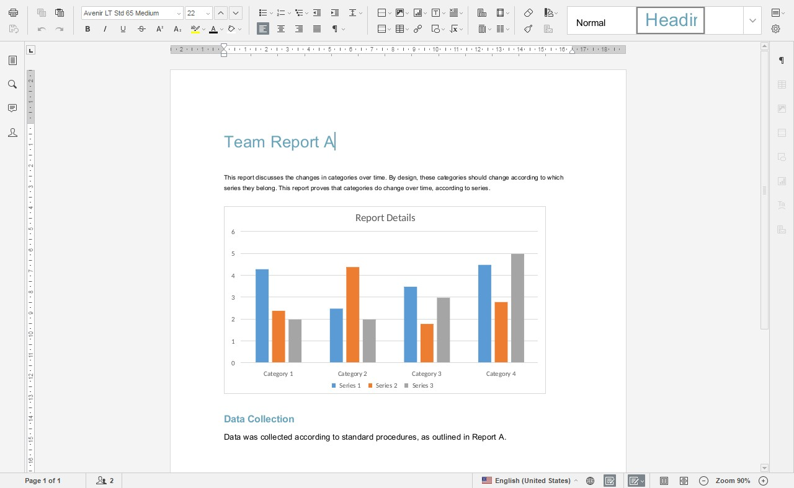

- In the Collaborative Web Editor, you can access a wide-range of formatting tools to help you update fonts, paragraph formats, charts, tables, images, style types, and more. Additionally, you can edit simultaneously with coauthors, send and re- ceive chats, and view and manage comments.

Creating and Managing Content

- In the Files tab of the web portal, you can use the toolbar buttons to manage con- tent in the selected folder.
  - Click the Create drop-down button to create a new file or folder inside the web portal.
  - Click the Upload Files button to add files to the web portal.
  - Click the Rollback button to restore all files within the entire folder to an earli- er revision before a selected date. The Revision Rollback feature is particu- larly useful in situations where a file might have been corrupted by ransom- ware; it utilizes a file’s revision history, and restores all currently-existing con- tent in the folder to a healthy revision at a specified point-in-time. In these ca- ses, you can use the Activity Log to determine when the infected revisions were uploaded, and then roll back files prior to the point of infection.
  - Click the Show Deleted button to show files that have been deleted.
  - Click the Restore Deleted button to return any deleted files to their original location.
  - Click the Erase all Revisions button to erase previous revisions.

- Use the foldermenu to manage individual folders:
  - Right-click a folder. A menu displays.
  - In the menu, you can:
    - Click the Share link to create a share link to the folder and its contents.
    - Click the Download ZIP link to download the entire folder as a ZIP file to your local machine.
    - Click the Erase Revisions link to remove previous revision of the folder from the system.
    - Click the Rename link to rename the title of the folder.
    - Click the Move link to change the path of the folder.
    - Click the Delete link to delete the folder from the system.

Note: When you delete an item, it is still stored in the system for a pre-determined number of days. Within this timeframe, you can restore a deleted file. Please contact your administrator for more information.

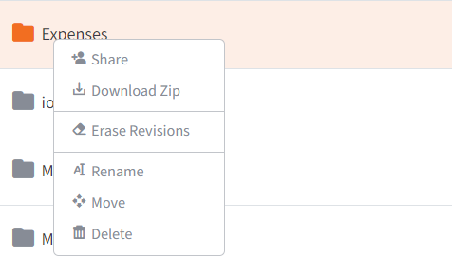
- Alternatively, you can use the filemenu to manage individual files; or, press and hold down the Shift key to select multiple files at one time.
  - Right-click a file. A menu displays.
  - In the menu, you can:
    - Click the Open in link to launch the file in the native browser, the Collabo- rative Web Editor, Microsoft 365 (if applicable), or the Web Preview tool.
    - Click the Share link to create a share link to the file.
    - Click the Download link to download the file to your local machine.
    - Click the Revisions link to view a list of revisions to the file, and optionally restore a previous revision.
    - Click the Erase Revisions link to remove previous revision of the file from the system.
    - Click the Activity link to review activity or events for the selected file.
    - Click the Rename link to rename the selected file.
    - Click the Move link to change the path of the selected file.
    - Click the Delete link to delete the file from the system.
Note: When you delete an item, it is still stored in the system for a predetermined number of days. Within this timeframe, you can restore a deleted file. Please contact your administrator for more information.

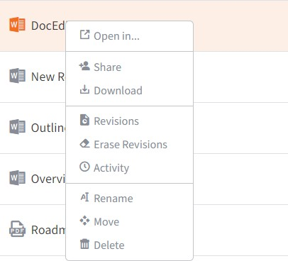

A Note about Excluded Extensions
While most of your files and folders will easily sync across all of your devices, certain system files and folders, as well as temporary application files, will not sync. Your ad- ministrator may have also configured other file extension types—such as application or video files—to be excluded from the syncing process.

You can add files with excluded extensions to Synced Folder, but they will not display in the web portal or in your mobile apps.

If you upload a file with an excluded extension through the web portal, you will receive a notification that the file is on the exclusion list. This file will not appear in the web portal or in your mobile apps.
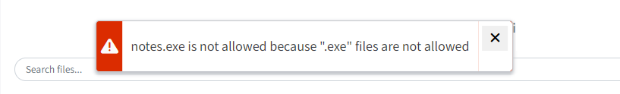

Live Databases

The system does not support the syncing of live database files, including Microsoft Ac- cess Databases, QuickBooks Files, .pst Files, and so forth. Attempting to sync a live database file could result in errors and collisions.

Mobile Apps

In addition to using the web portal or the desktop client on your local machine, you can manage files and folders from an app on your mobile device. Mobile app versions in- clude Android and iOS.
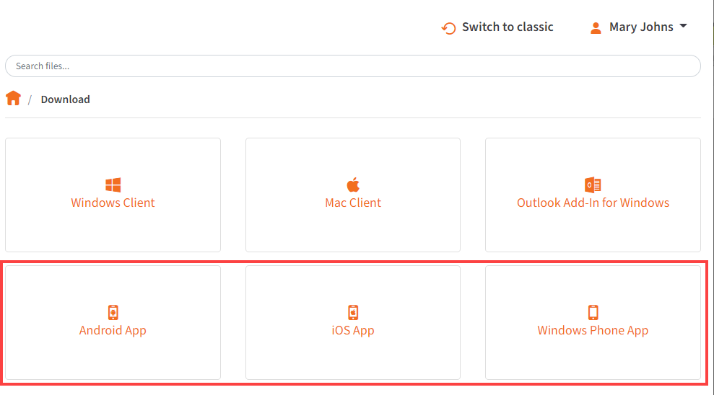

How to Download Mobile Apps

You can manage your files and folders from various mobile apps, including the An- droid app, the iOS app, or the Windows Phone app.

- Find and download the Android app in Google Play,
- Find and download the iOS app (for your iPhone or iPad) in iTunes, and
- Find and download the Windows Phone app in the Windows Phone site.

Alternatively, you can access a direct link to your device-specific app in the web portal. To find your device-specific app:
- In the web portal, click your username drop-down button and select Sync.

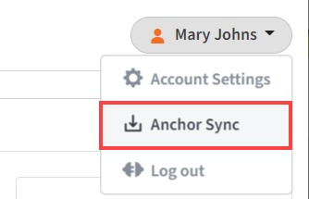

The Download page displays.
- In the Download page, select either the Android App, iOS App, or Windows Phone App button.

You will be redirected to the page that will allow you to download and install your device’s app.

How to Use the Android App

If you use an Android device, you can download the Android app in Google Play. The app allows you to:

  - View, rename, delete, and move content,
  - Upload content from your device,
  - Easily edit Microsoft 365 content,
  - Lock files and folders,
  - Share files and folders (including secure shares),
  - Manage share links,
  - Automatically back up your photo gallery to a synced folder, called Camera Up- loads, and
  - Pin files so that they are fully downloaded on your device.

Logging In

To log in to your Android device:

  - In your Android device, press the app icon to launch the app. The Login screen displays, prompting you to enter your credentials.
    - In the Host field, enter the host name of the system (for example, synced- tool.com).

    - In the User field, enter your username (for example, user@mail.com).
    - In the Password field, enter your password.
    - Press the Sign in button when you are finished.
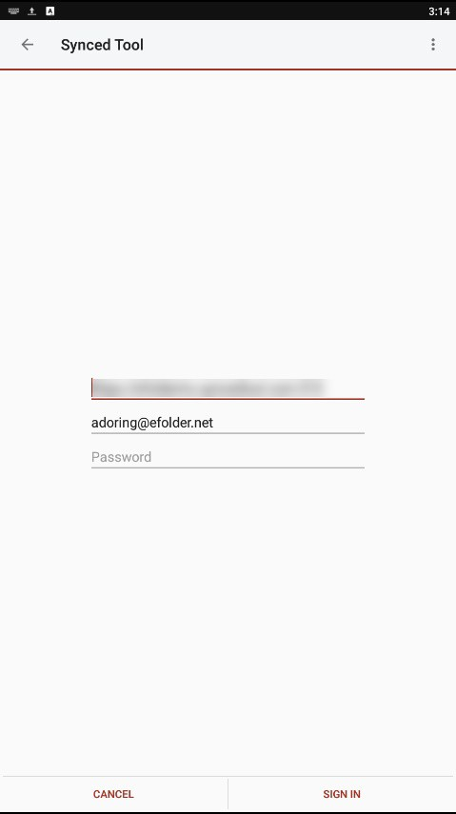
      - If Two-Step Authentication has been enabled for your organization or for your user account, you will be prompted to enter an authentication code at the time of initial registration. Enter the authentication code and press the OK button.

      - If Two-Step Authentication has been enabled for your entire organiza- tion, you will also be asked to configure a PIN after the initial registration process.
Note: If Two-Step Authentication has been turned on only for your user account (either by you or by your administrator) you will not be required to configure a PIN.
      - You will be directed to the Settings screen. Select Require PIN.

You will be prompted to enter a PIN.

      - When accessing the mobile app in the future, you will be prompted to first enter this PIN.

Navigating

When you have access to your account, you can use the app to open, view, and man- age content. For example:

- Press the menu tab to manage your Android app.
- Press the My Files link to view a listing of your files, folders, and Team Shares.
- Press the Share Links link to view a list of items shared by you.
- Press the Recent Files link to view your most recent files.
- Press the Offline Files link to view a list of pinned files that can be viewed offline.
- Press the Backups link to view a list of your backups.

- Press the Uploads link to view a listing of files uploaded from your device.
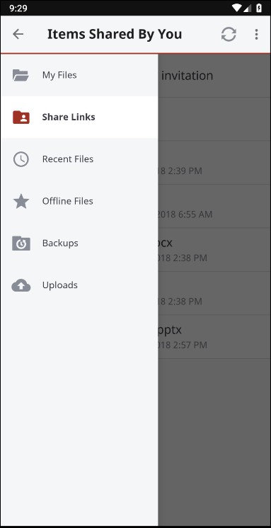

Locking a File or Folder

Optionally, you can lock a file or folder. To lock a file or folder:

- In the My Files screen, navigate to a Team Share.
- Within the Team Share, select the file or folder you want to lock.
- In the top right-hand corner of the screen, press the more options button and then press the Lock link.

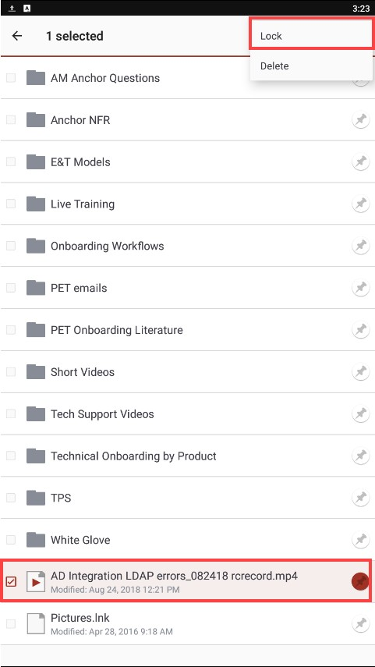

The file is now locked.

Editing Files and Folders

To edit files with Microsoft 365:

NOTE

To edit content with Microsoft 365, you must first download supported Microsoft 365 applications. File formats supported for editing include
*.docx, *xlsx, and *.pptx.

- Download the Microsoft Word app, Microsoft Excel app, or the Microsoft Power- Point app, depending on your needs and preferences.
- With the Microsoft app installed, press the appropriate file that you want to edit.
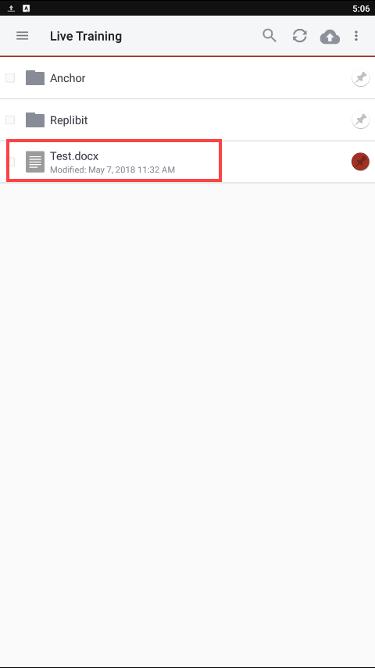
- The file will open in the Microsoft app, and will prompt you to sign in to your Mi- crosoft 365 account, if you are not already signed in. Press the Sign In button.
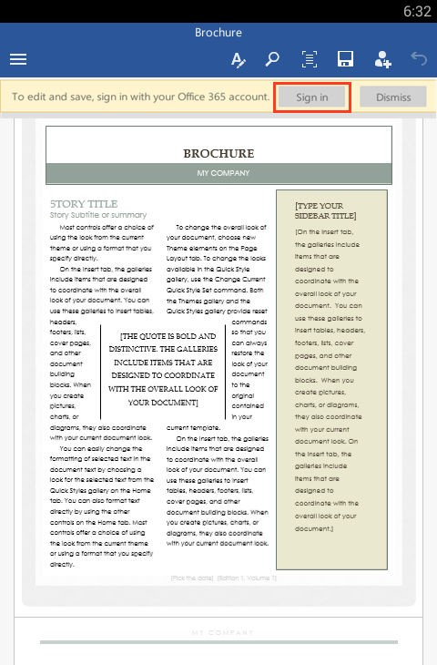
- The Microsoft 365 Sign In screen displays, asking you to either sign in or create a new account.

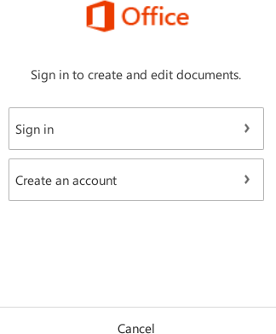
- When you are finished signing in, the file will display in the Microsoft app. Use the toolbar to edit the file as appropriate.
- Save your file when you are finished. The file will synchronize.

Sending Share Links

You can also send share links directly from your mobile app. To send a secure or pub- lic share:

- In the My Files screen, select the file or folder that you want to share and press the Share button.

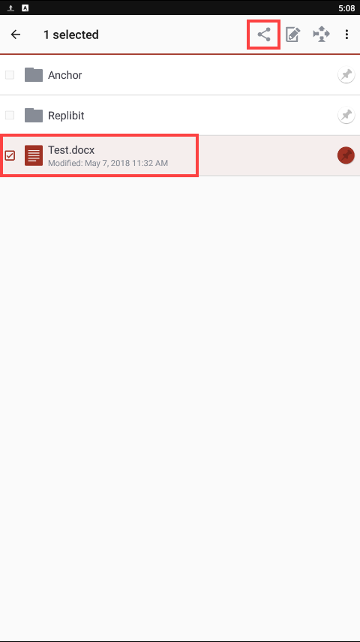
- In the Choose a share type window, select Public share to send a standard share. Alternatively, select Secure share to send a secure share, which will re- quire the recipient to log in before he or she can access the shared item.
- Press OK to confirm your selection.
Note: If your administrator has configured settings to only allow secure shares, you will only have the option to send a secure share.

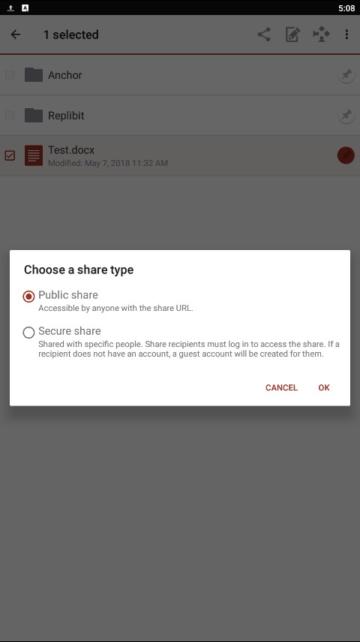
- In the Create a secure share window, enter your recipient's email address and press the OK button. Your item will be shared with the specified recipient.

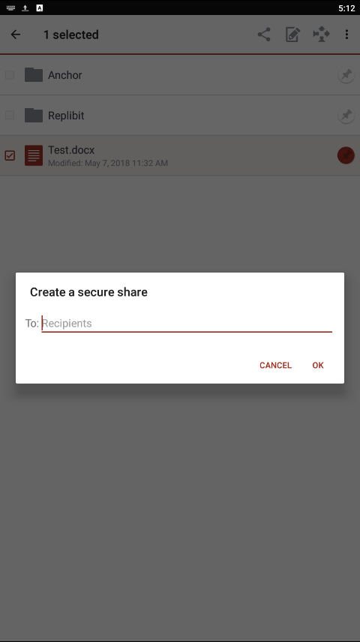
- To view a list of share links that you have generated, click the menu tab and se- lect the Share Links link.

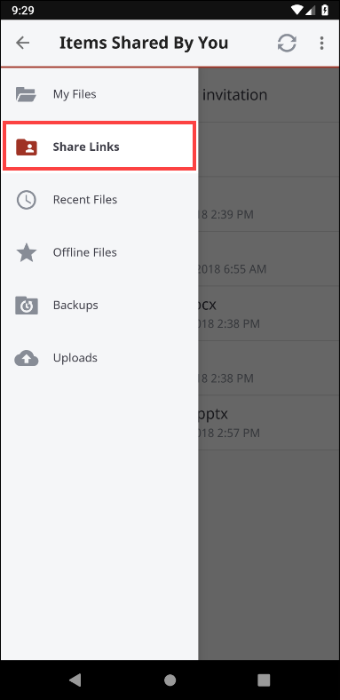
- In the Items Shared By You screen, you can view a list of shared items. Secure share links are indicated by a lock icon.

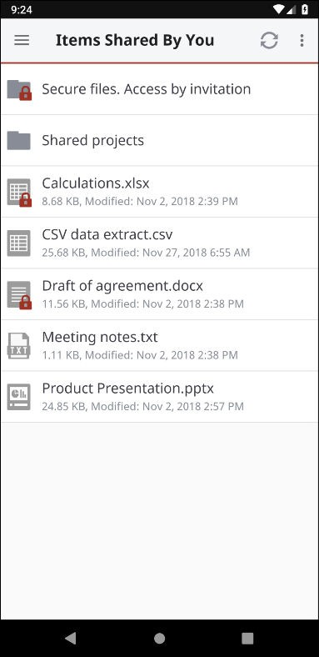
- Select an item in the list to manage share link details. For example, you can set an expiry date, change an existing expiry date, and make a share link permanent.

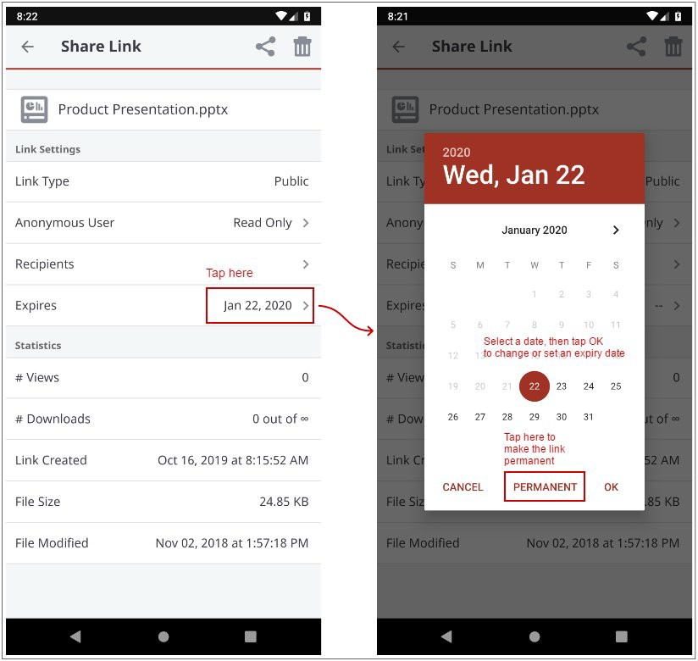

Backing Up the Gallery

You can also automatically back up your mobile phone's camera gallery to a synced folder using the Auto Backup feature. When this feature is turned on, your mobile app will automatically back up photos, videos, or both, to a synced folder called Camera Uploads. With this feature, you always have a backup of your mobile photos and vid- eos.

- In the top right-hand corner of the screen, press the more options button and se- lect the Settings link. The Settings screen displays.
- In the Settings screen, press the Enable Auto Backup option.
- Press the Back Up Photos option to configure settings for backing up photos in your photo gallery:
  - Select Never if you don't want to back up your photos.
  - Select Over Wi-Fi Only to back up photos only when you are connected to Wi- Fi.
  - Select Over Wi-Fi or Mobile Network to back up your photos whether you are connected to Wi-Fi or on your mobile network. Please note that uploading over your mobile network will use your data connection, and charges from your serv- ice provider may apply.
- Press the Back Up Videos option to configure settings for backing up videos in your photo gallery:
  - Select Never if you don't want to back up your videos.

  - Select Over Wi-Fi Only to back up videos only when you are connected to Wi- Fi.
  - Select Over Wi-Fi or Mobile Network to back up your videos whether you are connected to Wi-Fi or on your mobile network. Please note that uploading over your mobile network will use your data connection, and charges from your serv- ice provider may apply.
- Press Back Up Now if you want to back up your photos and videos immediately, if allowed by your connection settings configured above.

Turning on Grid View

Depending on your viewing preferences, you can turn on the Grid View feature, which displays thumbnails for easy browsing.

- While inside a folder or Team Share, press the More Options button and select

Grid View.

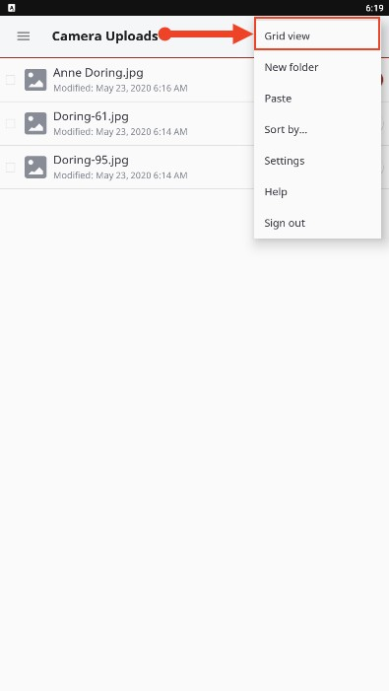
- Use the Grid View to easily browse file thumbnails.

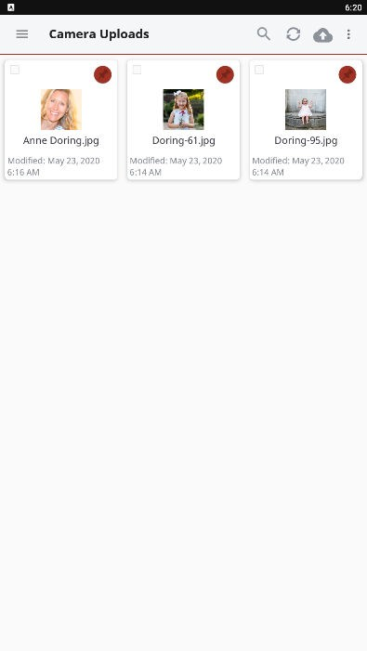

Pinning Files for Offline Viewing

Finally, you can pin files so that they are downloaded to your device. Your mobile app will be aware of unpinned files, but only pinned files will be fully downloaded. You can decide to pin and unpin files based on space limitations and access needs.

- In the My Files screen, select the Pin button next to the file or folder that you want to download to your device. If you pin a folder, all if its files will be pinned as well.

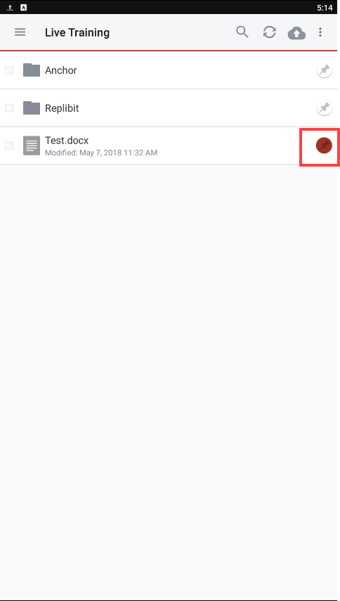
- When you unpin a file, it will remain on your mobile device until your cache is cleared. You can manually clear your cache through the Settings screen.

How to Use the iOS App
If you use an iOS device, such as an iPhone or an iPad, you can download the iOS app in iTunes. This app allows you to:

  - Open and view files and folders,
  - Edit files,
  - Lock files and folders,
  - Share files and folders,
  - Manage share links,
  - Upload content from your device, such as photos,
  - Automatically back up your camera roll to a synced folder, called Camera Uploads,

  - Rename, delete, and move items, and
  - Favorite items for offline viewing.

Logging In

To log into the iOS app:

  - In your iOS device, press the app icon to launch the app. The Login screen dis- plays, prompting you to enter your credentials, including:
    - In the Host field, enter the host of the system (for example, syncedtool.com).
    - In the User field, enter your username (for example, user@mail.com).
    - In the Password field, enter your password.
    - Press the Login button when you are finished.

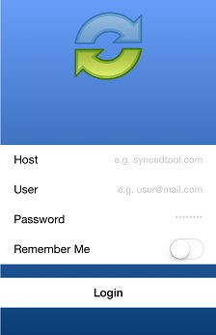

      - If Two-Step Authentication has been enabled for your organization or for your user account, you will be prompted to enter an authentication code at the time of initial registration. Enter the authentication code and press the OK button.

      - If Two-Step Authentication has been enabled for your entire organiza- tion, you will also be asked to configure a passcode after the initial regis- tration process. At subsequent sessions, you will be prompted to enter this passcode when you access your mobile app. If Two-Step Authenti- cation has been turned on only for your user account (either by you or by your administrator) you will not be required to configure a passcode.
        - You will be directed to the Settings screen. Select Use Passcode.

You will be prompted to enter a Passcode.

When accessing the mobile app in the future, you will be prompted to first enter this passcode.

Navigating

When you have access to your account, you can use the app to open and view files, manage files, and upload content. For example:

- Press the Files button to view and manage your files and folders; you can re- name or move an item or mark it as a favorite.
- Press the Share Links button to view a list of items shared by you.
- Press the Backups button to view a list of your backups.
- Press the Favorites button to view a list of items that you have marked as favor- ites.

- Press the Upload button to upload content—such as images—from your phone to the server.
- Press the Settings button to view your account information, such as the app revi- sion, your user name, space usage, passcode lock settings, and local storage settings. You can also turn on the option to only upload content over a wifi con- nection.

Operations

Synced Tool for iOS provides a variety of actions a user can perform on a file or folder:

Operation | Action
Open with Options | Long tap on a file.
Share, Favorite, Rename | Swipe to the right on a file of folder.
Delete | Swipe to the left on a file of folder.
Lock | Click Edit and select item(s).

Viewing and Editing Files

You can access and view files using the iOS app, allowing you to preview and edit content without fully downloading it to your mobile device. You can also use the Col- laborative Web Editor to edit and collaborate with coauthors in real time. In this way, you can review and update content without utilizing mobile resources.

- Press the Files button. The Files screen displays.
- In the Files screen, find the file that you want to view.
- Press the title of the file. The file opens, allowing you to review content without utilizing mobile resources.
- Click the Edit button to open the file in edit mode.

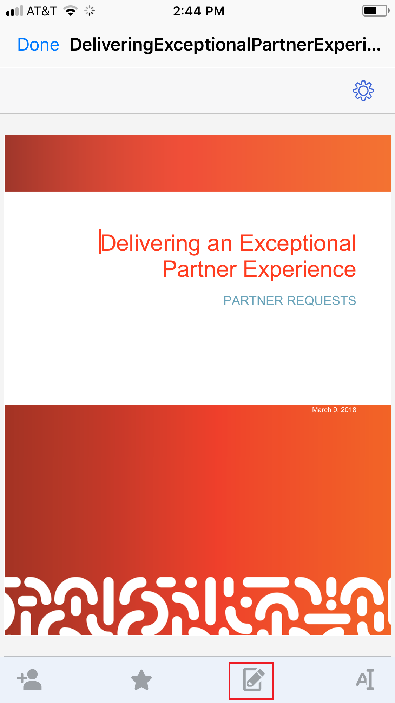

The Collaborative Web Editor opens in edit mode, allowing you to edit the file and collaborate with coauthors in real time.

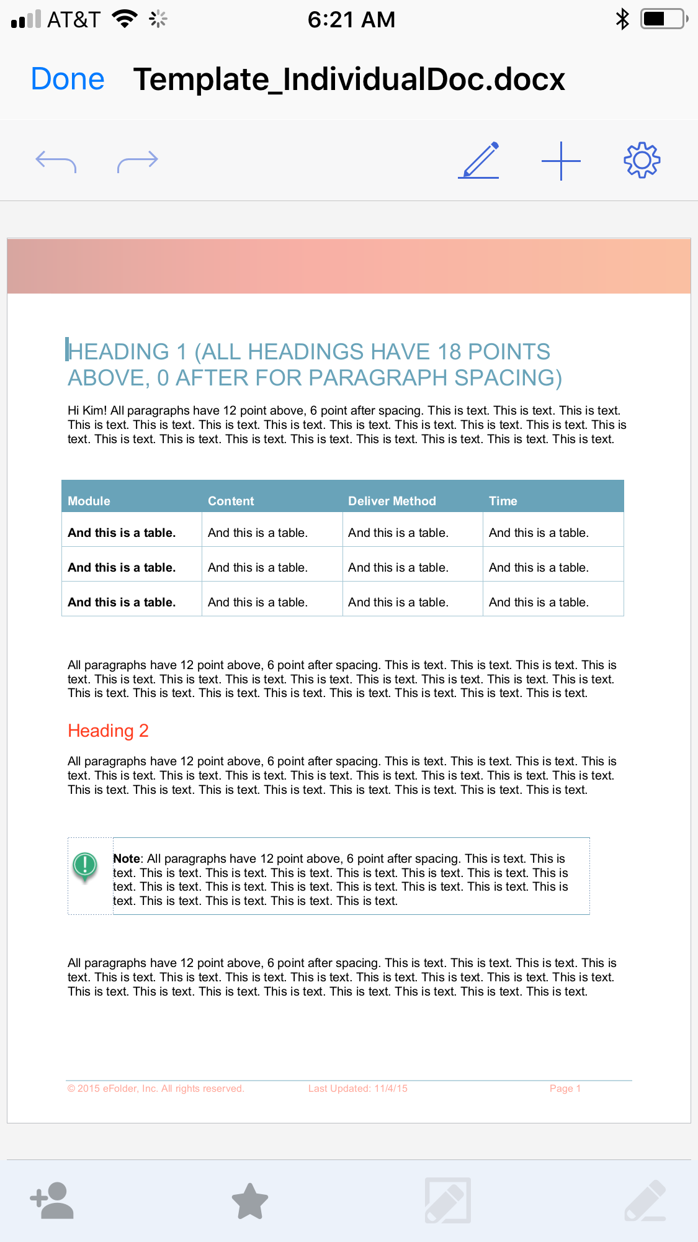

Locking Files and Folders

Optionally, you can lock a file or folder within a Team Share. To lock a file or folder:

- Press the Files button. The Files screen displays.
- In the Files screen, press the Edit link at the top right-hand corner of the screen.
- Select the appropriate file or folder, and then press the Lock button at the bottom of the screen. The item is now locked, preventing other users from accessing your content.

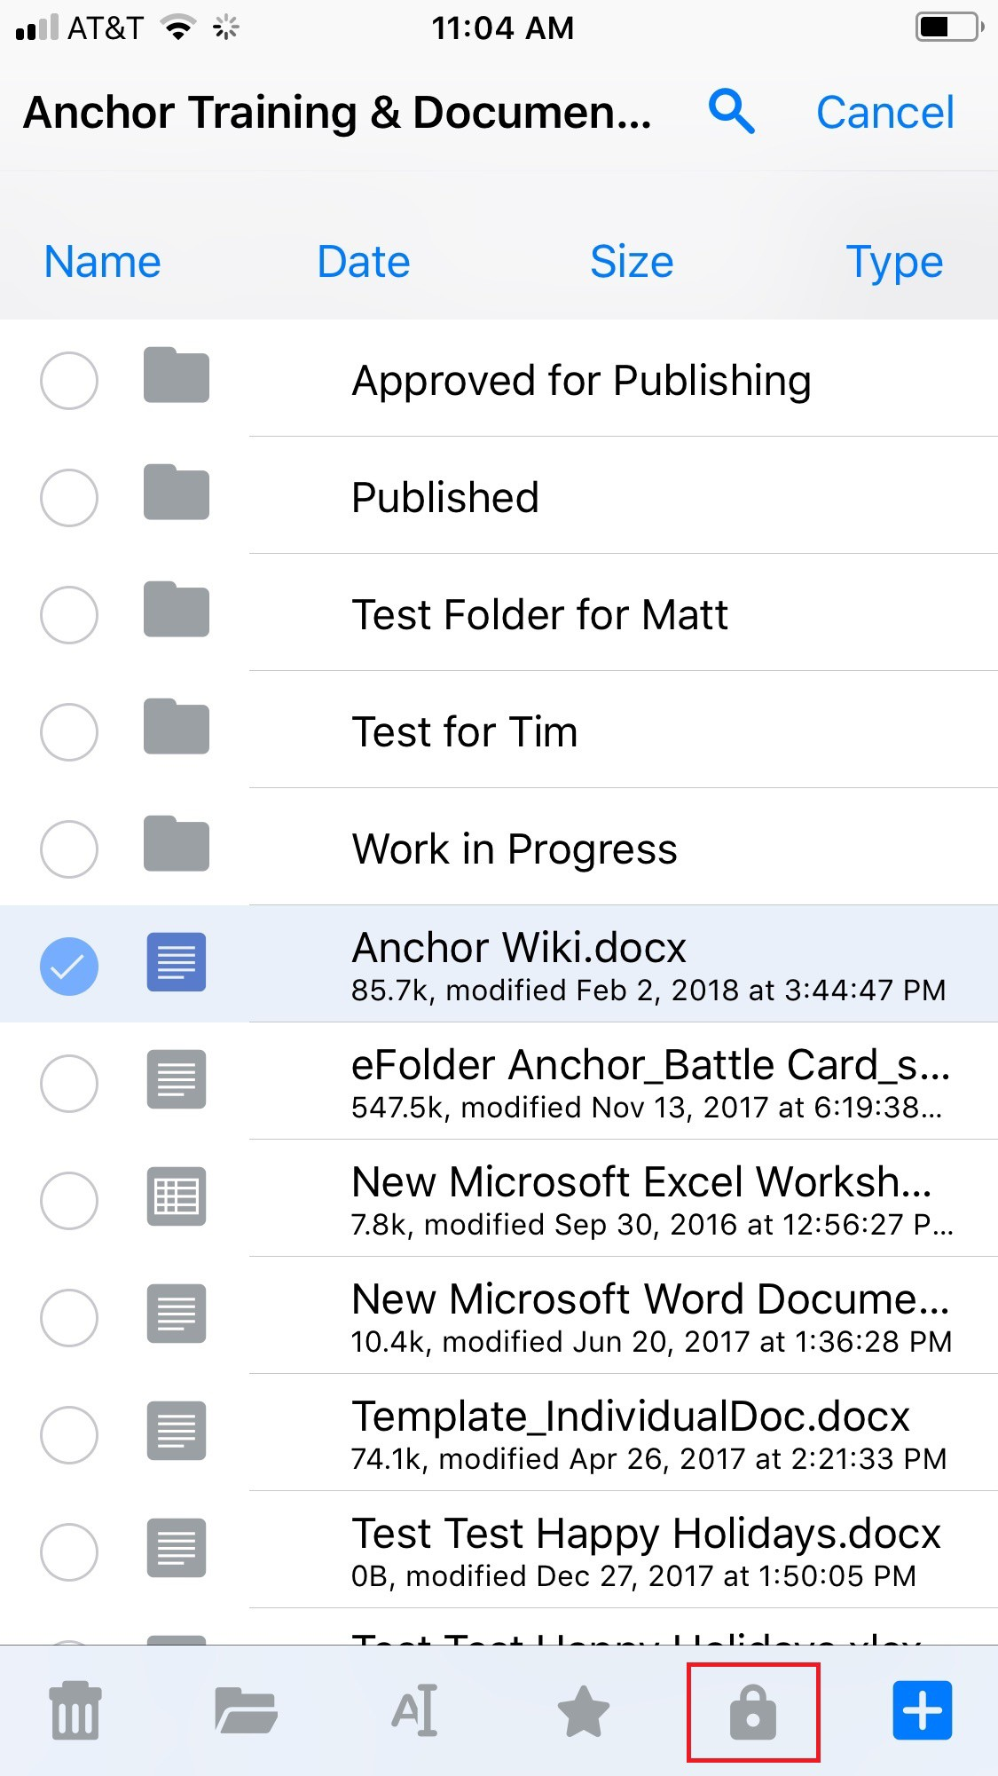

Sharing Files and Folders

You can also share files and folders directly within your app. To share a file or folder, or to send a secure share:

- Press the Files button. The Files screen displays.
- In the Files screen, find the file or folder that you want to share and slide it to the right.
- Press the Share button.

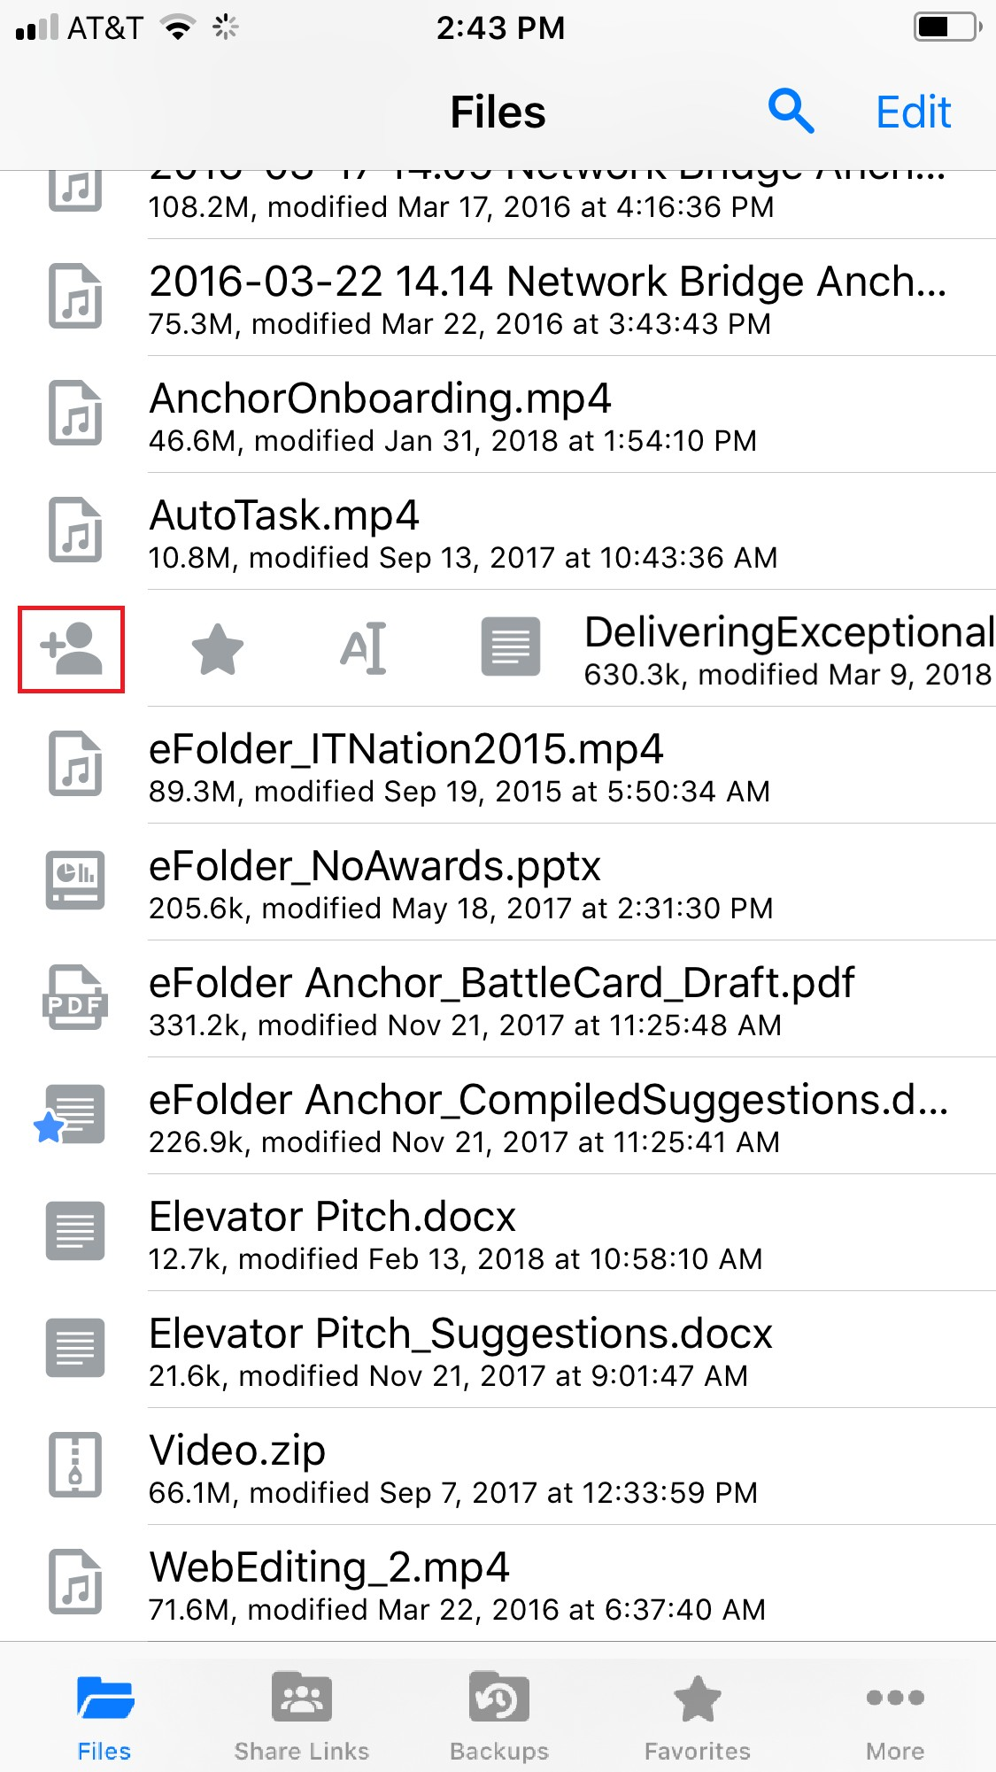
- To send a share link, press the E-mail link option. Alternatively, to send a secure share, press the E-mail secure link option. If your administrator has configured settings to only allow secure shares, you will only have the option to send a se- cure link.

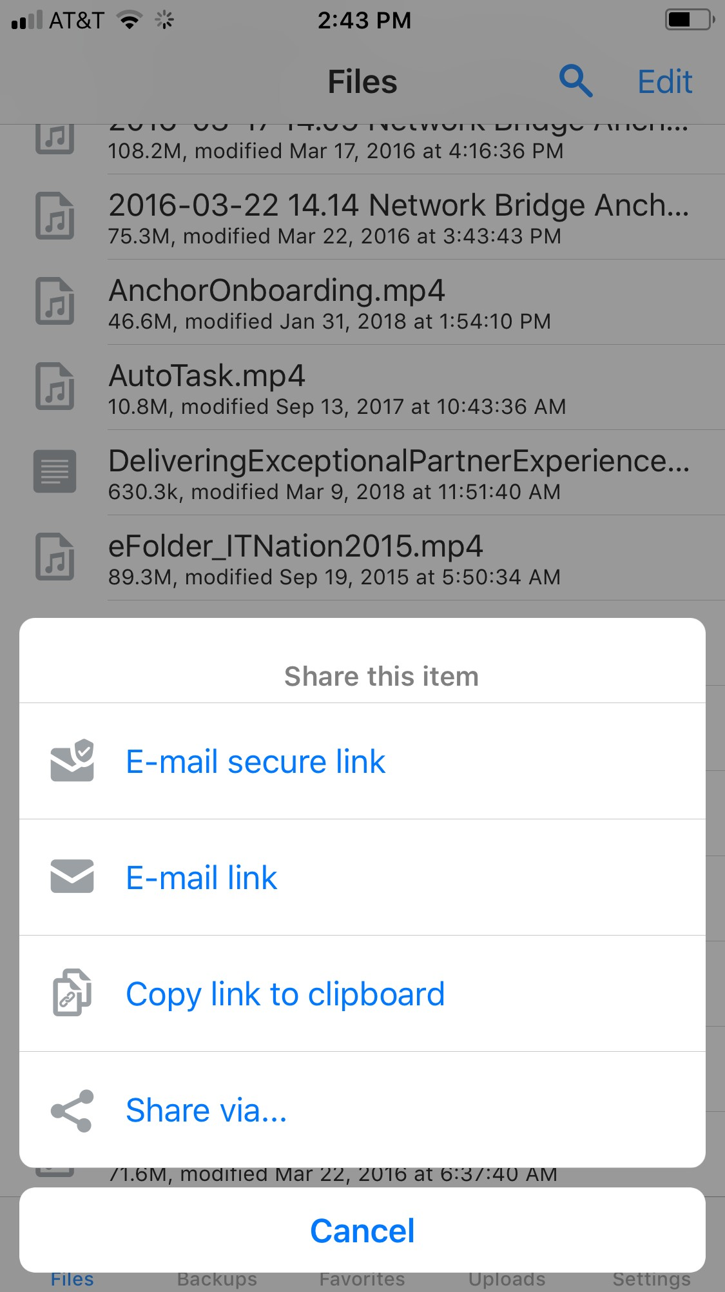

You will be prompted to select a recipient and compose an email message.
- To manage share links you created, press the Share Links button.

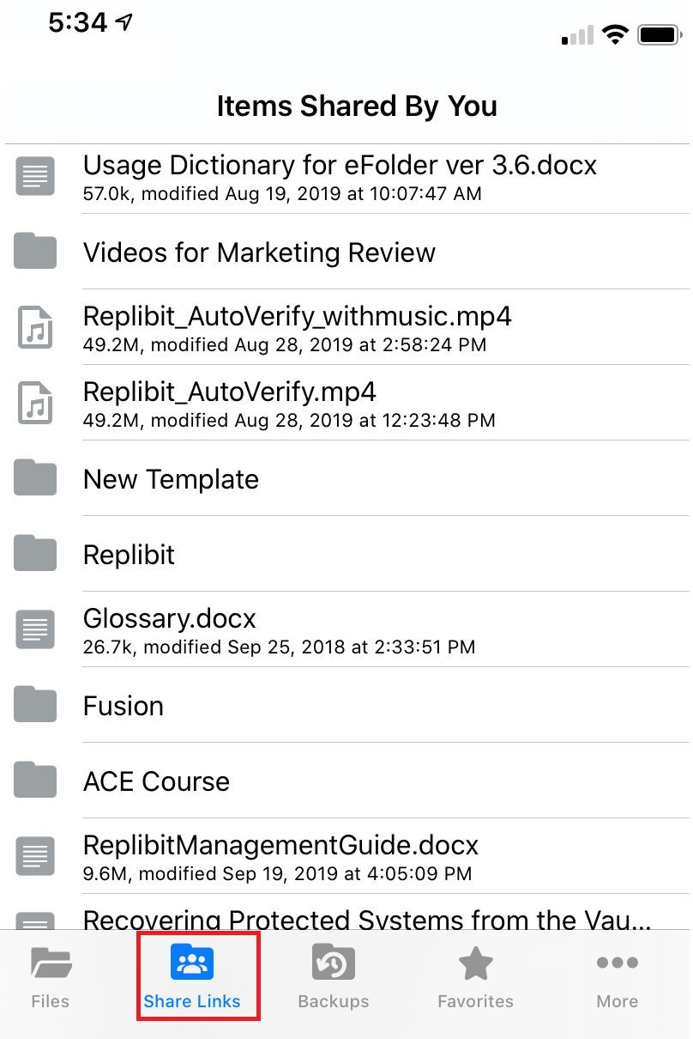
- Select an item in the list to view share link information and statistics. Secure share links are indicated by a lock icon.

Backing Up the Camera Roll

You can also automatically back up your mobile phone's camera roll to a synced folder using the Auto Backup feature. When this feature is turned on, your mobile app will automatically back up photos, videos, or both, to a synced folder called Camera Up- loads. With this feature, you always have a backup of your mobile photos and videos.

- Press the More button and select the Settings link.

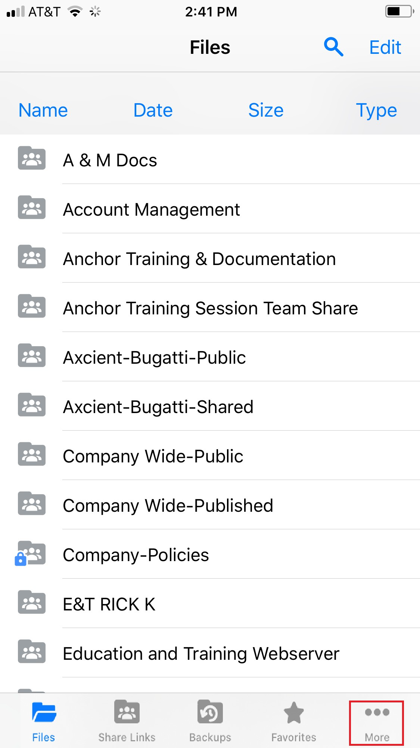

The Settings screen displays.
- In the Settings screen, press the Camera Upload option. The Camera Upload
menu displays.
  - Select the Enable Camera Upload option to back up photos on your device.
  - Select the Upload Videos option to back up videos on your device.
  - Select the Background Upload option to initiate backups without accessing the app.

Note: When uploading content over your mobile network, charges from your service provider may apply.

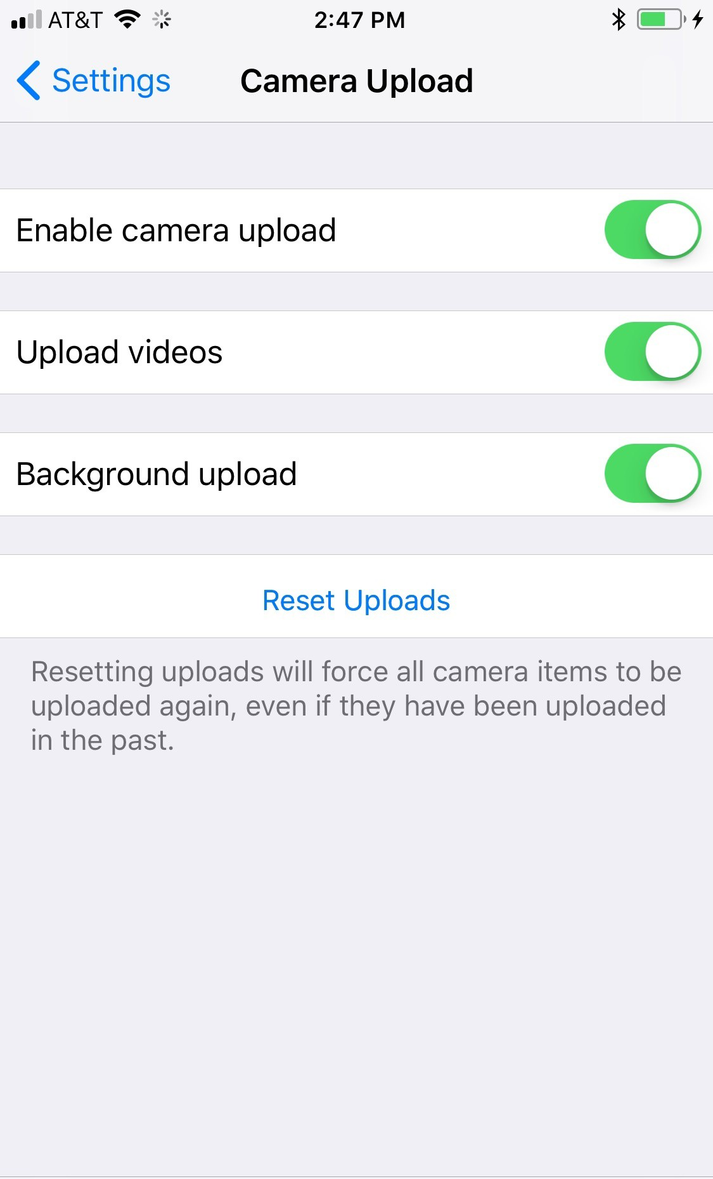
- Back in the Settings screen, you can optionally turn on the Only Upload over wifi option to upload content only when you are connected to a wifi connection. This setting will help you avoid charges from your service provider.

Setting a File or Folder as a Favorite for Offline Viewing

Finally, you can mark files and folders as a favorite so that they are downloaded to your device. Your mobile app will be aware of files that are not favorites, but only fa- vorite files and folders will be fully downloaded. You can decide to favorite and unfa- vorite files and folders based on space limitations and access needs.

- In the Files screen, slide the appropriate file or folder to the right to reveal a set of options for that file or folder.
- Press the Favorite button (star icon) to mark the file as a favorite. If you favorite an entire folder, all if its files will become favorites as well.

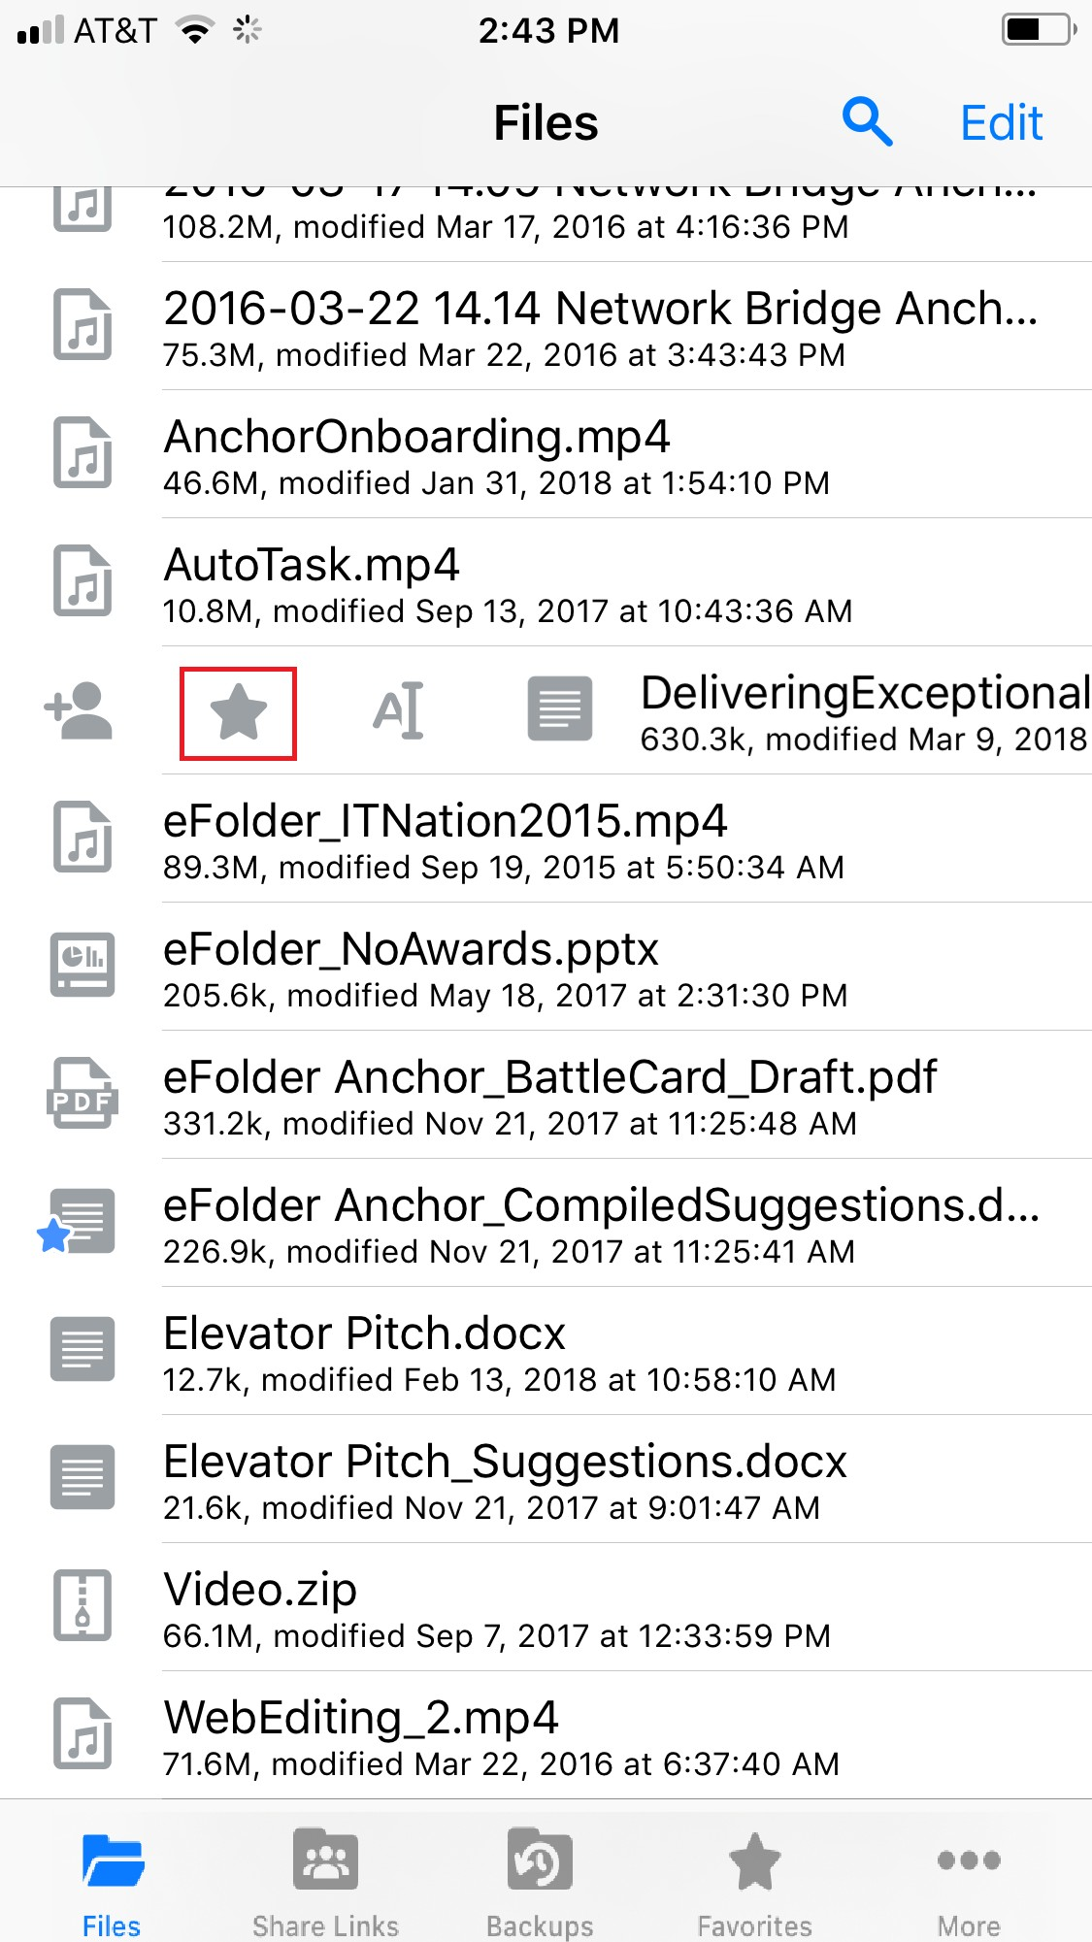
- To a view a full list of favorite files and folders, press the Favorites button.

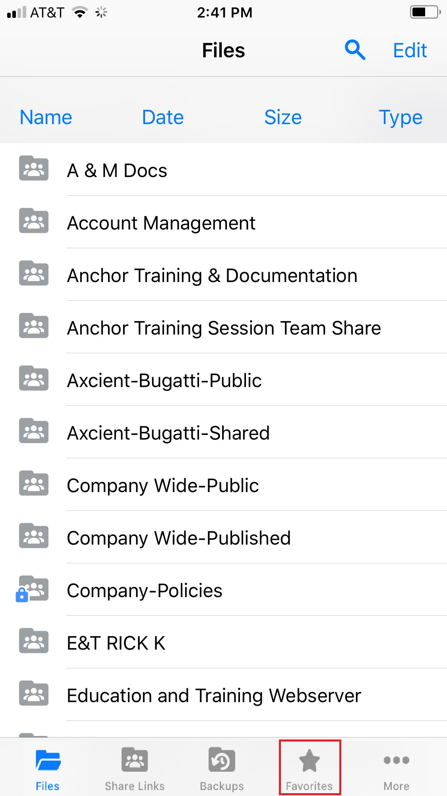

Synced Tool for Windows and Mac Machines
In addition to using the web portal and mobile apps, you can also manage files and folders from your computer (local machine) using the desktop client.

The desktop client includes a folder, called Synced Folder, which stores your files and folders on your local machine. Files and folders that are added to Synced Folder will automatically sync to the web portal and any other devices you have connected to your account. You can use the desktop client on both Windows and Mac machines.

How to Download the Desktop Client
When you download and install the desktop client, you can access your files and fold- ers directly on your computer (local machine).

To download the desktop client on a Windows or Mac machine:

- Click the Download button in the web portal.

The Download page displays.
- In the Download page, select either the Windows Desktop Client or Mac Desk- top Client button. The selected file will start to download, or you will be prompted to save the file, depending on your browser type.

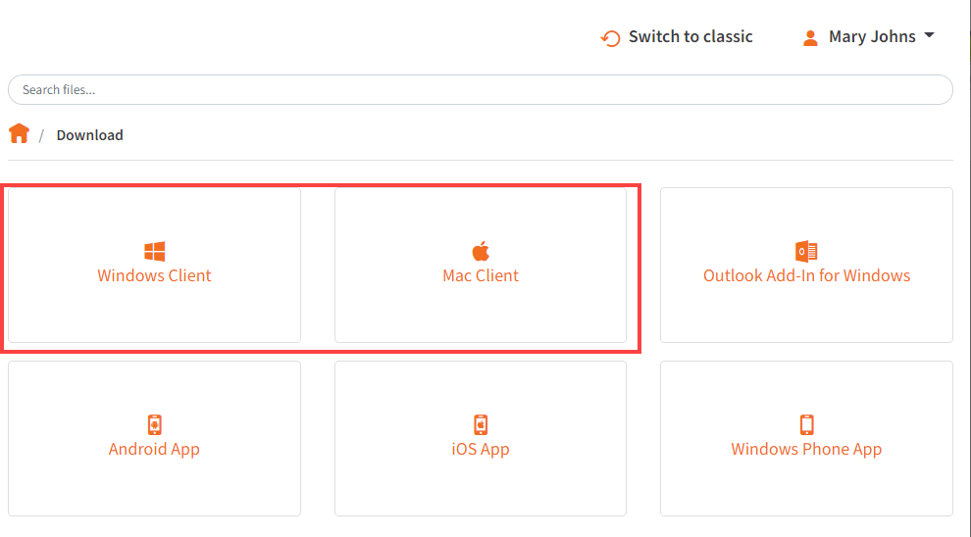
- When the file finishes downloading, click the installation file to launch the Setup Wizard.
- Select your language and click the OK button to continue.
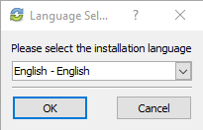
- Click the Next button to start the Setup Wizard.
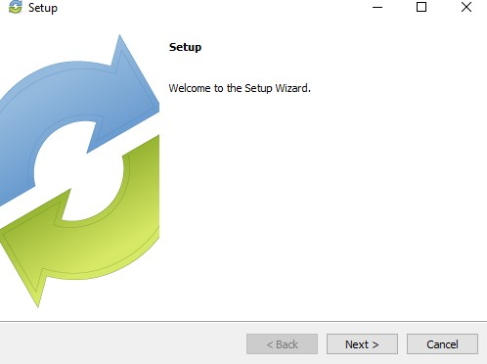
- In the License Agreement screen, click the I accept the agreement radio button if you accept the license. Then, click the Next button to continue.

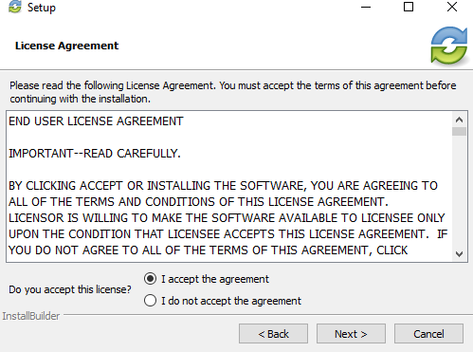
- In the Installation Directory screen, select the location where you want the instal- lation files to reside on your local machine. In most instances, you can accept the default location. Alternatively, manually input a new directory or click the Folder icon to select a new directory on your local machine. Click the Next button to con- tinue.
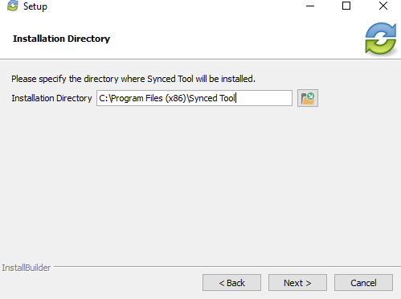
- In the Ready to Install screen, click the Next button to begin the installation proc- ess.

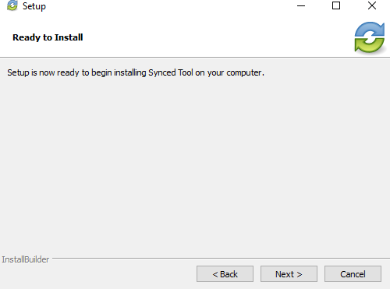
- When the Setup Wizard completes, you can optionally click the Create a Desk- top Shortcut checkbox. Then, click the Finish button. You must restart your com- puter to complete the installation process.
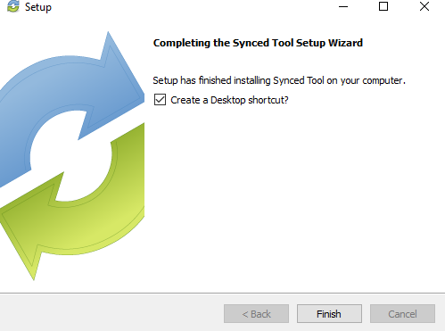

How to Register the Desktop Client
After the desktop client is installed, it must be registered to your user account so that it can recognize the files and folders that belong to you.
To register the desktop client on a Windows or Mac machine:

- After the Setup Wizard completes, the Registration Wizard will automatically launch. Alternatively, click the icon on your computer’s system tray or menu bar, and select Register. The Registration Wizard displays. On a Windows machine, the icon is located in the lower right-hand corner of the screen; on a Mac ma- chine, the icon is located in the upper right-hand corner of the screen.
- In the Registration screen, enter your login credentials as provided by your ad- ministrator. Click the Next button to continue.

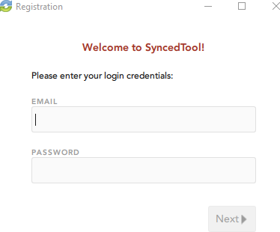
  - If Two-Step Authentication has been enabled for your organization or for your user account, you will also be prompted to enter an authentication code at the time of initial registration.

  - After you receive your authentication code, enter the authentication code
and press the Next button.
- In the Select Destination of Folder screen, select either a default or customized destination for Synced Folder, where all files, folders, and team shares can be ac- cessed on your local machine. In most instances, you can select Default, and you will be able to access Synced Folder in the following location: C:\Users\[User Name]\Synced Folder.

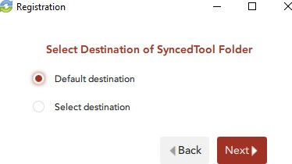
- If you selected the Select destination radio button, you will be prompted to choose your preferred folder location. In the Select Destination screen, click the Browse button to specify another location on your local machine. Click the Next button when you are finished.

In some cases, if you have previously installed using the same settings, you will receive a warning message indicating that a folder already exists. Click the Merge button to merge with the existing folder, and then continue with the Registration Wizard.
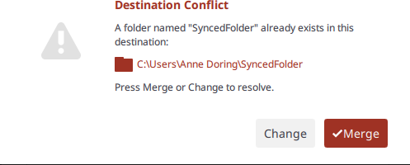
- In the Selective Sync screen, click the Skip and do this later radio button to sync down all Team Share content and personal folders currently available in the cloud. Or, click the Select what to sync radio button to deselect content that you do not currently want on your local machine.
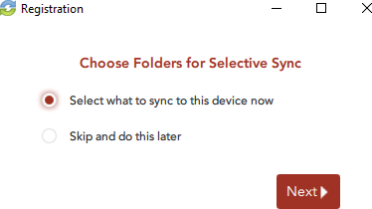

- If you select the Select what to sync radio button, you will be prompted to deselect the folders and Team Shares that you do not want immediately available on your local machine. Remember that you can change these set- tings at a later date.
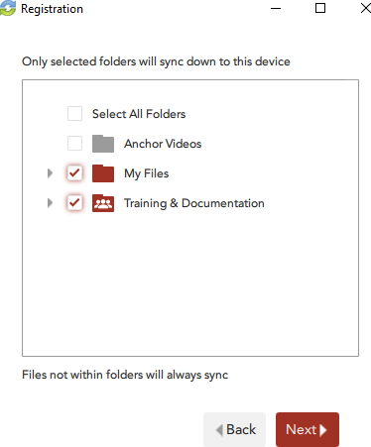
- Click the Finish button when the Registration Wizard completes.
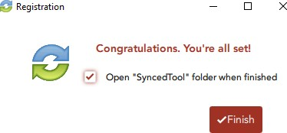

How to Upload Files in the Desktop Client
When files and folders are added to the web portal, they automatically propagate down to your local machine; you can then find these files and folders inside your Synced Folder. In the same way, files and folders that are added to Synced Folder will automatically sync to the web portal and any other devices you have connected to your account. You can use the desktop client on both Windows and Mac machines.
To upload files in the desktop client on a Windows or Mac machine:

- On your computer (local machine), open Synced Folder in an explorer window. Synced Folder displays.
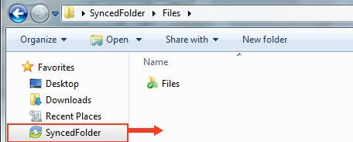

- Drag files or folders into Synced Folder. Alternatively, you can save files to Synced Folder directly from the application in which you are working (for example, Microsoft Word).
- Use the icons to understand when your files are syncing. For example:
  - A blue icon on a file indicates that the file or folder is currently syncing.

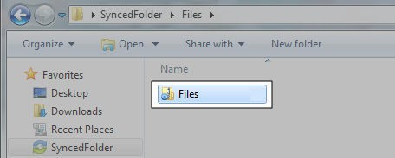

  - A green icon means that the file or folder has successfully synchronized, and is available in the web portal and on your mobile devices.
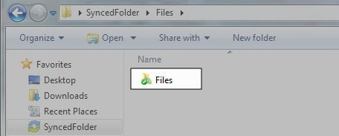

How to Manage Preferences for the Desktop Client

Using the icon on your computer's system tray, you can manage preferences, pause a sync process, and view warning messages.

Managing Preferences

To manage your preferences, or to change your settings:

- Click the system tray icon, click the Manage button, and then select Preferen- ces.
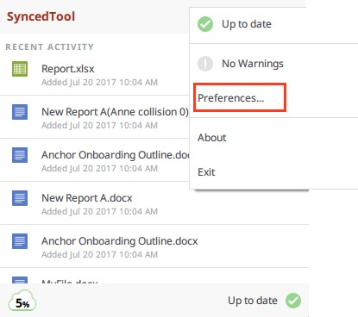

The Preferences dialog box displays, showing the Overview tab.
- Use the Overview tab to view important information and status updates, including:
  - The current state of the sync process, including whether the files are up to date, pending sync, or currently syncing
  - The total amount of space quota available and the total amount of space used
  - The device name and the device account information
  - The Unregister button, which unregisters the desktop client
  - The Activity area, which lists the status of uploaded and downloaded files, as well as a notification of excluded files

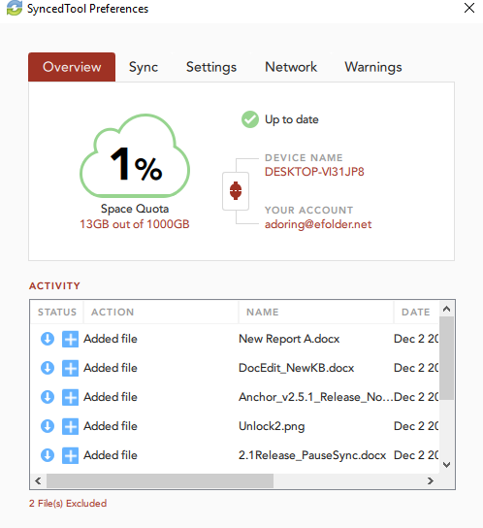
- Click the Sync tab to select and deselect the Team Shares, personal folders, and subfolders that you do not want available on your local machine.
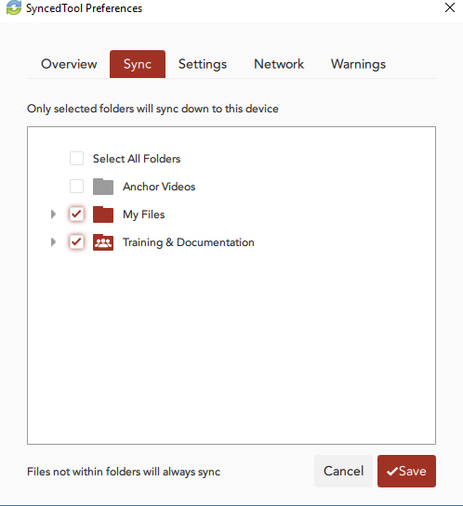

- Click the Settings tab to specify language, locking, and remote browsing settings. For example:
  - Click the Language drop-down menu to select your preferred language. You can also choose to show or hide desktop notifications.
  - In the File Locking section, click the Auto Locking drop-down menu to set your preferred auto-locking preference. If your administrator has turned on

the Auto-Locking feature for a Team Share, you can decide to automatically lock, never lock, or receive a prompt each time you open a supported Word, PowerPoint, or Excel file in a Team Share.
  - In the Privacy section, click the Disable Remote Browsing checkbox to pre- vent administrators from remotely browsing the contents of your Synced Folder (for example, to create a backup of your local folders).
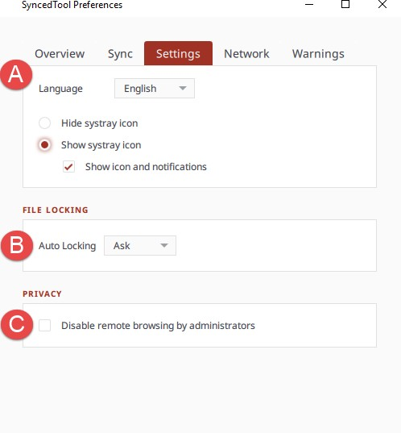

- Click the Network tab to manage LAN Sync, bandwidth, and proxy settings. For example:
  - If you are working within a Local Area Network (LAN), click the Enable LAN Sync check box to turn on the LAN Sync feature. LAN Sync refers to a file synchronization approach that accelerates the sync process when a shared file already exists on a LAN.
  - Use the Bandwidth Throttling section to configure bandwidth settings; you have the option to set a specific limit, or decide not to limit bandwidth. Please note that administrator settings might override your personal settings.
  - Click the Proxies drop-down to configure proxy settings for your network. You can select from:
    - No proxy
    - Detect Automatically, which auto-detects proxy settings from your system or network
    - Custom, which allows you to apply custom proxy configurations if you are unable to automatically have the system detect your proxy server settings

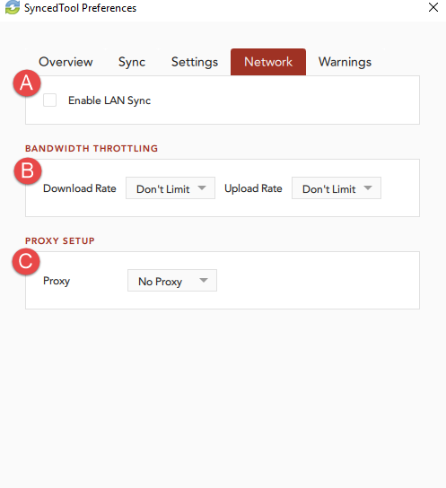
- Click the Warnings tab to view a list of file sync warnings. While still in this tab, you can also click the Export Sync Status Report link to save information about the current sync status to a text file.
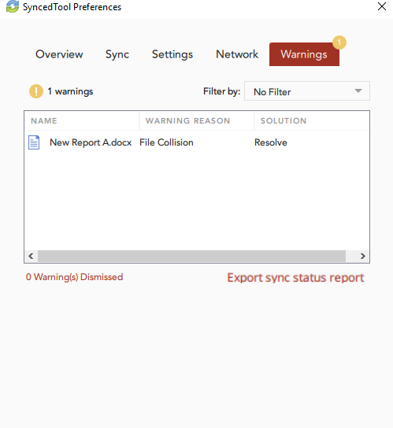

Pausing a Sync Process

You may find times when you would like to pause the sync process, such as when you are getting on a plane, when you want to conserve bandwidth, or if you would like to work in isolation.

To pause a sync process on a Windows or Mac machine:

- Click the system tray icon and hover over the Status message (for example, Up to date). On a Windows machine, the icon is located in the lower right-hand cor- ner of the screen; on a Mac machine, the icon is located in the upper right-hand corner of the screen.
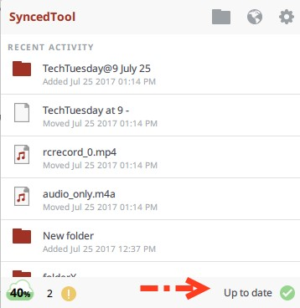
- When the text changes, click the Pause button.
- To resume the sync process, hover over Paused and select Resume.
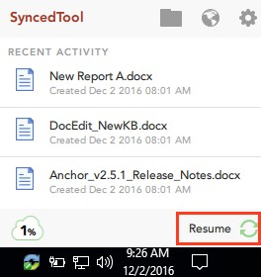

Viewing Warning Messages

In addition to managing preferences and pausing a sync process, you can view the desktop client warning messages and resolve issues directly from the system tray icon.

- The Space Quota indicator message displays the amount of space you are cur- rently utilizing.
- The Resolve Sync Warnings indicator activates when a file sync warning—such as a collision or a locked change warning—occurs on your local machine. When this indicator is active, click to resolve the file sync warning.
- The Status indicator displays the progress of the sync process. This indicator will alert you when the sync process is up to date, syncing, paused, or disconnected. You can also hover over this indicator to enable pause and resume functionality.
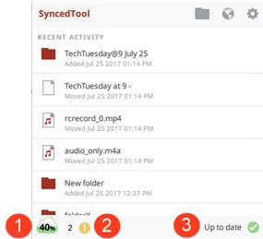

How to Use the Selective Sync Feature

The Selective Sync feature gives end users the ability to select the content that syncs down to their local machines. While all content is still accessible in the web portal, end users can control the amount of data that is downloaded and stored locally, reducing local storage and bandwidth requirements, and increasing options on where and how they access content.

To use the Selective Sync feature:

- Click the system tray icon, click the Manage button, and then select Preferen- ces.
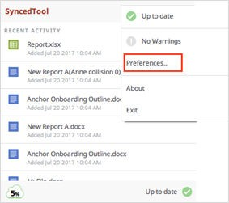

- Click the Sync tab.
- In the Sync tab, click to expand individual Team Shares to select or deselect Team Share roots or Team Share subfolders. Alternatively, click to expand My Files to select or deselect personal folders.

- Click the Save button when you are finished selecting and deselecting content.

A confirmation dialog box will display, notifying you that only the selected items will sync down to your machine.Click the Update button to confirm these changes.

All other folders will still be available in the web portal, and on any other device that can selectively sync content.

Sharing and Collaborating

You can collaborate and share files in many ways.

  - A Team Share is a shared folder that can be accessed by groups of users. Team Shares can be configured for users in your organization. When you work within Team Shares, it is important to be careful and courteous when you edit, delete, and move files and folders. Files and folders stored in Team Shares are shared among all other subscribers, so what you do affects your team members.
  - A share link allows you to share a direct link to a file or folder, rather than sharing an entire area. Share links can be configured for users in your organization and outside of your organization. You can send a public share to recipients inside or outside of your organization; alternatively, you can send a secure share, which requires login credentials. If you send a secure share to a recipient outside of your organization, the system will create a guest account for that user.

With both Team Shares and share links, you can share files and folders in the web portal, in the desktop client, or mobile apps.

Additionally, with the real-time Collaborative Web Editor, you can edit documents, spreadsheets, and presentations when working in the web portal, without needing to download a separate application or navigate away from the system.

How to Create a New Team Share
Your administrator might have created Team Shares for you when the system was first configured, but you can also create your own Team Shares. You can create a Team Share if you are collaborating with another person, or group, on a specific set of con- tent. You add files to Team Shares the same way you add files to standard folders.
When you or another user in your Team Share adds or edits a file or folder, changes synchronize across all subscribed accounts.

In both the web portal and in Synced Folder, Team Share folders can be recognized by icons with two people on it.

  - Team shares in the web portal:

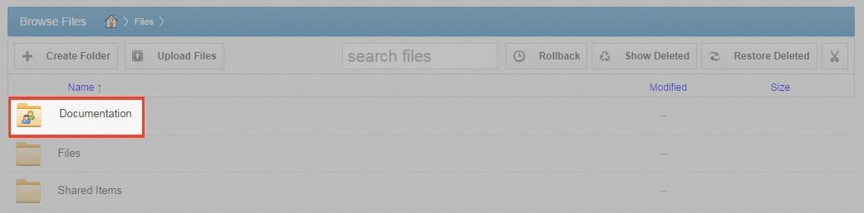
  - Team shares in Synced Folder:

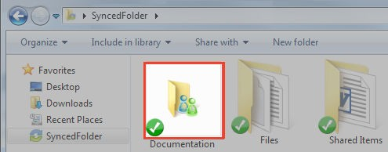

When you work within Team Shares, it is important to be careful and courteous when you edit, delete, and move files and folders. Files and folders stored in Team Shares are shared among all other subscribers, so what you do affects your team members.

You might find it useful to follow certain best practices to ensure that shared content is protected and well managed. These best practices include:

  - Locking files and folders before you begin making changes—when you lock a file and folder, you are essentially setting it as read-only for others subscribed to the Team Share, giving you exclusive editing rights while you make changes. For more information, please reference the Locking Files and Folders section of the Guide.
  - Monitoring activity using the File Report, the Activity Log, and the Daily Email Digest
—To see a summary of changes made to files and folders within a specific Team Share, you can optionally track and monitor activity in the web portal using the File Report and the Activity log. For more information, please reference the File Report and Activity Log section of the Guide. To create a Daily Email Digest that summari- zes activity for a particular Team Share, please reference the How to Manage Shared Items section of the Guide.

Team Share Permissions

When administrators create Team Shares, they assign permission roles, which define how each subscriber can interact with content in the Team Share. For example:

  - The Co-Owner has total control over content.
  - The Collaborator (default role) has the ability to seamlessly work with others by cre- ating share links and modifying all content locally and on the web.

  - The Editor is similar to the Collaborator, but without the ability to generate share links.
  - The Web Editor is similar to the Editor, but without the ability to download or sync content locally. Web Editors can edit the content within the Collaborative Web Editor only.
  - The Viewer is a restricted role, only giving users the ability to view content.
  - The Previewer is a restricted role, only giving users the ability to preview content in the web portal.
  - The Uploader is a restricted role, only giving users the ability to view folder struc- tures (not files) and upload files and folders on the web.

If you perform an unauthorized action in the web portal, you will receive an error mes- sage.

If you perform an unauthorized action from the desktop client, you will receive a file sync warning.
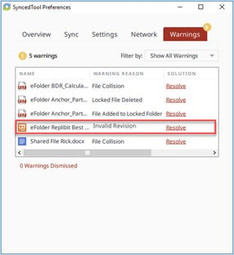

Please contact your administrator if you have questions about Team Share permission roles assigned to you.

Instructions

In many instances, an administrator will create a Team Share for you. As an end user, you can also create your own Team Shares. To create a new Team Share:

- In the web portal, click the Shares tab. The Team Shares page displays.
- In the Team Shares page, click the Create Team Share button.

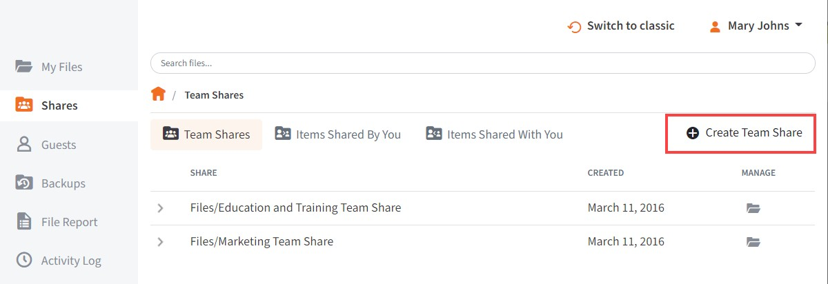

The Create Team Share page displays.
- In the Create Team Share page, type a descriptive name for the Team Share in the Team Share Name field.
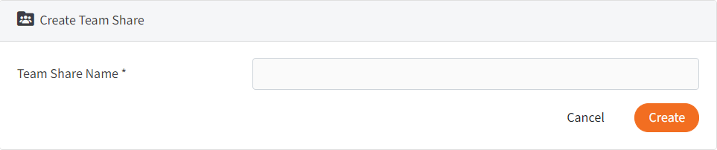

- Click the Create button when you are finished. You will be redirected to the Team Share Subscribers page.
- In the Team Share Subscribers page, select a name from the Select a User drop- down menu, and click the Add to Share button.
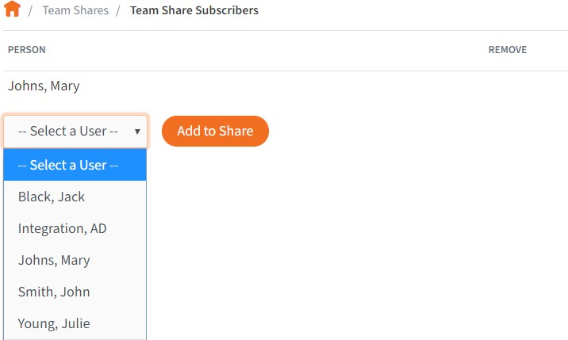

The selected user will now be added to the Team Share.

How to Send Share Links to Files

Share links to files can be created within the web portal, from the desktop client, or from a mobile device.

To send a share link to a file:

- In the web portal, right-click the file and select Share.
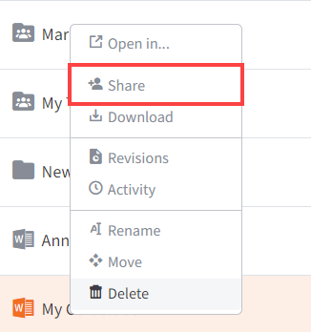

Or, if you are working within the desktop client, right-click on the file, point to the SyncedTool menu, and select Share link.
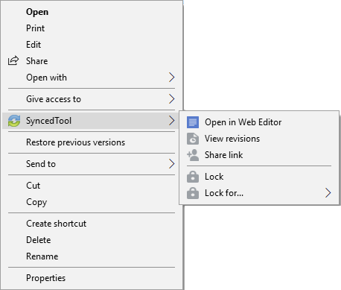

The Share Access dialog box displays.

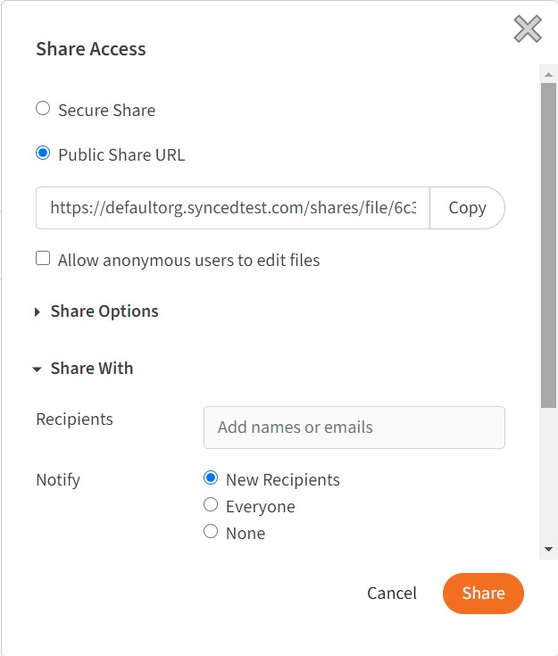
- In the Share Access dialog box, configure settings for sharing the link, including:
  - The Secure Share option, which requires each recipient to log in with his or her unique credentials.
  - The Public Share option, which sends a publicly available share link to the file. If you create a public share link, you can also select the Allow anony- mous users to edit files checkbox to allow users to edit the file online using the Collaborative Web Editor.
  - The Share Options settings, which allow you to:
    - Select whether the share link will expire after a certain date
    - Set a limit for the total number of times the file can be downloaded
    - Turn on email notifications for when the share is downloaded
  - The Share With settings, which allow you to specify share recipients and set permissions for each of these users. This section is only required if you are sending a secure share link. Alternatively, for public share links, you can op- tionally copy the share link and send it to desired collaborators through third- party communication tools.
  - The Permissions settings, which let you set Can Modify permissions, allowing the specified user to edit the file using the Collaborative Web Editor.
- Click the Share button save your changes. You will be redirected to a confirma- tion page.
- Click the Delete button to cancel your configurations and delete the share link.

Note: If you reopen and edit the share link, you will see a Cancel button, which will close the dialog box, but will not delete the share link.

How to Manage Guest Accounts
Guests are special accounts that are created for individuals outside of your organiza- tion. You can manually create a guest account and give that guest access to files and folders; you can even give a guest access to an entire folder so that the guest can up- load and manage content within the system.
Alternatively, if you send a secure share invitation to a person outside of your organi- zation, you are automatically creating a guest within the system. You can manage your guest accounts using the Guests tab inside the web portal. For example, you might want to remove guests who no longer need access to content that you have shared.
Guest users can also manage their own user settings—including their name, email ad- dress, and password—and can even delete their own account.
Specifically, Guest accounts can:

- Access a shared file or folder through the web portal
- Manage their account information and change their password Guest accounts cannot:
- Utilize the desktop client, WebDAV, or mobile apps
- Subscribe to Team Shares

TIP

If you will be collaborating with a guest account on a regular basis, you might consider sharing an entire folder with the guest account. When you create a secure share to a folder, you can invite a guest account and decide whether or not to give that guest account permission to up- load or delete content from that shared folder. You can also choose to be notified when the guest user uploads or downloads content. In this way, the shared folder becomes a collaborative space where you can exchange and review content.

To manage guest accounts:

- In the web portal, click the Guests tab. The Guests page displays, listing all of your existing guests.
- Use the tools in the Guests tab to manage guests.
  - The Create Guest button, which allows you to manually add a new guest. You can configure the guest's name, email address, password, and even de- cide if and when the password should expire.
  - The Remove button, which allows you to delete an existing guest.

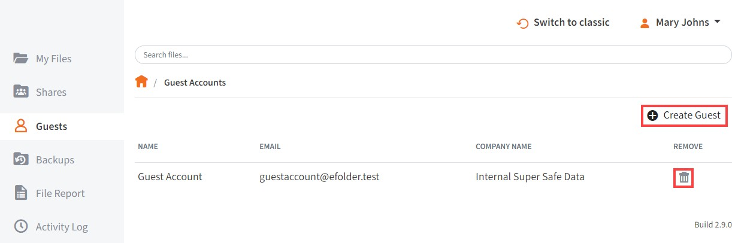

How to Send Share Links to Folders

Share links to folders can be created within the web portal, from the desktop client, or from a mobile device.

To send a share link to a folder:

- In the web portal, right-click folder and select Share.

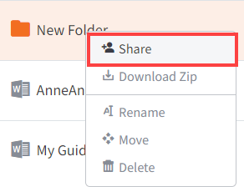

Or, if you are working within the desktop client, right-click the folder, point to the SyncedTool menu, and select Share link.

The Share Access dialog box displays.
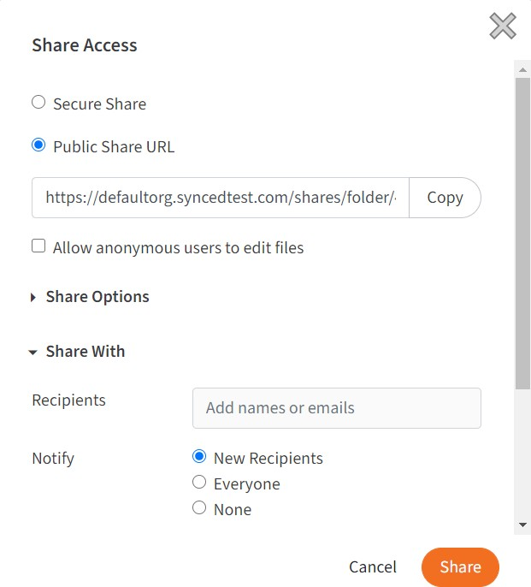
- In the Share Access dialog box, configure settings for sharing the link, including:
  - The Secure Share option, which requires each recipient to log in with his or her unique credentials.
  - The Public Share option, which sends a publicly available share link to the folder. If you create a public share link, you can also select the Allow anony- mous users to edit files checkbox to allow users to edit files within the fold- er using the Collaborative Web Editor.
  - The Share Options settings, which allow you to:

    - Select whether the share link will expire after a certain date
    - Set a limit for the total number of times items in the folder can be downloa- ded
    - Turn on email notifications for when the share is downloaded
  - The Share With settings, which allow you to specify share recipients and set permissions for each of these users. This section is only required if you are sending a secure share link. Alternatively, for public share links, you can op- tionally copy the share link and send it to desired collaborators through third- party communication tools.
  - The Permissions settings, which let you set the following permissions:
    - Can Modify permissions allow the specified user to edit files within the fold- er using the Collaborative Web Editor. Can Modify also lets users upload files into the folder.
    - Can Delete permissions allow the user to delete files within the shared folder.
- Click the Share button save your changes. You will be redirected to a confirma- tion page.
- Click the Delete button to cancel your configurations and delete the share link.

Note: If you reopen and edit the share link, you will see a Cancel button, which will close the dialog box, but will not delete the share link.

How to Manage Shared Items
You might find it useful to keep track of items in Team Shares, as well as items you have shared with third parties. Using the Shares tab in the web portal, you can gener- ate and view reports that allow you to manage these shared items. You can also re- move a share link if required.
To track shared items:

- In the web portal dashboard, click the Shares tab to manage your shares.
- Click the Team Shares button to access controls that allow you to create, view and edit Team Shares.
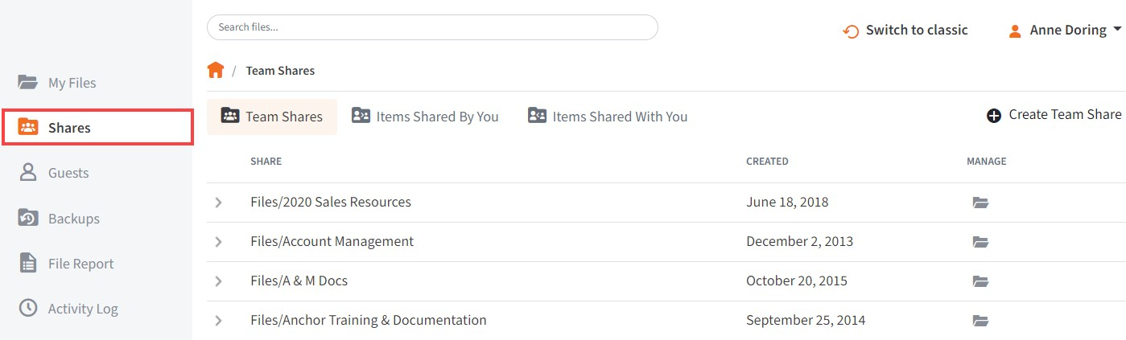

  - Optionally, click the arrow to expand a Team Share.

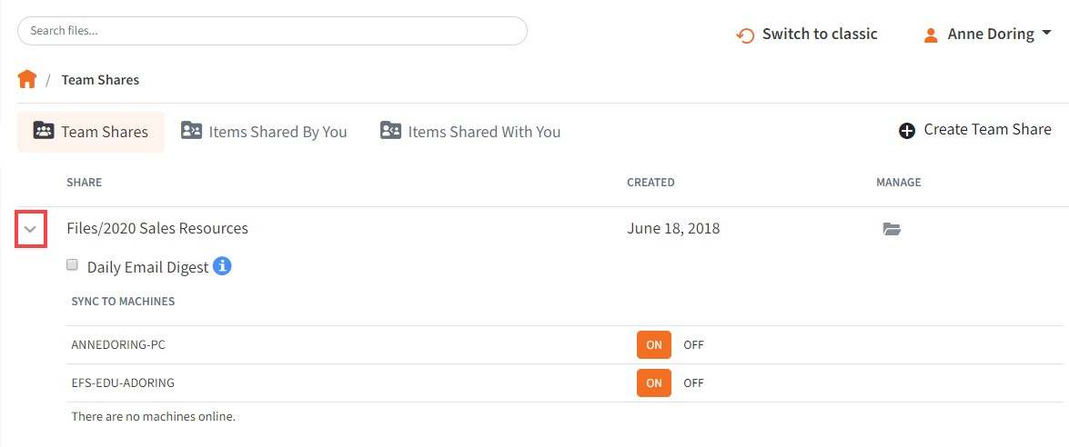

  - Click the On button to receive a Daily Digest email for the selected Team Share. A Daily Digest email will outline detailed information about events that occurred within the Team Share. You will receive a daily email until you turn off the Daily Digest option.
  - You can also turn on or off the syncing of Team Share content down to your local machine. This functionality is useful if a Team Share contains large files (such as video files) and you would rather only access the content when nec- essary from the web. Click the Off button to turn off the syncing of content to your local machine. Alternatively, click the On button to ensure that all con- tent gets synchronized to your local machine.

- Click the Items Shared By You button to track how many times an item you shared has been viewed, downloaded, and whether or not it is set to expire on a certain date.
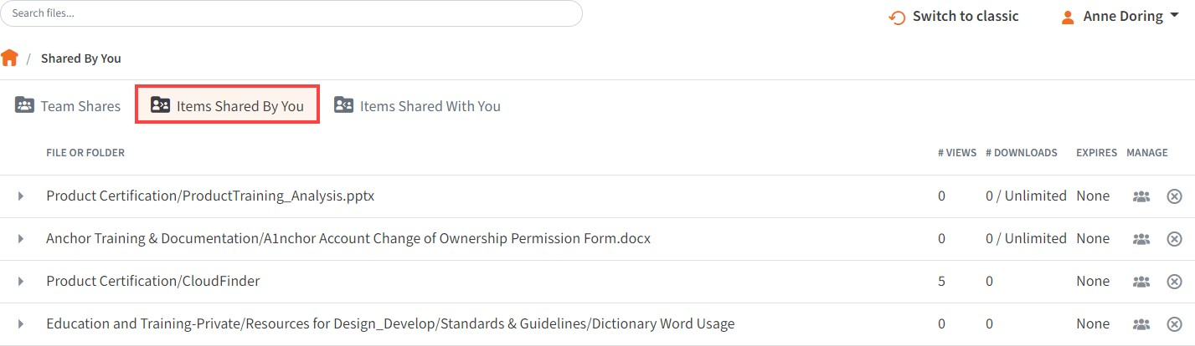

  - Find a previously configured share link and click the arrow to expand and view settings.
  - Click the Manage Share Access and Settings button to reconfigure settings configured in the Share Access dialog box.
  - Click the Deactivate Share button to delete the share link and remove all ac- cess.

  - Alternatively, click the Delete button to remove a share link for one or more share recipient.

- Click the Items Shared With You button to view files that were shared with you by others in your organization, as well as information about who shared the file and what access rights you were given (including read, write, and delete).
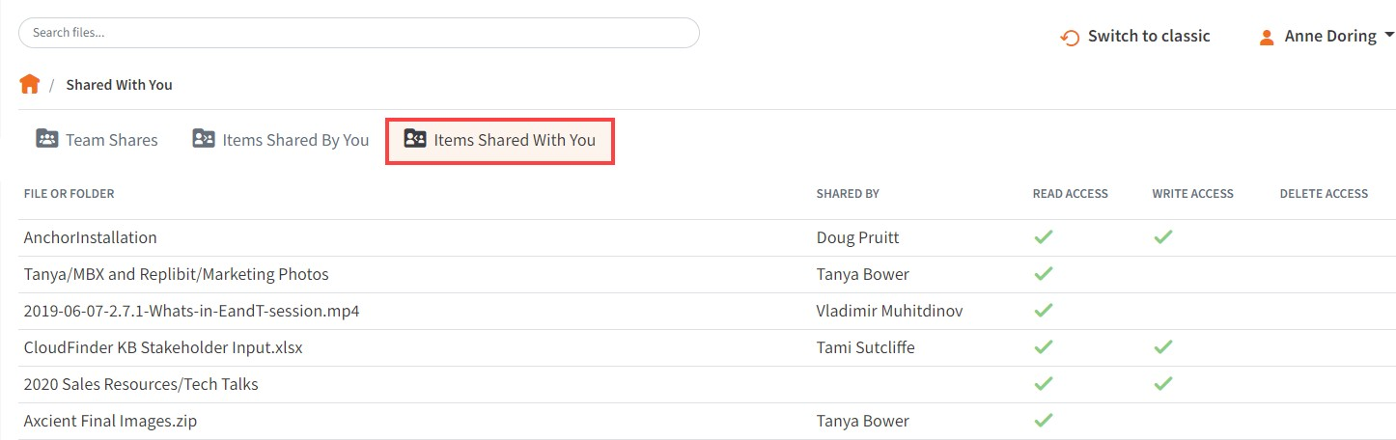

- Finally, in some instances, you might be invited to join a Team Share that is out- side of your standard work organization. When this happens, you will be alerted through email and by a notification in the Shares tab of the web portal. Use the Shares tab to accept or decline this invitation.
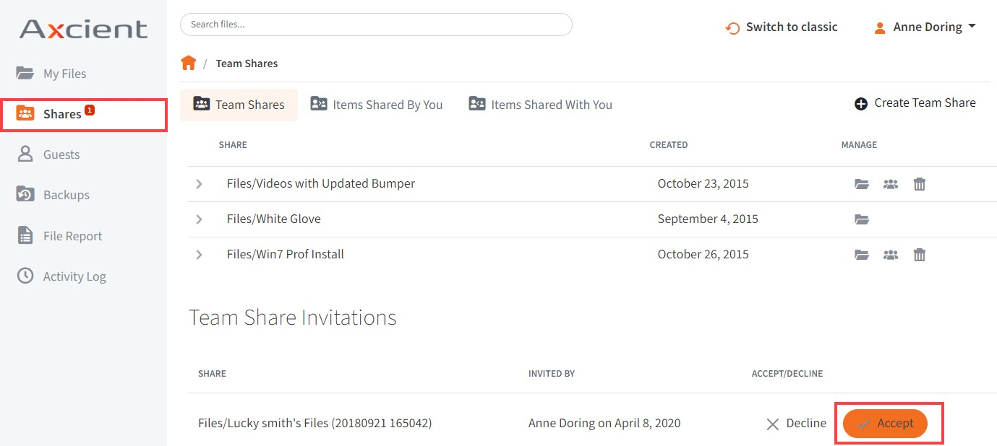

How to Edit Files in the Web Portal Using the Collabora- tive Web Editor

Overview

With the real-time Collaborative Web Editor, you can edit documents, spreadsheets, and presentations when working in the web portal, without needing to download a sep- arate application or navigate away from the system. Additionally, the Collaborative Web Editor allows you to make these changes simultaneously with multiple coauthors, and lets you see each edit in real time.

Advanced functionality includes:

- Access a wide range of formatting tools to help you update fonts, paragraph for- mats, charts, tables, images, style types, and more
- Edit simultaneously with coauthors and view their changes in real time
- Send and receive instant chat messages
- Add, view, and manage changes and comments

Revisions

- Files automatically save ten seconds after the latest edit.
- For security purposes, an editing session will end after one hour of inactivity.
- Editing a file within the Collaborative Web Editor will generate a revision in x360Sync.

Anonymous Editing Permissions

When sharing a file, users can grant anonymous editing permissions on public share links. Anonymous editing permissions allow anyone with access to the share link to edit the file using the Collaborative Web Editor.

Notifications and File Locking

- In the Web Portal, a file that is being actively edited from within the Collaborative Web Editor will be marked with a Web Edit icon. Team Share subscribers will still be able to launch this file from the web portal using the Collaborative Web Editor.

- In the desktop client, a file that is being actively edited from within the Collaborative Web Editor will be automatically protected by the File and Folder Locking feature

and marked with a lock icon. Team Share subscribers will not be able to edit this file using applications on their local machines.
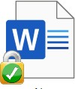

Launching the Collaborative Web Editor

To use the Collaborative Web Editor:

- If you are working from the desktop client, right-click a supported file, point to the context menu, and select Open in Web Editor.
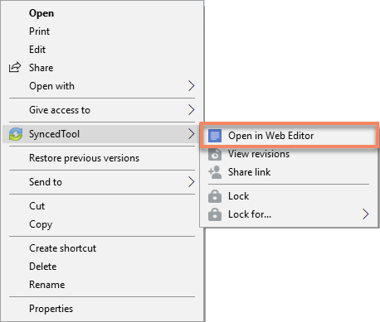
- Alternatively, if you are working in the web portal, navigate to a supported file, right-click the file, point to Open in and select Web Editor.

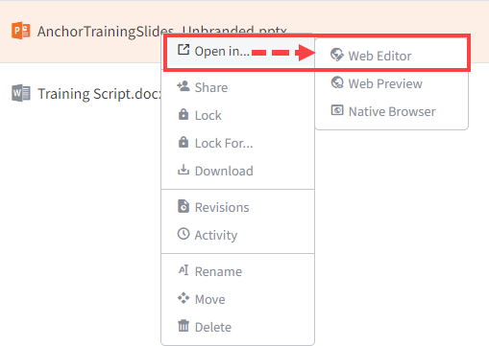

The file opens in a new tab.
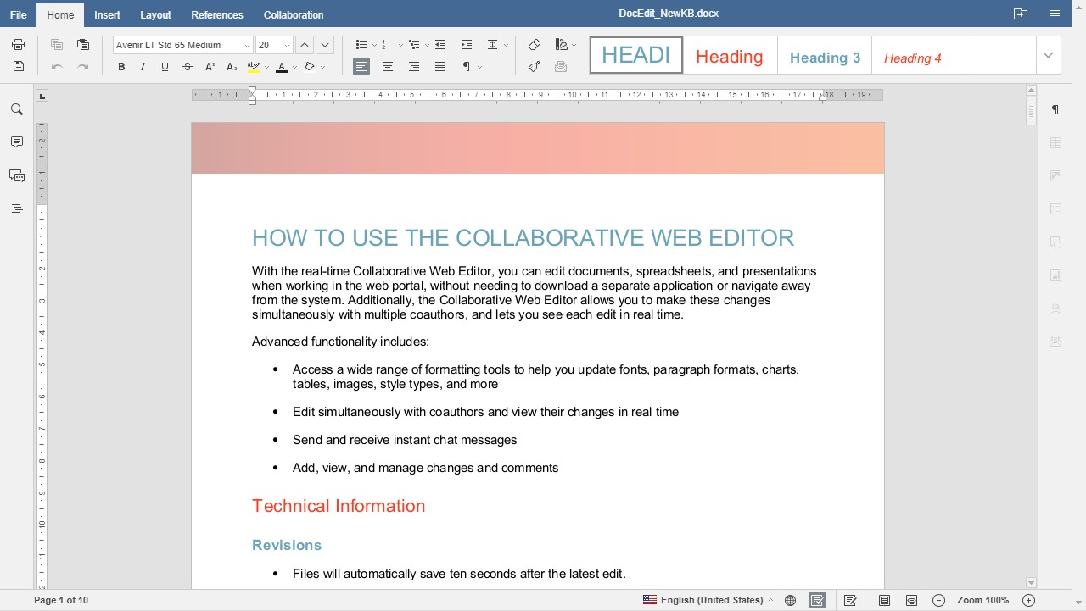
- To configure advanced settings, click the File tab, and then click the Advanced Settings link.

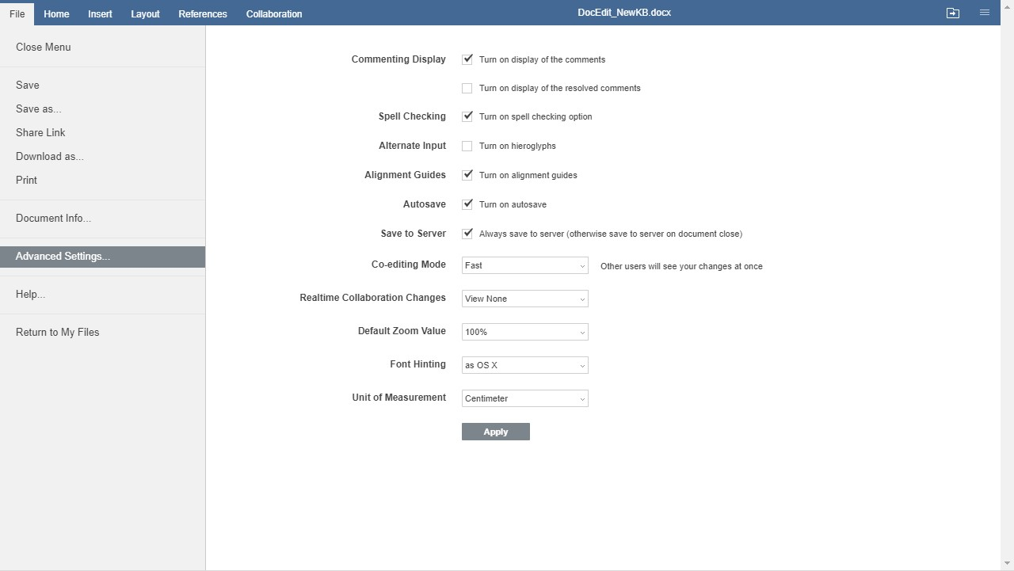

Use the Advanced Settings section to turn on and off features, such as comment- ing, spell check, auto-save, and so forth. You can also choose to view or disable real-time collaboration changes.
- While still in the Files section of the tool, you can:
  - Click Save to save the file.
  - Click Save as to save the file with a new name. You will also be given the option to save the file to a new file format or a new location (within the same root folder).
  - Click Share Link to generate a share link for a standard user or guest user. The recipient will be given privileges to co-edit the document using the Col- laborative Web Editor.
  - Click Download as to download the file to your local machine. You will be presented with the option to download the file in your preferred file format.
  - Click Print to print the document using your preferred printing device.
  - Click Help to view a comprehensive listing of all available functionality.

Inviting Coauthors to Collaborate

To collaborate on a single file in real time, you can create a share link from the web portal or your desktop client. You can also invite users to collaborate from within the Collaborative Web Editor.

- Click the File tab and select Share Link.
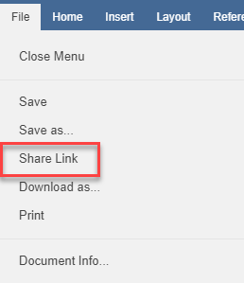

The Share Access dialog box displays.
- You can create a public share link to allow anonymous users to edit the file:
  - Select the Public Share URL radio button, and then click the Copy button to ensure that you capture the URL of the file.
  - Select the Allow anonymous users to edit files checkbox to let anyone who launches the share link to edit the file using the Collaborative Web Edi- tor.
  - Click the Share button to save your settings. You will then be able to paste the share link in an email, chat, or other messaging device.

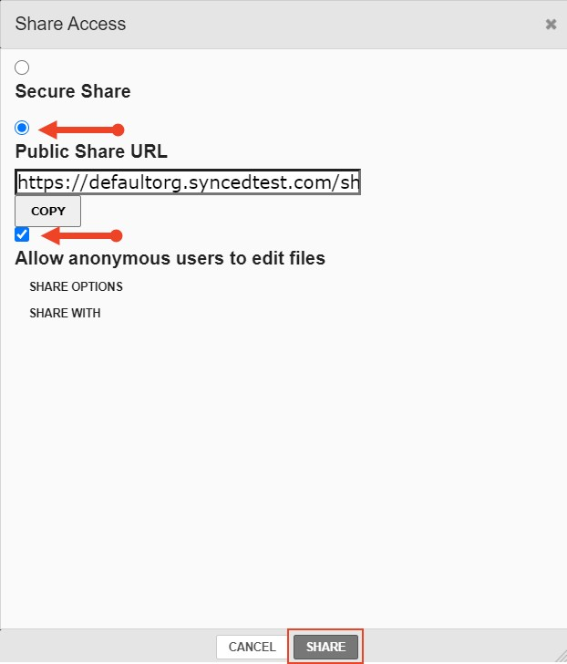
- Alternatively, you can create a secure share link to require recipients to log in:
  - Select the Secure Share radio button.
  - In the Recipients field, enter the name of the coauthor. The name of this new user will display in the lower portion of the screen.
  - Ensure the Can Modify checkbox is selected. The Can Modify permission al- lows this user to edit the file.
  - Click the Share button to send the share invitation to the recipient(s).

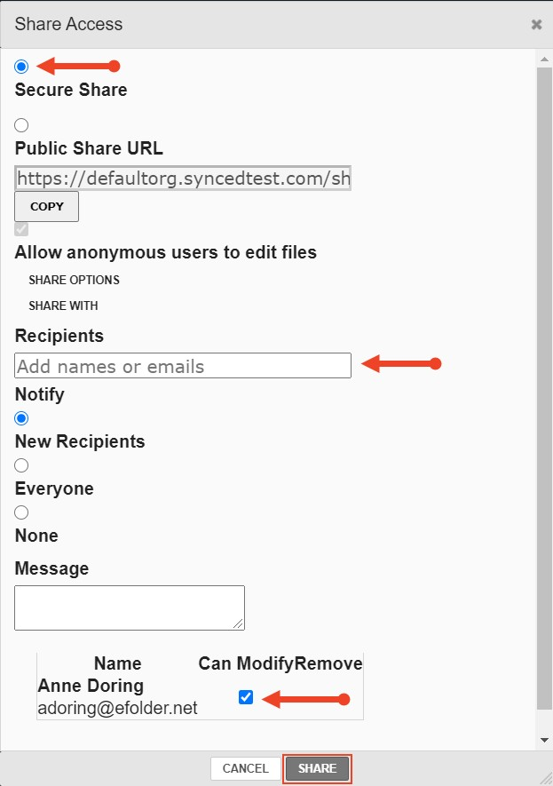
- To view a list of coauthors, click the View Users button. A pop-up window dis- plays, showing a list of users who are actively editing the document.
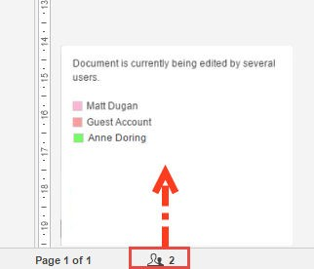

When these users make changes, their edits are visible immediately and are marked with a vertical bar.

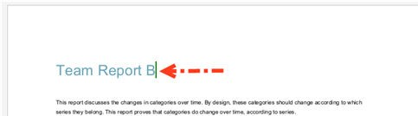
- Hover over the vertical bar to view editing details.
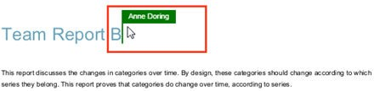

Chatting with Coauthors

When you are collaborating on a document in real time, you can use the Chat feature to communicate and share ideas with coauthors.

- In the left-hand navigation bar, click the Chat button to reveal the chat window.
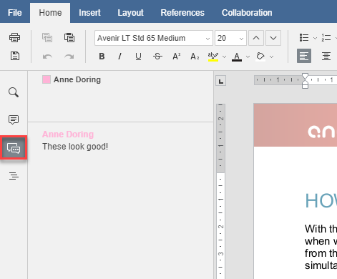
- Enter your message in the Chat dialog box and click the Send button. A visual overlay displays over the recipient's Chat button, indicating that a new message is available to view.

Editing with Coauthors

The Collaborative Web Editor allows you to edit using its Track Changes feature. You can also embed comments into files to aid in the collaboration process.

NOTE

If the file is later downloaded and opened on a local machine, these ed- its and comments will remain, and will display in all applications that support Track Changes and commenting (for example, Microsoft 365 products).

- To turn on Track Changes, click the Track Changes button found at the bottom right-hand corner of the screen.
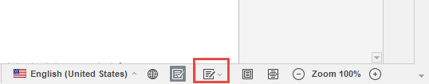

All changes made by you and coauthors will display in bubbles, allowing other users to accept or reject these changes.

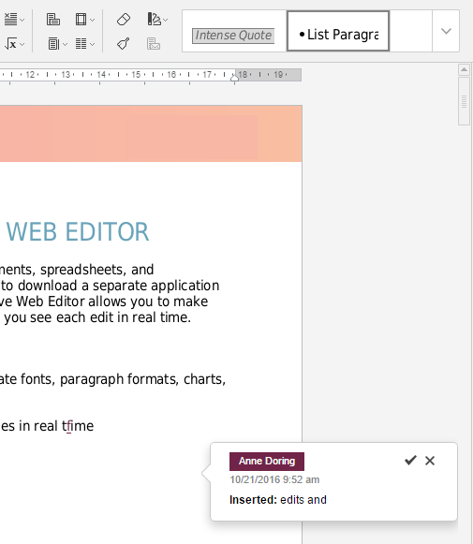
- To add a comment, highlight the appropriate portion of the file, right-click the high- lighted content, and then select Add Comment.
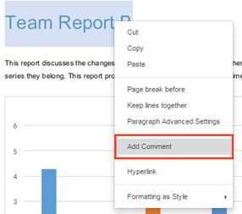

A pop-up bubble displays, allowing you to type a comment.
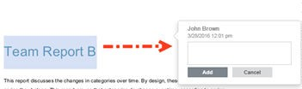

- To view all comments in the document, or to respond to an existing comment, click the Comments button in the left-hand navigation bar. You can use the tool- bar to edit, delete, or mark a comment as resolved.
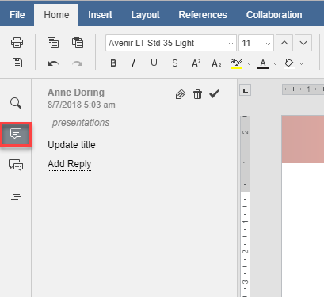

How to Edit Files in the Web Portal Using Microsoft 365 Apps

Overview

If your organization has access to a commercial Microsoft 365 subscription, you can edit files in the web portal using your Microsoft 365 apps. During the editing session, files are automatically saved, and all versions are tracked.

NOTE

Your administrator must turn on this feature before it can be used.

Advanced functionality includes:

  - Quickly view or edit files directly from the web portal, without needing to download files or use local applications.

  - Access a wide range of formatting tools to manage fonts, images, charts, styles, and more.
  - Edit and collaborate using the Track Changes and Commenting features.
  - Track file changes and revisions automatically through the auto-save feature.
  - Collaborate with co-authors in real time.

NOTE

Office Online stores a temporary copy of the file being viewed and edi- ted for the purposes of rendering and making changes to the file. Office Online is a Microsoft service and use of Office Online is subject to Mi- crosoft’s terms of use and privacy policy.

Supported File Formats

The following file formats can be edited using Microsoft 365 apps:

  - Microsoft Word (.docx)
  - Microsoft PowerPoint (.pptx)
  - Microsoft Excel (.xlsx)

Notifications and File Locking

  - In the Web Portal, a file that is being actively edited within a Microsoft 365 app will be marked with a Web Edit icon. Team Share subscribers will still be able to launch this file from the web portal.

  - In the desktop client, a file that is being actively edited will be automatically protec- ted by the File and Folder Locking feature and marked with a lock icon. Team Share subscribers will not be able to edit this file using applications on their local ma- chines.

Launching a Microsoft 365 App

To view or edit files using Microsoft 365 apps:

- In the Files tab of the web portal, navigate to the file that you want to view.
- Right-click a supported file, point to Open in, and select the appropriate Microsoft 365 app (in this instance, we are selecting Word Online).

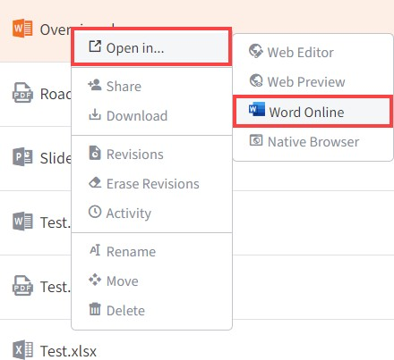

The file automatically locks and will be marked with an Editing icon in the web portal.
- If you are not logged in to Microsoft 365, you will be prompted to sign in. Click the
Sign in with a work or school account button to continue.
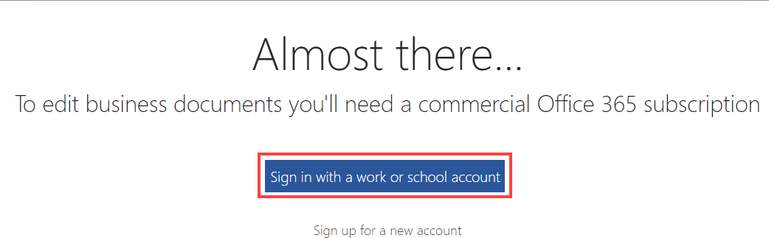

After you are authenticated, the file opens in the Microsoft 365 app. Depending on administrative settings, you might only have the option to view files. Contact your administrator for more information.

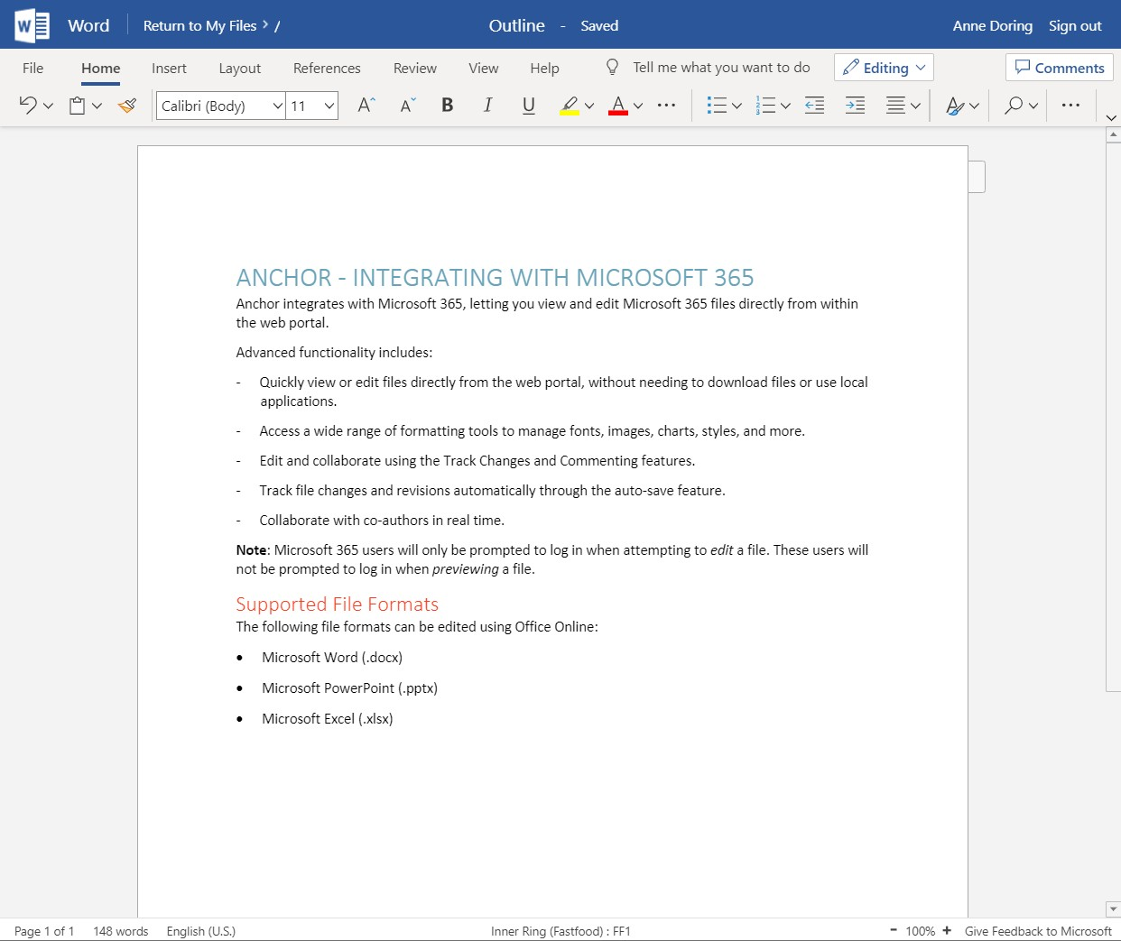
- When working in your Microsoft 365 apps, you can access advanced functionality, including:
  - Click the File tab to rename your file. If you are working in the Excel app, you will also have access to the Save As feature, which allows you to save to a different file. This new file will be saved to your root folder.
  - Click the Home tab to manage your clipboard, change fonts, control para- graph settings, and apply styles as defined in your file. You can also access the Find and Replace feature if needed.
  - Click the Insert tab to add page breaks, tables, pictures, links, and com- ments; you can also control headers, footers, and footnotes.
  - Click the Layout tab to manage margins and page formatting options.
  - Click the References tab to insert a Table of Contents or other reference tools.
  - Click the Review tab to manage the Spell Check feature, add comments, and show editing activity.
  - Click the View tab to set preferred viewing settings. For example, you can control the display of the navigation page, adjust zoom settings, and so forth.
  - Click the Help tab to access the Microsoft Help file.
  - Click the Comments button to expand or collapse the Comments panel.
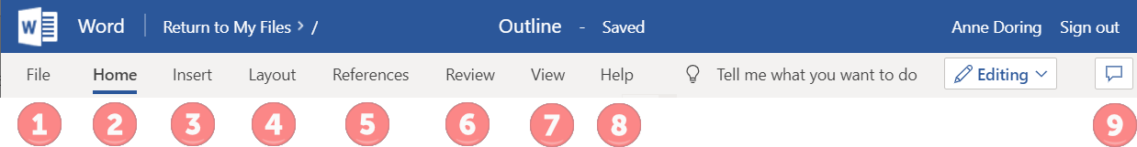
- Click the Return to My Files link when you are finished. You can also close your browser tab to end the editing session. All changes will be automatically saved.

NOTE

The Sign Out link currently signs you out of the web portal; it does not sign you out of Microsoft 365. This functionality will change in future re- leases.

Locking Files and Folders

File locking allows users to place locks on files and folders in Team Shares. This fea- ture is useful when you want to prevent other user accounts from editing your items when you are making changes, which prevents file sync warnings. You can place locks on a whole Team Share, a subfolder in a Team Share, or a file in a Team Share. When an item is locked, a lock icon will be placed over the file or folder, and it will be- come read-only for others subscribed to the Team Share.

If you forget to lock a file or folder before you begin making changes, you could en- counter file sync warnings. A file sync warning might take the form of a collision, where two Team Share subscribers try to edit the same file at the same time, or a locked change warning, where a user attempts to edit a locked file. When a file sync warning occurs, the system will notify you of the conflict, and will help you resolve the issue.

Your administrator can configure a Team Share so that Microsoft Team Share files au- tomatically prompt you to lock the files each time they are opened. When you confirm the lock, the files will automatically unlock when you close the file.

How to Lock Files and Folders in the Web Portal
In the web portal, you can place locks on a whole Team Share, a subfolder in a Team Share, or a file in a Team Share. When an item is locked, a lock icon will be placed over the file or folder, and it will become read-only for others subscribed to the Team Share.

To place a lock on a file or folder in the web portal:

- In the web portal, right-click the item, and select lock.

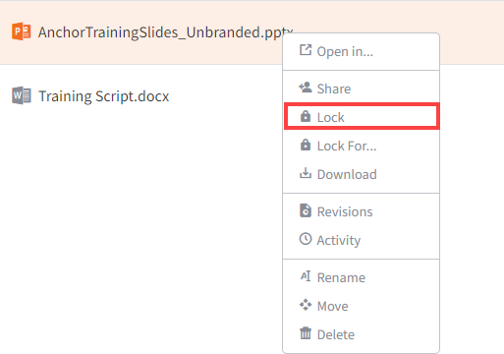

The item is now locked, and is read-only for everyone else in the share.
- Alternatively, to lock the folder or file for a specific amount of time, select Lock For. A pop-up window displays, allowing you to select a time period, including: 30 minutes, 1 hour, 3 hours, 6 hours, or 1 day.
- When you are finished editing, you must unlock the item. To unlock the item, right- click the file or folder again, and select unlock.

Viewing Lock Information

When you are working in the web portal, you can view information about who locked the file or folder.

  - In the web portal, right-click the Team Share item, and select Lock Info. A dialog box displays, giving you information about who locked the item, where the item was locked, and when the lock expires.
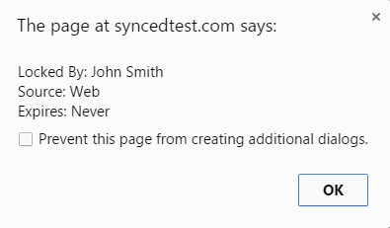

How to Lock Files and Folders in the Desktop Client

In the desktop client, you can place locks on a whole Team Share, a subfolder in a Team Share, or a file in a Team Share. When an item is locked, it will become read- only for others subscribed to the Team Share.

Manually Locking a File or Folder

To manually place a lock on a file or folder on a Windows or Mac machine:

- In the desktop client, right-click on the Team Share item, point to the sync menu, and select Lock. The Team Share item will remain locked until you unlock the item.
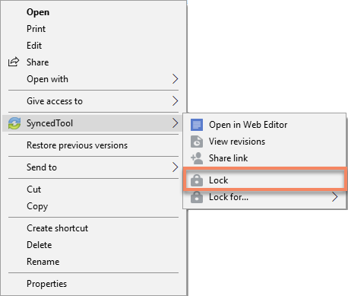
- Alternatively, to lock the folder or file for a specific amount of time, point to Lock for, and select a time period, including: 30 minutes, 1 hour, 3 hours, 6 hours, or 1 day.

Auto-Locking Files

If your administrator has turned on Auto-Locking, please note expected Auto-Locking behavior:

  - This feature applies to .doc, .docx, .xlsx, .ppt, and .pptx files. This feature also ap- plies to .xls, .odt, .ods, and .odp documents if the documents are opened with Li- breOffice or OpenOffice.
  - This feature is not supported for Word for Mac and .xls files opened with Excel.

  - This feature is only accessible from the desktop client installed on local machines.

To open a file using this feature:

- Click to open a file in the Team Share. You will be presented with a dialog box that will prompt you to lock the file.
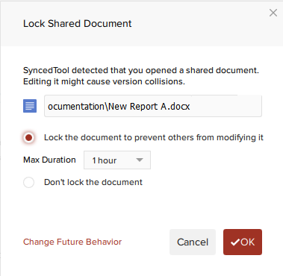
- Select the Lock the document radio button to confirm the lock. You can also se- lect a maximum lock time period in the Max Duration drop-down menu to deter- mine how long the auto-lock will be in effect. You can select from 1 hour (default), 2 hours, 4 hours, or 8 hours. After the time period has expired, the auto-lock will expire. Or, the file will automatically unlock when you close the file.
- Depending on the administrator's configuration settings, if another user opens a file that you have locked, he or she will be presented with a pop-up notification. If this notification is ignored, the user will be prompted to save the file with a differ- ent name.
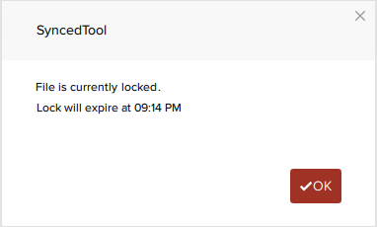

Note: When attempting to edit a Microsoft Word 2013 or Microsoft Excel 2013 locked file, offending users will need to actively clear the read-only notification before they can edit a file. Older revisions of Microsoft Word, however, will only display a read-only notification in the toolbar area. It is important to be mindful when working in Team Shares, and to pay attention to display indicators and warning mes- sages.

Viewing Lock Information
When you are working in the desktop client, you will see a lock icon displayed over a file or folder when it has been locked by you or another Team Share subscriber. Op- tionally, you can view information about who locked the file or folder.

  - In the desktop client, right-click the Team Share item, point to the sync menu, and select Lock Info. A dialog box displays, giving you information about who locked the item, where the item was locked, and when the lock expires.
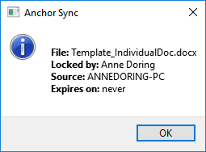

How to Resolve File Sync Warnings
The desktop client generates file sync warnings to alert end users of potential prob- lems with the file sync process. Each warning provides an automated resolution op- tion.
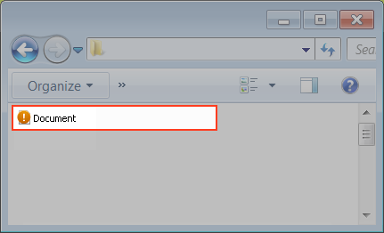

Common Types of File Sync Warnings

You might encounter a few different types of file sync warnings when working in Team Shares. For example:

  - Collision—A collision occurs when one file is modified in two different places at the same time. When this happens, only one of the revisions will successfully sync to the server, and the other revision will be marked as a collision. For example, User A and User B both open the same file from two separate locations, without locking the file. User A edits and saves her file, and this new revision is synchronized to the server. User A edits and saves her file again, and this updated revision is again synchronized to the server. User B is now editing an older revision of the file. When User B saves his revision of the file, it will not synchronize to the server, and will in- stead be marked as a collision.
  - Locked Change Warning—A locked change warning occurs when a user attempts to modify a file that has been previously locked by another user, either at the file lev- el or the folder level. For example, User A locks a file and the file is marked with a lock icon. Later, User B opens the file, ignoring the lock icon, and begins modifying the file. When User B attempts to save his revision, it does not immediately syn- chronize with the server, and is instead marked as a locked change warning. When User A unlocks the file, User B's revision will automatically synchronize to the server without any additional action on his part.

Your administrator can configure file locking so that locks are stronger (hard locks); in these instances, you will not encounter a locked change warning. For more infor- mation, please contact your administrator.
Note: If Team Share subscribers forget to lock files and folders before making changes, file sync warnings will occur more often; it is therefore considered a best practice to lock files or folders before making changes.

Resolving a Collision

To resolve a collision on a Windows or Mac machine:

- When a collision occurs, you will see a Resolve Sync Conflict icon.

- Click the icon on your computer’s system tray or menu bar and select the Sync Conflicts notification icon.
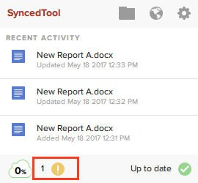
Note: On a Windows machine, the icon is located in the lower right-hand corner of the screen; on a Mac machine, the icon is located in the upper right-hand corner of the screen.

The Preferences dialog box displays, showing the Warnings tab.

- In the Warnings tab, click the Resolve link to learn more about the collision.
  - Click the Rename button to rename your copy to include the term collision appended to the end. When this option is selected, you will see two files: the original_file_name file and the original_file_name (collision) file.
  - Click the Discard button to delete your copy without saving changes.
  - Depending on administrative settings, you might also have the option to click the Overwrite Current button to sync your local copy as the current server revision.
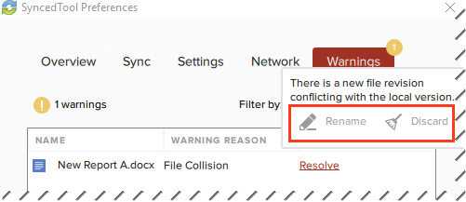
- Alternatively, you can resolve the file sync warning directly within Windows Ex- plorer or Mac Finder. For example, on a Windows machine, right-click the affected file, point to the sync menu, and select your preferred option.

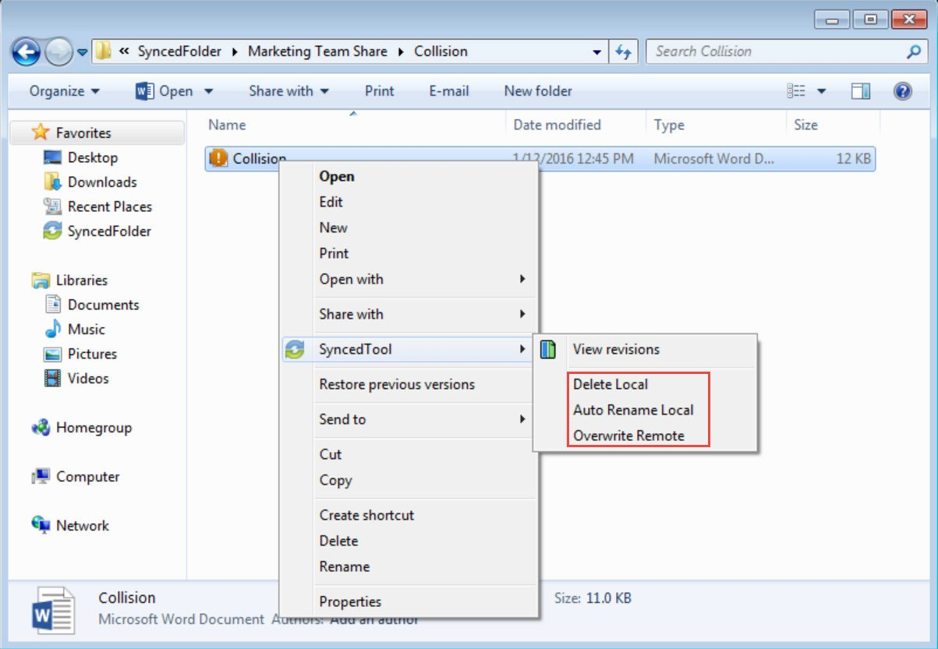

Resolving a Locked Change Warning

To resolve a locked change warning on a Windows or Mac machine:

- When a locked change warning occurs, you will see a Resolve Sync Conflicts
icon.
- Click the icon on your computer’s system tray or menu bar and select the Sync Conflicts notification icon.

Note: On a Windows machine, the icon is located in the lower right-hand corner of the screen; on a Mac machine, the icon is located in the upper right-hand corner of the screen.

The Preferences dialog box displays, showing the Warnings tab.
- In the Warnings tab, click the Resolve link to view more information about the locked change warning.
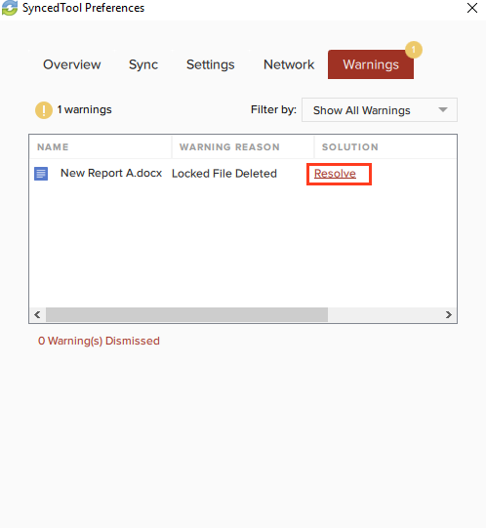
- Click the Dismiss link to clear the warning. The system will resolve this issue for you as soon as the lock is removed.

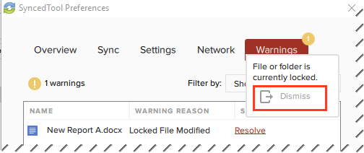

Other Types of File Sync Warnings

In total, the desktop client can generate six different types of file sync warnings:

File Collision

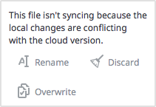
This file isn't syncing because the local changes are conflicting with the cloud version. To resolve this issue, you can select from:

- Rename - Rename the local file so the new changes sync to the cloud. This creates a new file.
- Discard - Discard the new changes and sync down the cloud version. This option will send your recent local changes to the Recycle Bin.
- Overview - Overwrite the cloud version with the new changes.

Note: This option will only be visible if it the Allow users to overwrite collisions policy is enabled.

Folder Exists Upstream (Folder collision)

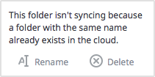
This folder isn't syncing because a folder with the same name already exists in the cloud. To resolve this issue, you can select from:

- Rename - Rename the local folder to begin syncing to the cloud. This creates a new folder.
- Delete - Delete this folder and sync down the cloud version. After choosing Delete, users are prompted to confirm. Clicking the OK button will send your local folder to the Recycle Bin.

Invalid Credentials for Synced Network Path
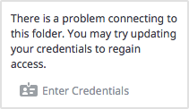
There is a problem connecting to this folder. You can try updating your credentials to regain access. After clicking Enter Credentials, the user will be prompted to log in.

File Is Locked
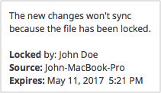
The new changes won't sync because the file has been locked. This error will resolve itself when the file is unlocked.

Sync Root Folder Missing
This folder isn't syncing because it could not be found. This could happen due to one of two situations:
- Folder was actually deleted or never created.
- Not able to access the drive itself (for example, the folder is located on a flash drive or network share).

To resolve this error, you can select from:

- Unsubscribe - this option will unsubscribe the user from the Team Share.
- Re-Sync - this option will re-sync this data from the cloud.

Folder Permission
You don’t have the right permissions to sync this folder. To resolve this warning, you can select from:

- Dismiss - this option will hide the warning; the folder will not sync.

Team Share Permission

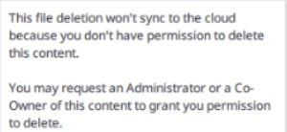
You do not have permission to delete this file. To resolve this warning, you can select from:

- Restore - this option will restore the deleted file.
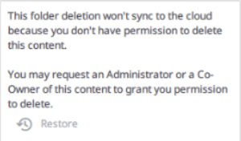
You do not have permission to delete this fold- er. To resolve this warning, you can select from:

- Restore - this option will restore the deleted folder.
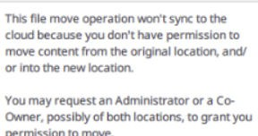
You do not have permission to move this file. To resolve this warning, you can select from:

- Revert - this option will restore the moved file.
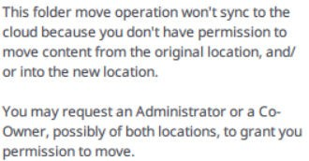
You do not have permission to move this fold- er. To resolve this warning, you can select from:

- Restore - this option will restore the moved folder.
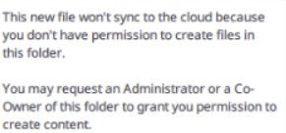
You do not have this permission to create files. To resolve this warning, you can select from:

- Delete - this option will delete the newly cre- ated file.

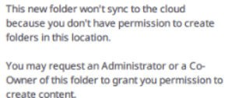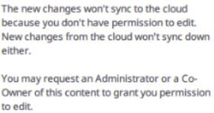

You do not have permission to edit files. To re- solve this warning, you can select from:

- Discard - this option will discard edits to the file.
You do not have permission to create folders. To resolve this warning, you can select from:

- Delete - this option will delete the newly cre- ated folder.

Restoring Files and Folders

The system provides many options for protecting—and optionally restoring—data. When you use the system, you can be sure that your data is safe and protected. For example, you can restore older revisions of files and folders, restore deleted files and folders, or use the Revision Rollback feature to restore all files within an entire folder to an earlier revision before a selected date.

This section will provide information on how you can protect, and optionally restore, your data.

How to View and Restore a Revision
When you edit a file, the system keeps track of each revision. Using the revisions fea- ture in the web portal, you can view—and optionally restore—older revisions of files. This feature is useful when you make a mistake editing and saving a file, or if you want to see revisions made by other members of your Team Share.

To view and restore revisions:

- From the desktop client on your local machine, right-click a file, point to the sync menu, and select View Revisions.
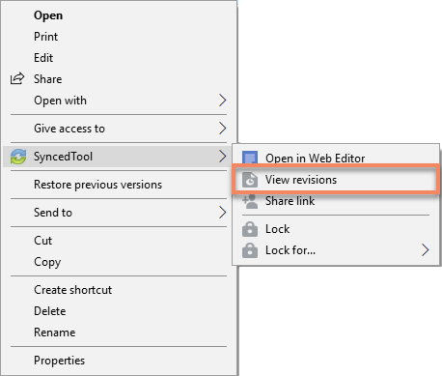
- Alternatively, if you are working in the web portal, right-click a file and select Revi- sions.

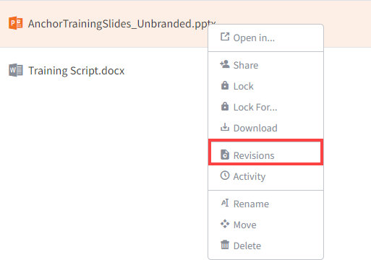

The Browse File Revisions page displays, listing all revisions of the file.
- In the Browse File Revisions page, click the title of the file to view the file in the Web Preview tool.
- Click the Download Revision link to download a previous revision. The file will download to your local machine.
- Click the Restore Revision link to overwrite the current file with the previous revi- sion.
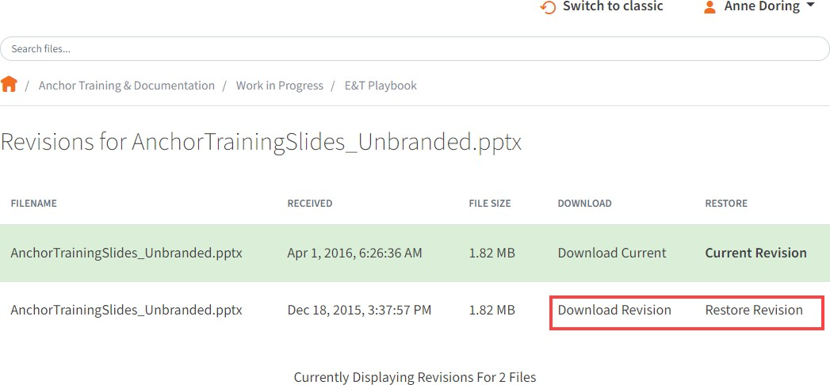

How to View and Restore Deleted Files and Folders
Depending on your administrator's settings, you can view and restore deleted files and folders from within the web portal. The ability to view and restore deleted content is one of many data protection features available to you.

To restore files and folders from the web portal:

- In the web portal, click the Files tab. The Browse Files page displays.
- In the toolbar, click the Show Deleted button.

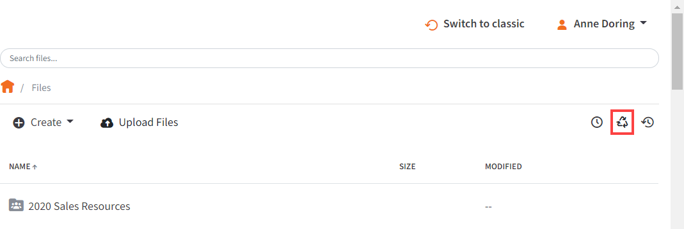

The deleted files and folders display as semi-transparent.
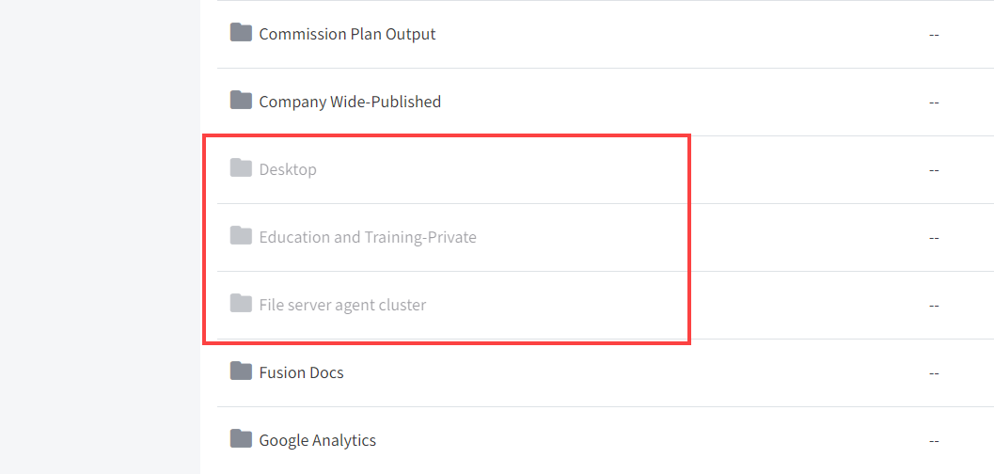
- Right-click an individual file or folder and select the Restore link.
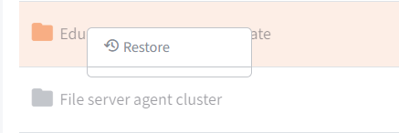
- Alternatively, to restore all deleted files in the current folder, click the Restore De- leted button in the toolbar.

The Restore Files dialog box displays, allowing you to restore all deleted files, or certain files deleted between a specified time frame.

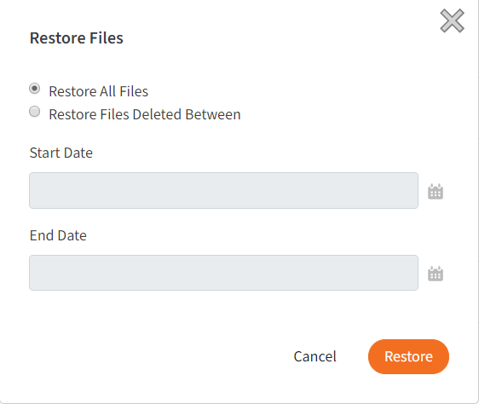

The selected files and folders will be restored.

NOTE

You cannot navigate away from the page until the restore process is complete.

How to Use the Rollback Feature
The Revision Rollback feature allows end users to restore all files within an entire fold- er (standard folder, Team Share, or Backup) to an earlier revision before a selected date. The Revision Rollback feature is particularly useful in situations where files might have been corrupted by ransomware; it utilizes a file’s revision history, and restores all currently-existing content in the root to a healthy revision at a specified point-in-time.
In these cases, you can use the Activity Log to determine when the infected revisions were uploaded, and then roll back files prior to the point of infection.

NOTE

Note: A file's revision can refer to the originally uploaded file (first ver- sion) or a revision of an edited file (subsequent revisions).

To access the Revision Rollback feature:

- In the web portal, click the Files tab. The Browse Files page displays.
- In the Browse Files page, navigate to the appropriate folder. While inside the fold- er, click the Rollback button in the toolbar.

The Rollback pop-up window displays, prompting you to select a date and time.
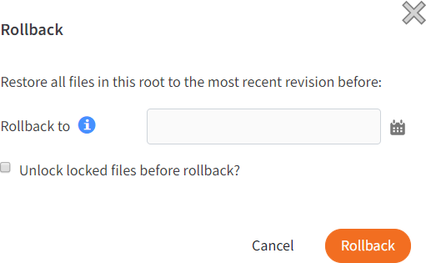
- Select a day and time before the time to which you want to restore. For example, if you select June 25th at 12:40 PM, the feature will find the first file revision be- fore June 25th at 12:40. If a revision exists at 12:40 and another at 12:39, the file at 12:39 will be restored.

Please note that the Revision Rollback feature utilizes a 24 hour clock, and is based off of the timezone of the x360Sync server. The US SaaS server is located in the Mountain timezone; the Canadian SaaS server is located in the Pacific timezone.
- Click Rollback when you are finished.

Backups

You can create backups of files and folders that exist on your local machine. You might want to create a backup of a file or folder that you want to protect, but do not want to sync. Backups do not reside in Synced Folder, and cannot be shared with an- other user account.

To create a backup, you can use the Backups tab in the web portal, where you can also manage and restore backups. Alternatively, you can create backups directly on your local machine.

How to Create Backups in the Web Portal

When you back up a folder, you can access your backups from the web portal and from mobile apps. All new changes are continuously backed up. Additionally, backups include revisions to files.

To back up a folder from the web portal:

- In the web portal, click the Backups tab. The Backups page displays, listing all of your existing backups.
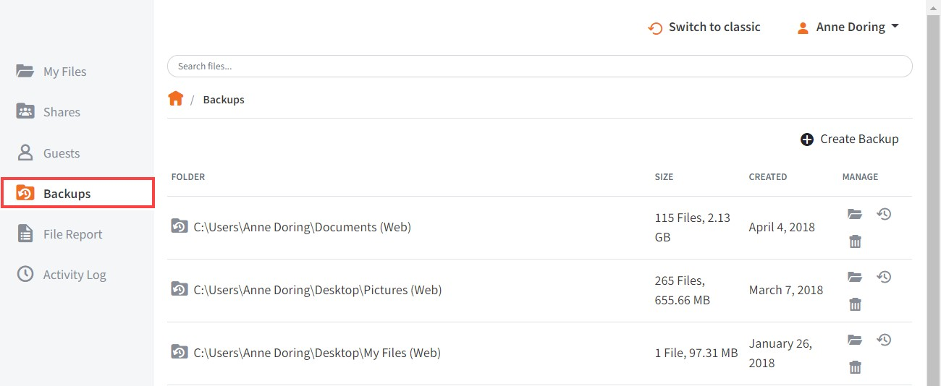
- In the Backups page, click the CreateBackups button. The page refreshes to al- low you to navigate your local machine and select the folder you want to back up.
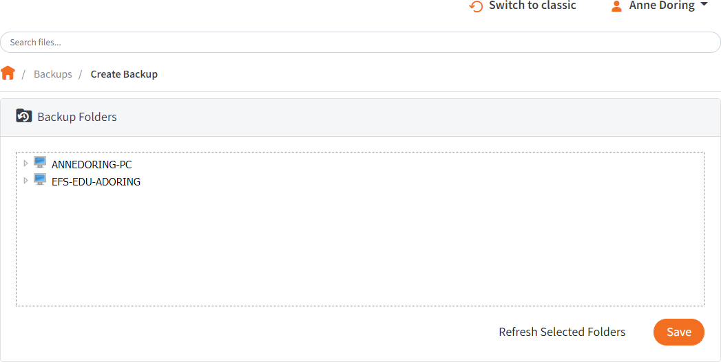

- Click the Save button when you are finished. The page refreshes to show you all backups that have been configured.

How to Create Backups on your Local Machine

In addition to backing up folders in the web portal, you can also back up your folders directly from your local machine. Like backups configured in the web portal, backups configured on your local machine continuously back up new changes, and will keep revisions.

To back up a folder from your Windows or Mac machine:

- Right-click the folder you want to back up. A menu displays.
- Point to the sync menu, and select Back up this folder.

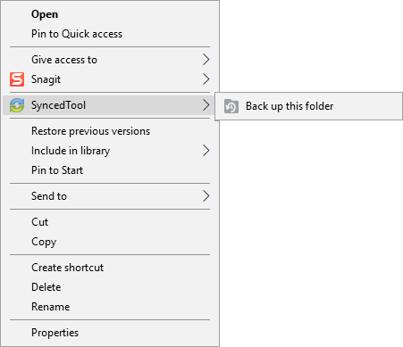

Your browser opens, displaying the newly created backup.

- To deactivate a backup from your machine, right-click the back up on your com- puter or laptop, point to the sync menu, and select Remove backup. The folder will no longer back up, and will be listed as deactivated in the web portal.

How to Manage Backups in the Web Portal

You can manage all backups by clicking the Backups tab in the web portal. In the Backups page, you can manage the content of backups, browse the content of back- ups, delete backups, or restore backups.

To manage backups:

- In the web portal, click the Backups tab. The Backups page displays, showing a list of all existing backups.
- In the Backups page, you can browse the contents of the backup.
  - Click the Browse button.

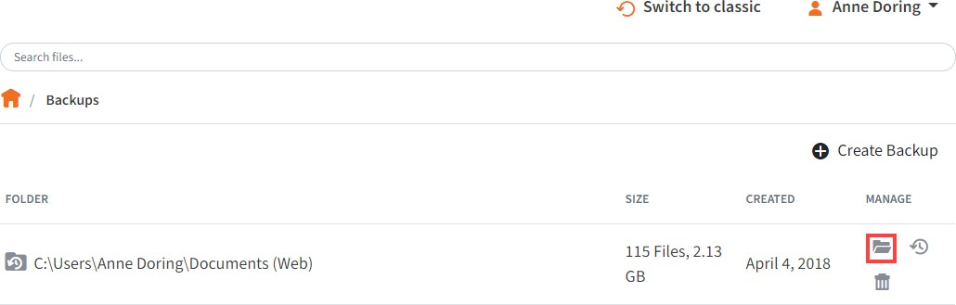

The backup opens, allowing you to browse its content.
- Inside the backup, you can also:
- Click the Create Folder button to create a new folder inside the backup.
- Click the Upload Files button to add files to the backup.
- Click the Rollback button to restore all files within the entire folder to an earli- er revision before a selected date. The Revision Rollback feature is particu- larly useful in situations where a file might have been corrupted by ransom- ware; it utilizes a file’s revision history, and restores all currently-existing con- tent in the folder to a healthy revision at a specified point-in-time. In these ca- ses, you can use the Activity Log to determine when the infected revisions were uploaded, and then roll back files prior to the point of infection.
- Click the Show Deleted button to show files that have been deleted within the backup
- Click the Restore Deleted button to return any deleted files to the backup.
- Click the Erase All Revisions button to erase previous revisions to files in the backup.

- In the Backups page, you can restore a backup to a specific location.

- Click the Restore button.

A Restore Backup page displays.
- In the Restore Backup page, browse to select a restore point. Optionally, click the New Folder button to create a new folder as a restore point.
- Click the Save button when you are finished.
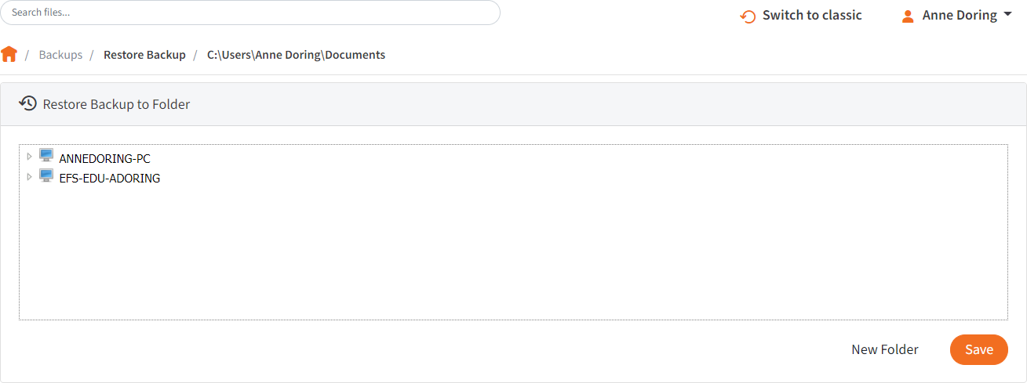
- Optionally, in the Backups page, click the Delete button to delete a backup.

The backup will delete.

File Report and Activity Log

In addition to managing and sharing files and folders, you can also keep track of file listings and activity directly from the web portal.

With the file report, you can generate reports for all of your files, and export the report to your local machine. Use the File Report page in the web portal to generate these reports.

With the activity log, you can track all usage across the system, view audit trails, and track activity on Team Share users and guest accounts. Use the Activity Log page in the web portal to filter activity based on a set of criteria.

How to View File Reports
The File Reports page allows you to keep track of all of your content in the system from one central location. In the File Reports page, you can filter by a specific folder or Team Share. You can then view the files within the folder, the date that each file was modified, and the size of the file. You can even export the report to your local machine.

To view file reports:

- In the web portal, click the File Reports tab. The File Reports page displays.
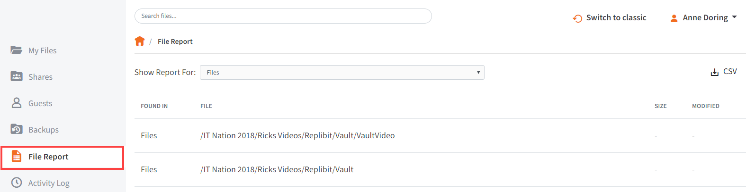
- In the File Reports page, use the Show Reports For drop-down menu to filter files within a specific folder or Team Share. The page refreshes to show files based on your selection. The information displayed for each file includes:
  - Found In—the folder in which the file is located
  - File—the path and the file name
  - Modified—the date the file was modified
  - Size—the size of the file

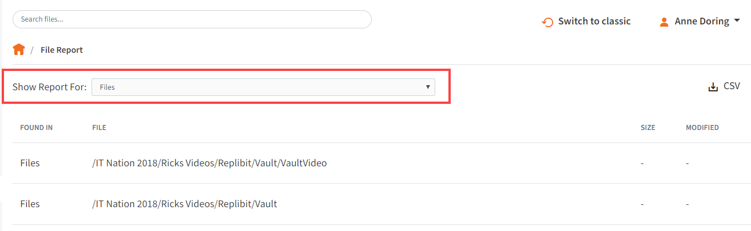
- Optionally, click the CSV button to export the report to your local machine.

How to Track Activity

The Activity Log page allows you to track activity across the system from one central location. Using the Activity Log page, you can track usage, view audit trails, and follow activity on Team Share users and guest accounts. You can even track activity per- formed by your guest users.

To track activity:

- In the web portal, click the Activity Log tab. The Activity Log page displays.

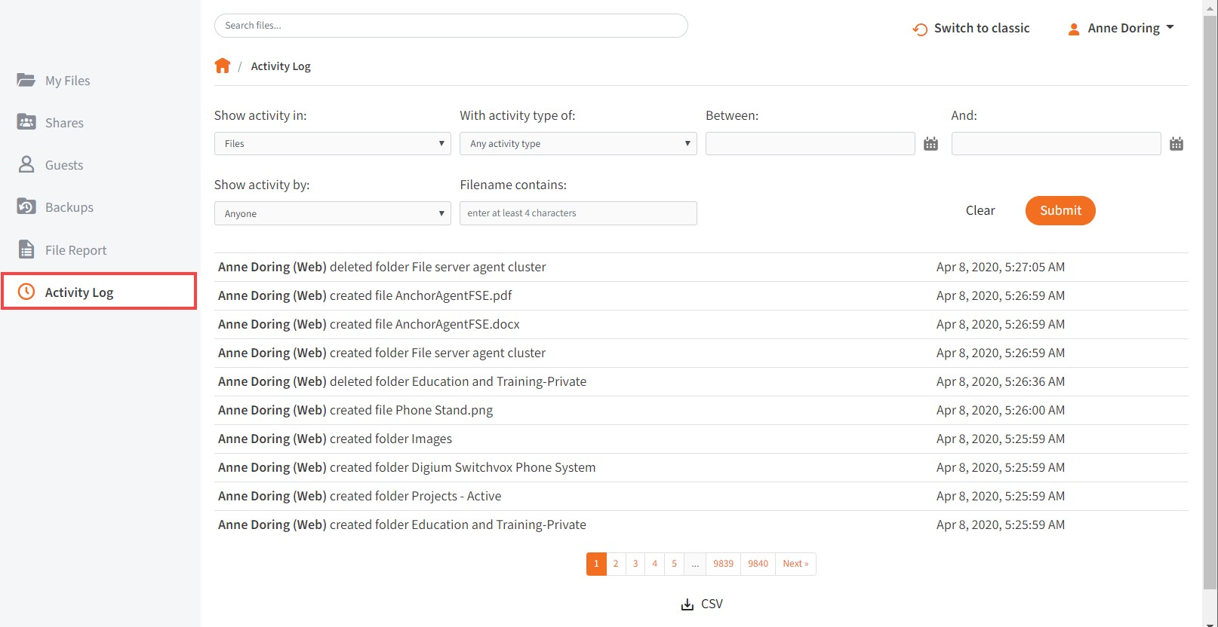

- In the Activity Log page, use the drop-down menus to filter activity based on a set of criteria.
  - Use the Show Activity In drop-down menu to select which folder or Team Share you want to track.
  - Use the with activity type of drop-down menu to select the type of activity
you want to track.
  - Use the between date fields to enter the date on which the activity occurred.
  - Use the Show Activity By drop-down menu to select the user who performed the activity. This list includes guest accounts that you have created, allowing you to track activity performed by your guest users.
  - Use the filename contains textbox to enter a set of characters that should be included in the search.

- When you are finished entering criteria, click the Submit button. You will be pre- sented with a list of activities that meet your selected criteria.

Outlook Add-In

The Outlook add-in allows you to email links to files and folders using your Microsoft Outlook application. When you use this feature, you can share links to Synced Tool items, as well as local content, directly from within your email platform. Additionally, the Outlook add-in keeps track of the items that you have shared by creating and pop- ulating a Shared Items folder in your Synced Folder.

Other benefits of the Outlook add-in include the ability to send links—rather than standard attachments—to files and folders of any size, and the ability to send items as secure shares. Additionally, when you forward an email that originally included an at- tachment, you have the option of converting that attachment to a share link. Because the Outlook add-in integrates with Synced Tool, you always have a backup of these shared items without needing to store attachments within your email client.

NOTE

Microsoft Outlook revisions 2010+ (both 32-bit and 64-bit) are supported and recommended. Microsoft Outlook for Mac does not support third- party add-ins.

NOTE

Disabling the Outlook setting, Use Cached Exchange Mode, will prevent the add-in from generating share links when composing emails.

Configuring the Outlook Add-In
When you configure your default settings, you can decide to

- Send notifications when a shared item is downloaded or uploaded;

- Limit the number of times a shared item is downloaded;
- Expire a shared item after a specified number of days; or
- Depending on your organization policy settings, send all items as secure shares.

NOTE

You can optionally configure the Outlook add-in so that all items are sent as secure shares; however, if certain policies are enabled for your or- ganization, this feature is turned on by default, and you will not be able to configure this option.

Additionally, when configuring attachment policies, you can determine how the Out- look add-in manages your sent content. When you send items through the Outlook add-in, a new Shared Items subdirectory is created for you in your Synced Folder. By default, this folder is located at the top-level of your Synced Folder, but you can change its location when you configure your Outlook add-in preferences.
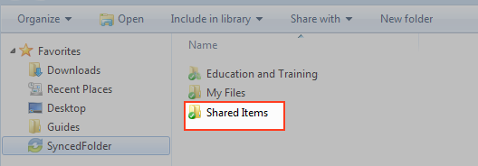

When you configure these policies, the Outlook add-in operates as a truly intelligent tool, automatically sending share links according to the way you like to work. For ex- ample, you can tell the add-in to

- Automatically use the Outlook add-in for attachments over a certain size, even when an email draft already includes a standard attachment (for example, when forward- ing messages);
- Automatically use the Outlook add-in for all attachments, even when an email draft already includes a standard attachment; and
- Only use the Outlook add-in when selected.

Using the Outlook Add-In

When you compose a message in Microsoft Outlook, you use the ribbon button to at- tach content in a variety of ways, including

- Browse and select files and folders stored in Synced Tool,
- Browse and select a local file stored on your machine, and
- Convert an attached file to a share link, which is particularly useful when forwarding email messages that originally included a standard attachment. You can decide to manually convert these items using the Attach drop-down menu, or this will happen automatically, depending on your attachment polices.
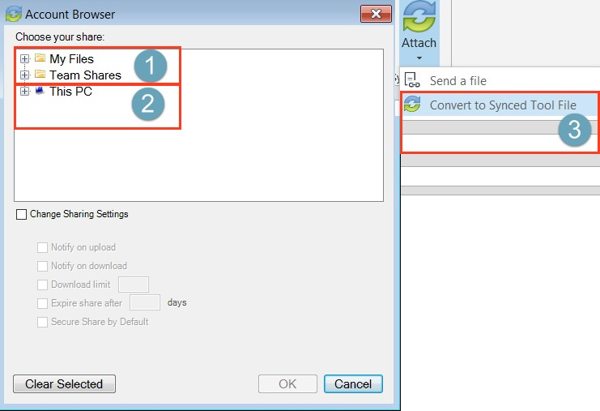

NOTE

When you send local files, or you convert an item to a share link, these items are stored as Synced Tool content in your Shared Items folder.

How to Install the Outlook Add-In

Before you can use the Outlook add-in, you must first download it from the web portal. To download the Outlook add-in:
- Click the Download App button in the web portal. The Download page displays.

- In the Download page, click the Outlook button.
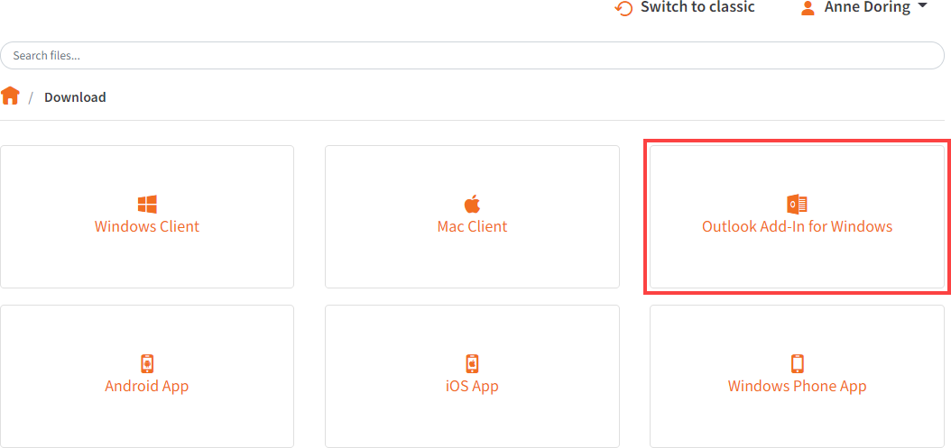

The file will start to download, or you will be prompted to save the file, depending on your browser type.
- When the file finishes downloading, make sure Microsoft Outlook is closed, and click the installation file. The Setup Wizard opens.
- Click the Next button to start the Setup Wizard.
- In the License Agreement screen, click the I accept the agreement radio button if you accept the license. Then, click the Next button to continue.

- In the Installation Directory screen, select the location where you want the instal- lation files to reside on your local machine. In most instances, you can accept the default location. Click the Next button to continue.
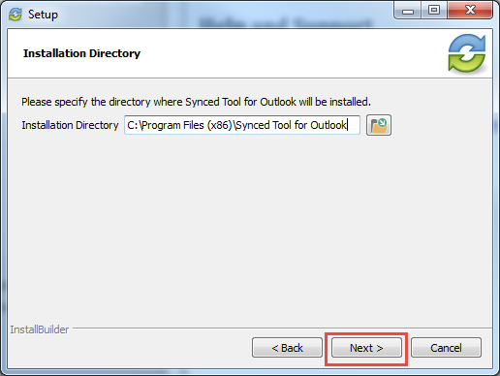

- In the Ready to Install screen, click the Next button to begin the installation proc- ess.
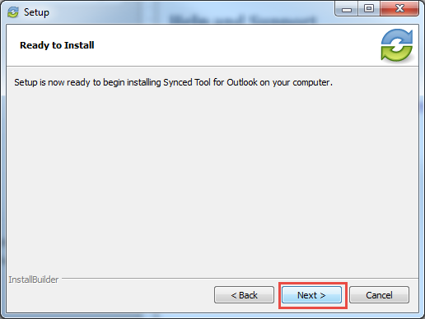

- When the Setup Wizard completes, click the Finish button.

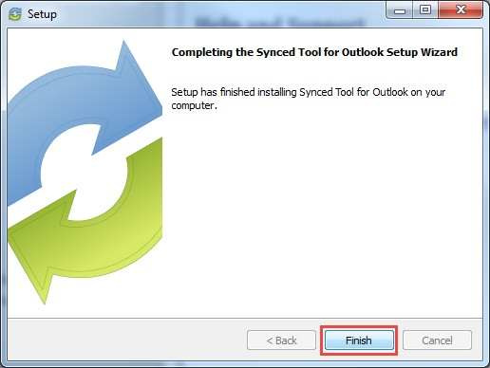

How to Configure the Outlook Add-In

After you install the Outlook add-in, you can configure default share settings and at- tachment policies. When you configure these settings, the Outlook add-in operates as a truly intelligent tool, automatically sending share links according to your preferences.

- When you launch Microsoft Outlook for the first time after installing the Outlook add-in, the Wizard displays, prompting you for login credentials.
  - If prompted, enter the host name of your organization in the Host field (for example, syncedtool.com).
  - In the Username field, enter the same username that you use to access the web portal.
  - In the Password field, enter the same password that you use to access the web portal.
  - Click the Next button when you are finished.

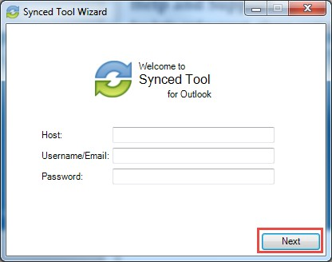

- In the Choose your Default Share Settings screen, set default settings for how you share links.
  - Click the Notify on upload checkbox to receive notifications when an item is uploaded to a shared folder.
  - Click the Notify on download checkbox to receive notifications when the share is downloaded.
  - Click the Downloadlimit checkbox, and enter a download limit number, to limit the number of times the share is downloaded by each recipient.
  - Click the Expire share after checkbox, and enter a number of days, to set a share to expire after the specified number of days.
  - Depending on your administrator's configurations, you may also have access to the Secure Share by Default checkbox. Click this checkbox to send all content as secure shares. If this option is selected, all recipients will be re- quired to log in to access the shared content. Recipients who are not mem- bers of your organization will be added as guest users; a guest account will be created for the recipient, and login credentials will be provided.
  - Click the Next button to continue.
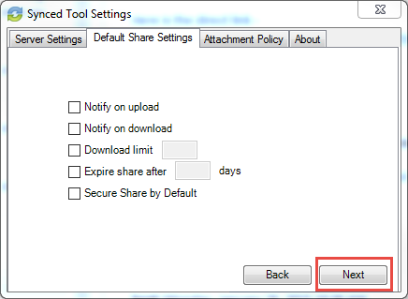
- In the next screen, set default attachment policies.
  - Click the Automatic radio button to automatically use the Outlook add-in for attachments over a certain size.
  - Click the Always use the desktop client for attachments radio button to automatically use the Outlook add-in for all attachments.
  - Click the Advanced radio button to only use the Outlook add-in when selec- ted.
  - Click the Use default folder checkbox to use the default location for storing shares configured from Outlook. If you uncheck this checkbox, you will be prompted to select another location on your local machine.

  - Click the Next button to continue.
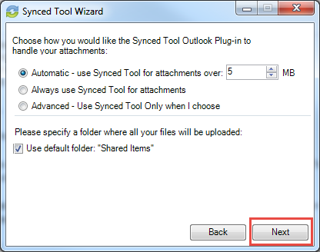
- When the Wizard completes, click the Finish button.
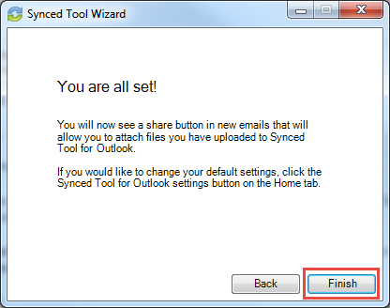

How to Use the Outlook Add-In
When you compose a message in Microsoft Outlook, you can use the Attach drop- down button to attach specific share content according to your defined preferences.

To use the Outlook add-in:

- In Microsoft Outlook, create a new email message. The ribbon will display an At- tach drop-down button.
- Click the Attach drop-down button and select Send a File.

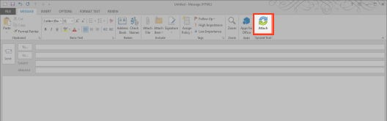

The Account Browse dialog box displays.

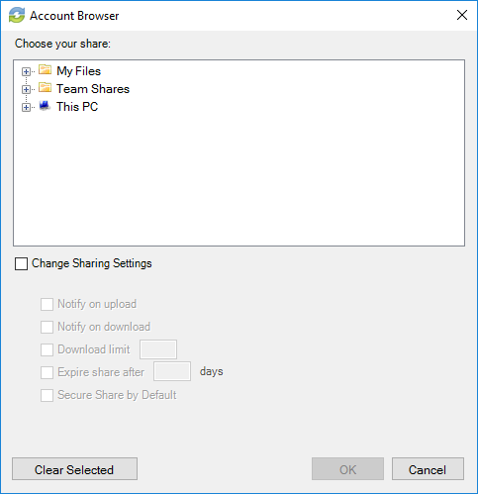
- In the Account Browser dialog box, select the content you want to share.
  - To attach a file or folder stored in Synced Tool, click to expand the My Files
folder, or the Team Shares folder, and select the appropriate content.
  - To send a file from your local machine, click to expand This PC. You can then browse and select a file on your machine.
  - Optionally, you can change your default share settings by clicking the
Change Share Settings checkbox.
- Alternatively, to convert an attached item to a share link, click the Attach drop- down arrow and select Convert to Synced Tool File.
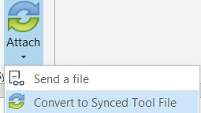

Any attached item will automatically convert to a share link, and will be stored in your Shared Items folder.
- Click Outlook's standard Send button to send your email.
- If you have selected to send a secure share link to an entire folder (rather than a single file), a Secure Share Settings dialog box will display, prompting you to con- figure permission for each recipient. You can set upload permissions, which al- lows recipients to upload content into the shared folder, or delete permissions, which allows recipients to delete content in the shared folder.
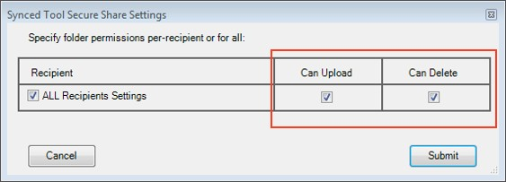

Optionally, uncheck the ALL Recipients Settings checkbox if you would like to configure separate permissions for each recipient.
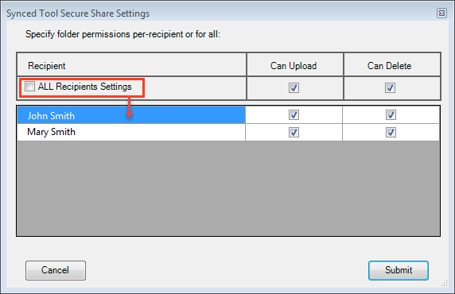

WebDAV

WebDAV allows you to map a network drive to your files in the cloud. With WebDAV, you will not have to download files or install the desktop client. Before configuring WebDAV, you should check with your administrator to ensure that this option is ena- bled in your system.

How to Map a Network Drive on a Windows Machine
To map a drive on a Windows machine:

- In your start menu, click Computer. The Computer dialog box displays.
- In the Computer dialog box, click the Map Network Drive button.
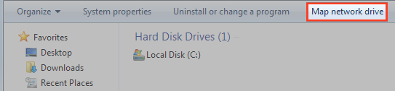

The Map Network Drive dialog box displays.
- In the Map Network Drive dialog box, configure the appropriate drive and folder.
  - In the Drive drop-down menu, select a drive letter.
  - In the Folder field, enter the location of the folder (for example, https:// dav.syncedtool.com).
  - When you are finished, click the Finish button.
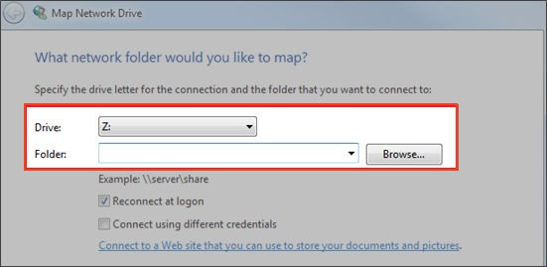
- Enter your username and password when prompted and click the OK button. Your personal folders and Team Shares will now display. You will be able to ac- cess the WebDAV folder in My Network Places.

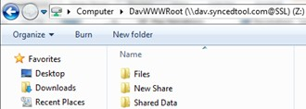

How to Map a Network Drive on a Mac OS X Machine
To map a drive on a Mac Machine:

- In Finder, click the Go menu and select Connect to Server. The Connect to Server window displays.
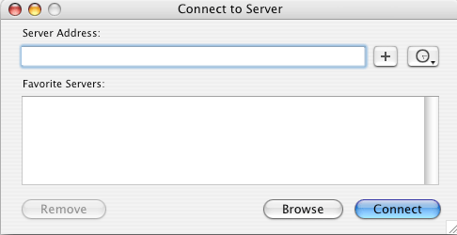
- In the Connect to Server window, enter your server address (for example, https:// dav.syncedtool.com), and click the Connect button.
- When prompted, enter your username and password. Active Directory users must enter credentials as domain\username.
- When you are finished, click the Connect button.

