Please complete this form and send it back to Axcient along with your logo files.
Logo Images (Basic):
You have the option of sending between two and five different logos based on the level of customization you are looking for. For a custom look, you need to send a minimum of two logo files in .png (preferred) or high resolution .jpg or .gif format.
- Large Version: The first and larger logo should be 80 to 580 pixels wide and 80 to 120 pixels tall. This larger logo will be displayed horizontally across the top of the backup manager (client) software, the web portal and any system generated emails. If you have a patterned background as part of your logo, please read section 2.b.iv under “Logo Images (Optional)”.
- Email Archiving Logo Image: The second, smaller logo will be displayed in the email archiving software. This logo must be exactly 40 pixels high and no more than 580 pixels wide. If the console window is wider than the logo image, the system will use a white background to fill-in the extra space. Keep in mind that it may be necessary for you to modify your logo to make it look clear with this 40 pixel height restriction. Consider making your logo wider and moving any text off to the side of the image. Fonts may not look crisp when scaled down from a much larger image.

Logo Images (Optional):
You can optionally provide separate logo images for the backup manager, web portal and system generated emails. Please send any additional logo files in .png (preferred) or high resolution .jpg or .gif format:
- Backup manager (client) software: This logo can either be a vertical banner displayed on the left side of the software or a horizontal banner displayed across the top.
  - Horizontal Banner (default). The logo image for a horizontal banner should be 80 to 580 pixels wide and 80 to 120 pixels tall.
  - Vertical Banner. The logo image for a vertical banner should be 80 to 130 pixels wide and 80 to 500 pixels tall.
- Web portal (web-based management software): This logo is composed of two images, a background image and a foreground image. The background image can be a solid color (e.g. white), a color fade (e.g. fade from blue to white), or a custom pattern.
  - Foreground Image: The foreground image should be 80 to 750 pixels wide and 80 to 140 pixels tall. If your logo includes a patterned background, this foreground logo image needs a transparent background.
  - Background Image: The background image needs to be 8 pixels taller than the foreground.
    - Solid: If you choose to use a solid background for this logo, please specify the color to be used in the Logo Parameters box for “Web portal logo background”.
    - Fade: We can also generate a left-to-right color fade background for this logo. Please specify the left and right colors (e.g. fade from white to blue) in the Logo Parameters box for “Web portal logo background”.
    - Custom (tiled): If the background image can be tiled horizontally, make this image only as wide as needed to hold the pattern (approx. 6 to 20 pixels wide).
    - Custom (not tiled): If the background image is more complex and cannot be tiled horizontally, please provide an image that is 2000 pixels wide.

- System notification emails: This is a horizontal logo displayed across the top of all notification emails sent by the software. Ideally, this logo should be 410 pixels wide (but can be as wide as 580 pixels) and 80 to 120 pixels tall. Email notifications may be printed, so dark backgrounds are less desirable.

Logo Parameters:
Please fill out the table below with information about your branded logos. If you do not have specific color requirements, please leave this section bank and we will use the colors in your logo or on your company website.

Description | Choose One Style per Box | Color Selection**
Backup manager (client) software - banner orientation | __ Horizontal (-default-)  __ Vertical | N/A
Backup manager (client) software - color preferences | __ Solid Color (-default-)  __ Custom (specify color)  __ Follow Company Website | (Blue#2858B4 is default color)
Web portal - logo background | __ Solid Color (-default-)  __ Color Fade (fade color to color)  __Custom Background (provide file) | (White #FFFFFF is default color)
Web portal - color preferences | __ Solid Color (-default-)  __Custom (specify color)  __ Follow Company Website | (Blue#2858B4 is default color)
** specify color preferences in the exact colors in either RGB or HTML format.

Company Information (Required):
Please supply the following information – fields marked with an asterisk (*) may not be left blank:

Description |  |  | Example Value | Actual Value
Long Name of Backup Product* |  |  | ABC Company Backup
Short Name of Backup Product* |  |  | ABC Backup
Email Archiving Product Name* |  |  | ABC Email Archiving
Tech Support Email* |  |  | xxx@xxx.xxx
Tech Support Phone No. * |  |  | xxx-xxx-xxxx
Customer Service Email* |  |  | xxx@xxx.xxx
End-user Billing Email |  |  | xxx@xxx.xxx
Company Name* |  |  | ABC Company Inc.
Company Address (line 1) |  |  | xxxx Streetname
Company Address (line 2) |  |  | City, xx, Zip
Company Address (line 3)
Company Phone No. |  |  | xxx-xxx-xxxx
Company Fax No. |  |  | xxx-xxx-xxxx
Company Web Site* |  |  |  | http://
Contact Us Web Page |  |  |  | http://
Support Web Page |  |  |  | http://
Select Server Region* |  | Data Storage in United States (default) |  |  |  | Data Storage in Canada

URL/Hostname Hiding (Optional):

You can choose to hide the URL of the web portal website and also change the hostname of the backup server. However, these steps require additional effort on your part.
Please indicate if you want to hide our URL and change the hostname of the backup server.
URL of  THE WEB PORTAL | Indicate Yes/No | Additional Information (if YES, indicate new actual value)
***  Your users will see our default URL in their Internet Browser when they access the web portal. You can use framesets on your web server to mask our URL address with one you define.  *** | Yes  or  No | For instructions and additional information, you MUST read our knowledge bases article:  “How can I hide backup.securewebportal.net everywhere?”  (see https://support.efolder.net/hc/en-us/articles/115010512867 )  Default Value: https://backup.securewebportal.net  Actual Value: (only if YES)  If you use https:// then you must buy your own SSL certificate.  If you do not want to buy a certificate, use http://  (either way internally the web portal will still communicate via https and be secure)  Suggestions: “http://securebackup.yourcompanywebsite.com”,  “https://datasafe.yourcompanywebsite.com”,  “http://yourcompanywebsite/datavault/”  -- NOTE: This URL cannot be your company website URL. --  -- NOTE: You must host a PHP or ASP page at this URL. --

HOSTNAME of  THE SERVER | Indicate Yes/No | Additional Information (if YES, indicate new actual value)
*** The backup manager (client) software installed on your customers’ computers will need to connect to our backup server to upload data. By defining a new DNS CNAME, you can mask our default server name with one you define.  *** | Yes  or  No | For instructions and additional information, you MUST read our knowledge bases article:  “How can I hide backup.securewebportal.net everywhere?”  (see https://support.efolder.net/hc/en-us/articles/115010512867 )  Default Value: backupserver.securewebportal.net  Actual Value: (only if YES)  Suggestions: “backupserver.yourcompanywebsite.com”,  “dataserver.yourcompanywebsite.com”,  “datavault.yourcompanywebsite.com”  -- NOTE: You must create a DNS CNAME record that points to backupserver.securewebportal.net  (do not create a DNS A record) --  -- NOTE: This cannot have the same hostname the URL above. --  (The hostname is the text following “http://” or “https://”.)

Details Regarding the Company Information Fields:

If you want further information about how the above fields are used, we have provided it here.
The following fields are displayed both on the branded web portal and the client software.

Any field that is not marked as required can be left blank.

TECH SUPPORT EMAIL ADDRESS (required)
This is where a customer using the web portal or client should be able to send a technical question to your company about the backup software. Example: Support@yourcompany.com.

TECH SUPPORT PHONE NUMBER (required)
This is where a customer using the web portal or client should be able to call into your company about a technical question regarding the backup software.

CUSTOMER SERVICE EMAIL ADDRESS (required)
This is where a customer using the web portal or client should be able to send an email to your company with a general question regarding the backup software. This email address is also used for outgoing mail from the web portal, and tis field must be filled in order for emails to be delivered successfully. This email address could be the same as or different from the Tech Support Email Address provided above.
Examples: Support@yourcompany.com or CustomerService@yourcompany.com.

END-USER BILLING EMAIL ADDRESS
This is where a customer using the backup software could email your company with a question about their billing for their use of the backup software. This email address could be the same as or different from the Tech Support Email Address provided above. Example: Billing@yourcompany.com.

COMPANY NAME (required)
This is the name of the company that is providing this branded software.

COMPANY ADDRESS (line 1, line 2, line3)
This should be the mailing address of the company listed in Company Name.

COMPANY PHONE NUMBER and FAX NUMBER
This is the main phone number and fax number of the company listed in Company Name.

COMPANY WEBSITE (required)
This should be the website for the company listed in Company Name.

CONTACT US WEB PAGE
This should be the Contact Us web page for the company listed in Company Name.

SUPPORT WEB PAGE
This should be the Support web page for the company listed in Company Name.

SERVER REGION
Location where you want your backup data to be stored. If no choice is made, all data will be stored at locations in the United States.

If you need more information or have any questions, please contact Branding@Axcient.net.

Web Portal Branding Components
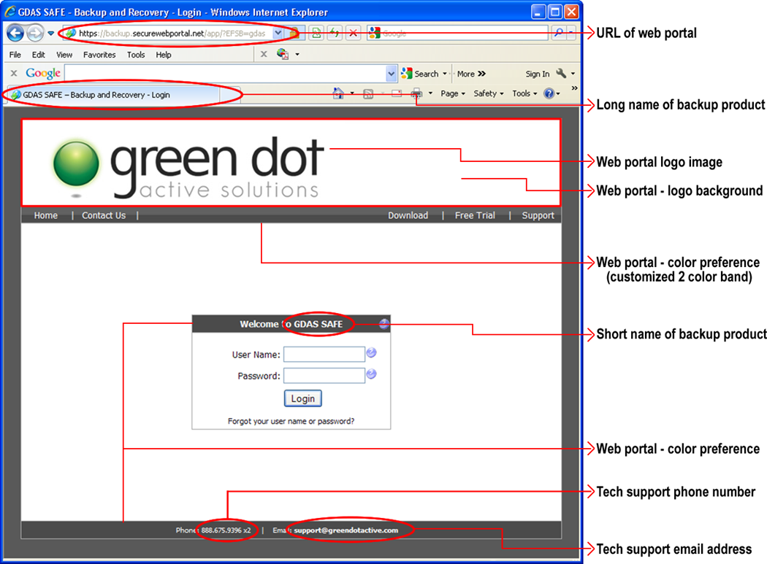

Backup Manager (Client) Branding Components
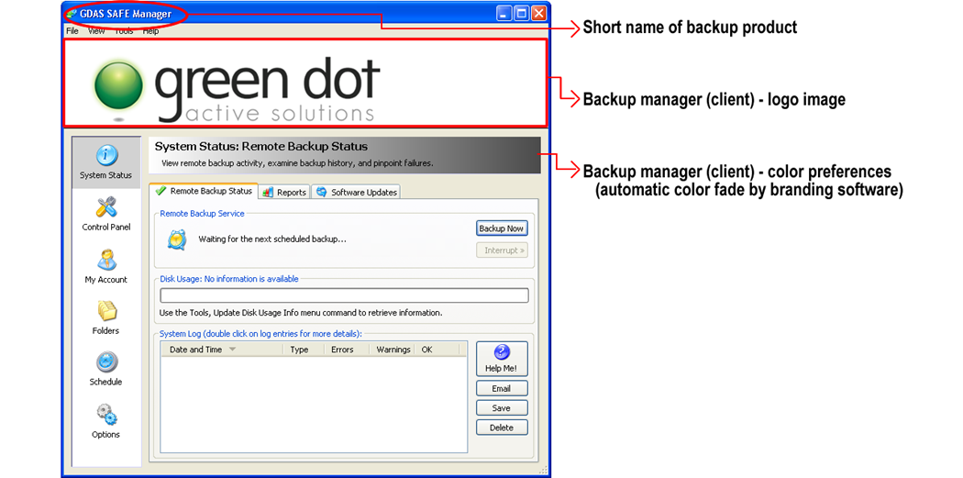

System Notification Email Branding Components
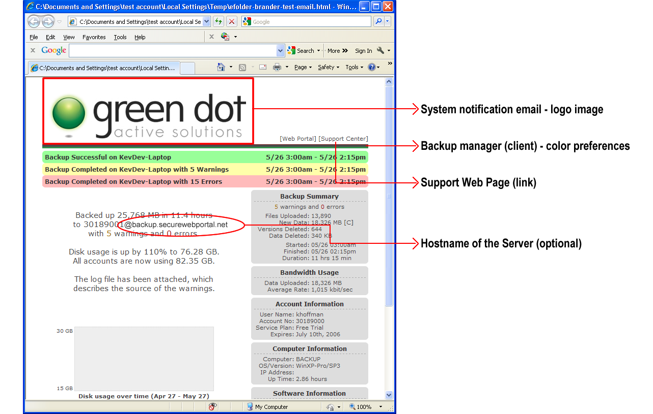

Email Archiving Branding Components
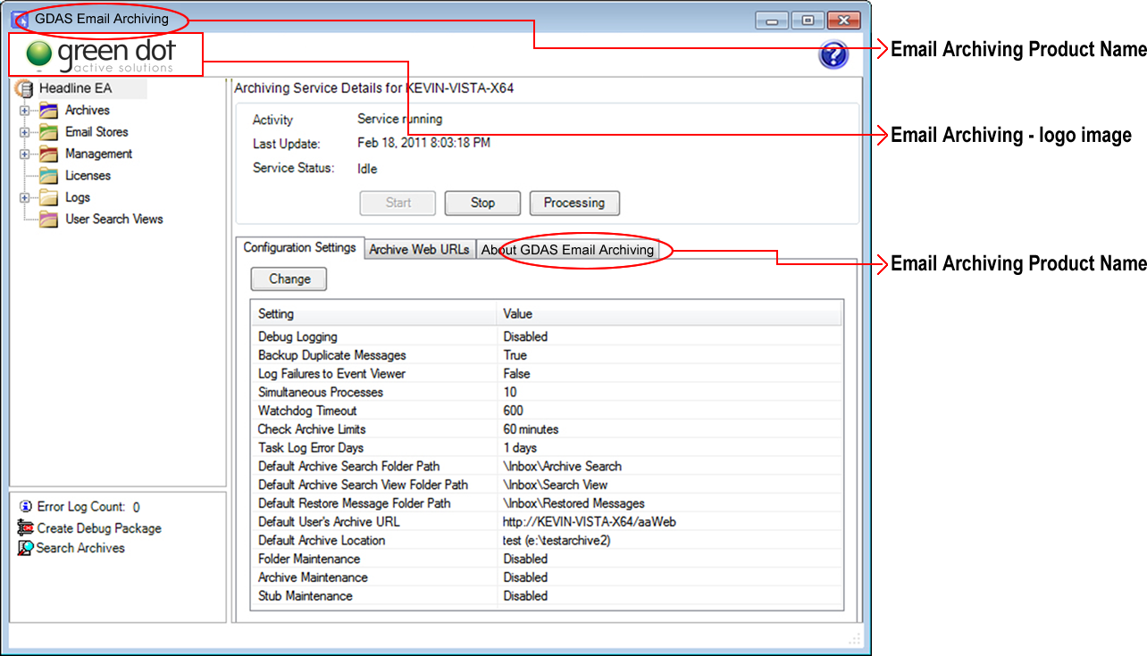

Sample Branding Completed with our Default Logo Images

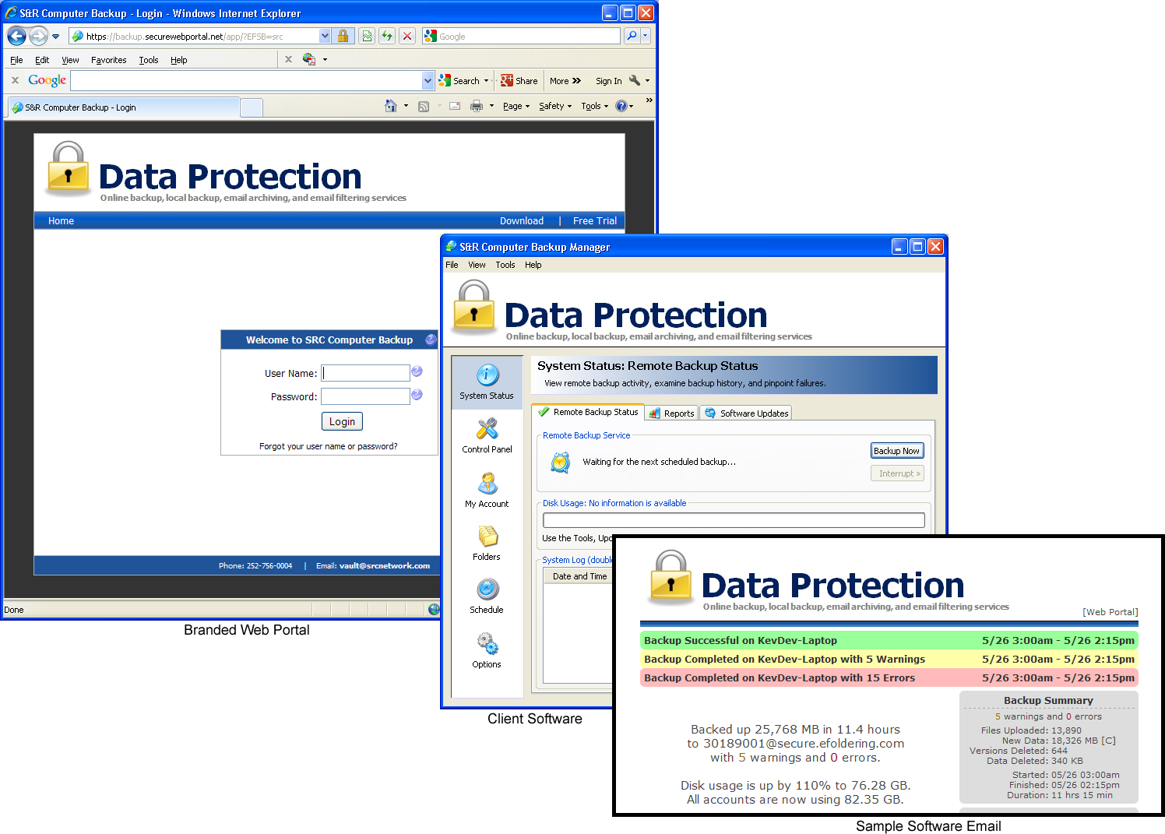

Finding Additional Support
Please contact us if you need additional support.
Call: 800-352-0248
Email: https://axcient.com/partner-support/

